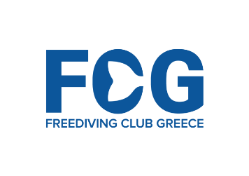
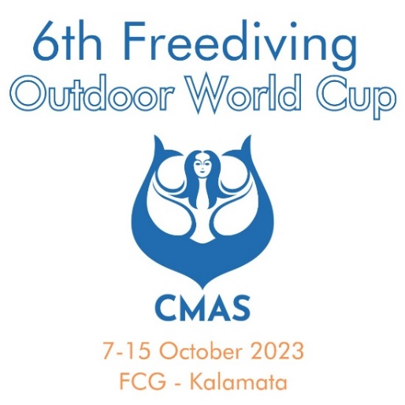

Official Information
&
Registration Form

Official Information
6th CMAS Freediving World Cup 2023 & CMAS Masters Freediving World Cup
Dates: Saturday 7th October 2023 to Sunday 15th October 2023
Disciplines: CWT(Monofin), CWT (Bifins), FIM, CNF - All CMAS Age Categories
World Record Status with WADA Antidoping
Location: Kalamata, Greece
Sanctioning: EOYDA (Greek Underwater Federation – CMAS National Affiliate)
​
Schedule:
Fri 6th October 2023 - 1st Athlete Registration Day
Sat 7th October 2023 - 2nd Athlete Registration Day
Start of the CMAS Outdoor World Cup 2023
Opening Ceremony by the Municipality of Kalamata
Sun 8th October 2023 - Official Training Day CWT
Mon 9th October 2023 - Official Competition Day 1 CWT (Bifins)
Tue 10th October 2023 - Official Competition Day 2 FIM
Wed 11st October 2023 - Rest Day
- Official Training Day CWT (Monofin), CNF
Thu 12th October 2023 - Official Competition Day CNF
Fri 13th October 2023 - Official Competition Day CWT (Monofin)
Sat 14th October 2023 - Back Up Day
Closing Ceremony and Awards Organized by the Municipality of Kalamata
Sun 15th October 2023 - Departure of Athletes
Depth Competition Setup
The event will be based off a 1 main dive boat/platform with a motorized counterballast system and sonar permanently moored at 160m of water 1,5 miles (6 minutes by boat) from the Marina of Kalamata. A motorized counterballast system will be used for the main dive line capable of lifting divers at speeds of 2m/s or faster in case of emergency. A high resolution sonar will be operating on the dive boat, giving detailed real time information on the diver’s progress. Traditional counter-ballast system will be available as back up as well as safety scuba on the surface.
A fully equipped hospital with an ER is located in the city of Kalamata 15 minutes from our dive location, via our rapid evacuation boat. Emergency Medical Doctor and a Rescue Team will be available on location to assist in cases of serious incidents. Evacuation will be to Kalamata Beachfront approximately 6 minutes from the dive location, where a fully equipped ambulance will be on standby, to take any athlete requiring treatment, to the Kalamata Hospital (10 minute drive from the beachfront).
O2 will be available for cases requiring it and decompression O2 will be available on the dive location for athletes who wish to use it. Dry area boats will be available for athletes wishing to warm up dry. 5 Warm up lines will be available.
The Freediving Club Greece safety team comprises of experienced and specifically trained competition safety divers with an extensive background of safety diving in depth competitions.
The above setup and crew have been used in the 2011, 2013 & 2016 World Championships and the very successful Mediterranean World Cup competitions. All factors (team, location, safety procedures, equipment and co-ordination) have been tested and are known to work properly with large numbers of athletes (140+ divers per day). It should be noted that using the above setup throughout the 2011 & 2013 Depth World Championships no delays or incidents occurred that affected the normal progress of the competition.
Travel
The city of Kalamata can be reached by flights (regular and charter) from many European cities. Nearest airport is Kalamata Int Airport (KLX). Shuttle flights are also available from Athens Int Airport as are regular buses connecting Athens to Kalamata (Timetables will be made available prior to the event).

Registration Form

Please fill in all fields marked with _________ and return this document to us as soon as possible to reserve your place. If you do not have all information please send us the information you have at this time and resend the form when you have the rest of the info.

Personal Information:
NAME: __________________ FAMILY NAME: ________________
NATIONALITY: ____________ DATE OF BIRTH: ____/___/_______
E-MAIL ADDRESS: _________ PHONE NUMBER: ________________

Arrival Information
Arrival Date in Kalamata: __________ Details of arrival: _________ (Airport of Arrival)
Departure Information
Departure Date from Kalamata: ________________

Competition Fees 6th CMAS Freediving World Cup Outdoor

- Competition Week booking up to 15th September 2023 €595
- Last minute booking Competition Week after 16th September 2023 €675
- Official Training Day (official training starts Sept 7th) €50/day

Options
- Post dive decompression O₂ (5-8min @ 5m after diving) €25/week

Accommodation
We have arranged special Competition Rates at Elite Resort Hotel (4*) on the beachfront of Kalamata - please contact us for additional info.

All training & competition fees are payable during freediver’s arrival & registration on the 1st day of their arrival at the event.

A non-refundable (for cancellations without a serious medical reason, or cancellations during the 4 weeks prior to your arrival) registration deposit of 50% of your total fees is required to confirm your booking.

By submitting this registration form you agree to all terms and conditions as described in this document and on the event webpage.

* Any costs mentioned in this document refer to costs shared by all participating freedivers in order to cover the running costs and expenses of the event.

See you all in the Calm Zone ☺

Stavros Kastrinakis & Freediving Club Greece Team

