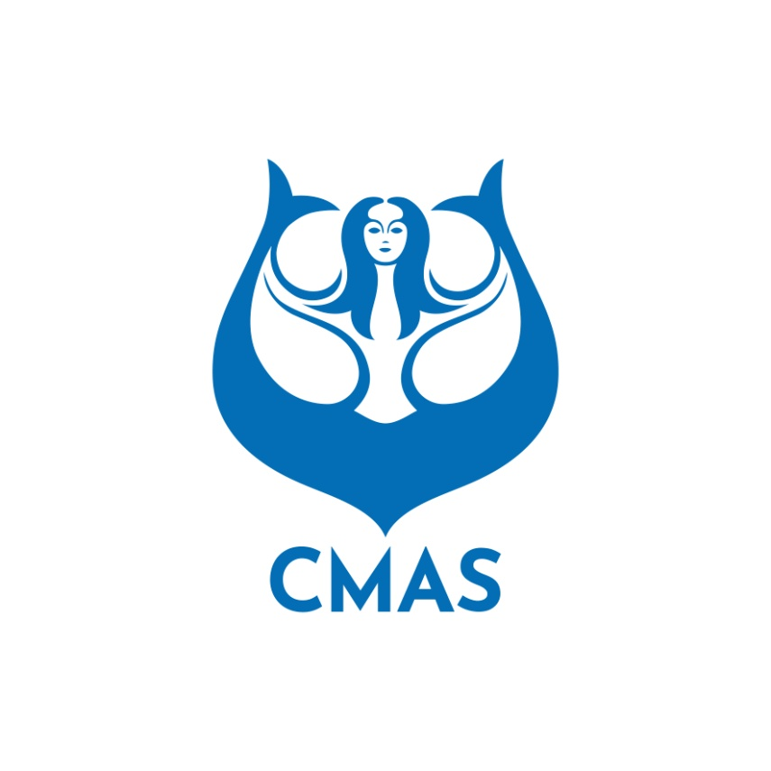
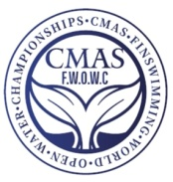
ANNEX 2
HOTEL BOOKING FORM (Before August 20th 2023)
Please complete this form and send to CMAS HQ and Organizing Committee by e-mail:
wcfsbelgrade@gmail.com
Country:
Federation:
Telephone: | Fax: | e-mail:

JUNIORS

Please complete: | Number of Rooms | Date
 | Number of Rooms | From | To
Single
Double / Triple
 | Number of Rooms | Date
 | Number of Rooms | From | To
Single
Double / Triple

Extra Nights: If you need extra nights, please fill in the following.
Please complete: | Number of Rooms | Date
 | Number of Rooms | From | To
Single
Double / Triple
 | Number of Rooms | Date
 | Number of Rooms | From | To
Single
Double / Triple
SENIORS

Please complete: | Number of Rooms | Date
 | Number of Rooms | From | To
Single
Double / Triple
 | Number of Rooms | Date
 | Number of Rooms | From | To
Single
Double / Triple

Extra Nights: If you need extra nights, please fill in the following.
Please complete: | Number of Rooms | Date
 | Number of Rooms | From | To
Single
Double / Triple
 | Number of Rooms | Date
 | Number of Rooms | From | To
Single
Double / Triple

 | Date
(President Signature / stamp) |  | (Full name in block letters)

