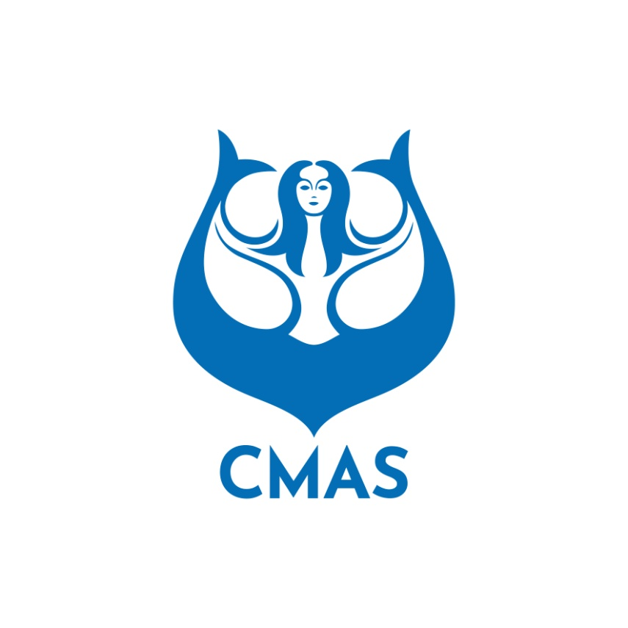
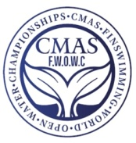
ANNEX 1
INITIAL ENTRY FORM (Before August 20th 2023)
We will participate in the “CMAS Open Water Finswimming World Championships 2023” in BELGRAD (SERBIA). Please complete this form and send to CMAS HQ and Organizing Committee by e-mail: wcfsbelgrade@gmail.com
Country:
Federation:
Total number of Competitors: | Men seniors: | Women seniors:
Total number of Competitors: | Boys juniors: | Girls juniors:
Total number of Officials: | male: | female:
Total number of Delegation: | male: | female:

Declaration Form: By registering my federation in this championship, I undertake to respect the statutes, regulations and directives of the CMAS.
Date and Signature: ________________
Insurance: I hereby declare that all the delegation members have valid health insurance for the duration of the stay, which covers the full extent of the consequences of accidents and reimbursement for the costs of treatment and rehabilitation following the accident that may occur during the stay.
Date and Signature: ________________
Consent to the publication of imagery: I grant the Organizing Committee permission for my imagery, full name, nationality, and voice to be recorded during the competition.
Date and Signature: ________________
Antidoping: this point is not applying for the Visual Championships and competitions.
- I, the undersigned, am responsible for all the delegation members acknowledging WADA Antidoping Rules and CMAS Antidoping Rules.
- As a voluntary and mandatory commitment, the athletes must obtain the certificate ADEL (insert link of ADLE) before receiving the CMAS licences according to the relevant point in the CMAS Procedures and Obligations.
- The expenses regarding the controls in competition belong to the organisers. In case of eventual supplementary analysis requested by WADA related to the bio-physiology of an athlete as ex ABP (athlete biological passport), the expenses belong to her/ his national federation.
Date and Signature: ________________

Please check CMAS Procedures and Finswimming rules for participation in CMAS Championships.

The President | Date
(Full name in block letters)
President Signature/stamp)

