
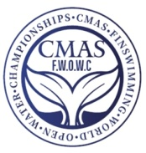
ANNEX 3
COMPETITORS LIST FORM
(Before Sept. 10th 2023)
Please complete this form and send to CMAS HQ and Organizing Committee by e-mail:
wcfsbelgrade@gmail.com
Country:
Federation
Competitors |  | Seniors Men |  |  |  | Seniors Women
Competitors |  | Juniors Men |  |  |  | Juniors Women
Officials |  | Men |  |  |  | Women
n. | NAME |  | FIRST NAME |  | Athlete, Trainer, Delegation Chief, Doctor, Judge, Other |  | Male senior | Male junior | Female senior |  | Female junior | Single  room
1
2
3
4
5
6
7
8
9
10
11
12
13
14
15

ARRIVAL | Date: |  |  |  | Time
Airport |  |  |  |  | Flight No.
DEPARTURE | Date: |  |  |  | Time
Airport |  |  |  |  | Flight No.
 |  |  |  | Date
 |  | (President Signature / stamp) |  |  |  | (Full name in block letters)

