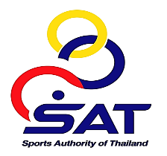
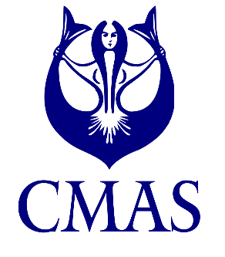
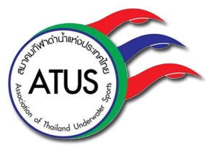
Final Sport Diving World Cup
5th – 7th September 2022, Phuket Thailand

ENCLOSURE 2
BOOKING FORM-ACCOMMODATION

Please complete this form and send it to CMAS HQ and Organizing Committee
no later than 1st August 2022 by E-Mail: atus.cmas.sport@gmail.com
We will participate in the Final Sport Diving World Cup, Phuket Thailand, and book accommodation as the following details:
- Booking of accommodation must be made until 1st August 2022 (Enclosure 2: Booking Form).
- Late bookings are not accepted because room capacities are available only to 1st August 2022
- Capacities are limited! - Rooms are assigned like “first come, first serve”.
- Package - 2 nights/days including transfers from the hotel to the competition area with a FULL BOARD from Monday, 5th September 2022, starting with dinner to Wednesday, 7th September 2022,
ending with lunch.
- Package - 2 nights/days including transfers from the hotel to the competition area with a HALF BOARD from Monday, 5th September 2022 to Wednesday, 7th September 2022, including BREAKFAST ONLY.
- Extra days - arriving earlier than Monday, 5th September 2022 and/or leaving after Wednesday, 7th September 2022 is offered in the following categories:
  - Patong Merlin Hotel Phuket is 60$ per person per day including breakfast, free Wi-Fi, and VAT.
  - Dara Hotel Phuket is 65$ per person per day including breakfast, free Wi-Fi, and VAT.
  - B2 Phuket Premier Hotel is 30$ per person per day including free Wi-Fi and VAT, NO BREAKFAST.
- After your booking via Enclosure 2 the ATUS will contact you via E-Mail immediately.
- Payment and accounting of accommodation are managed directly and only by ATUS during the whole time of planning.
- For questions about accommodation please contact the ATUS via E-Mail: atus.cmas.sport@gmail.com
Country: |  | Club or Federation:
Address for accounting (street + nr., postal code, city):
Telephone: |  | E-Mail:

Package 1 | Please ✓to your choice | Date |  | Optional Extra Night
Patong Merlin Hotel Phuket | Please ✓to your choice | From | To | From-To/Total Room
Superior Room |  | 5th – 7th September 2022 |  | Superior Room
Full Board (3 Meals) | 170$/person/room
Half Board (Only Breakfast) | 130$/person/room
Total Rooms
Final Sport Diving World Cup
5th – 7th September 2022, Phuket Thailand

Package 2 | Please ✓to your choice | Date |  | Optional Extra Night
DARA Hotel Phuket | Please ✓to your choice | From | To | From-To/Total Room
Grand Deluxe Room |  | 5th – 7th September 2022 |  | Grand Deluxe Room
Full Board (3 Meals) | 180$/person/room
Half Board (Only Breakfast) | 140$/person/room
Total Rooms

Package 3 | Please ✓to your choice | Date |  | Optional Extra Night
B2 Phuket Premier Hotel | Please ✓to your choice | From | To | From-To/Total Room
Standard Room |  | 5th – 7th September 2022 |  | Standard Room
Full Board (3 Meals) | 150$/person/room
Half Board (Only Breakfast) | 110$/person/room
Total Rooms

Remark: B2 Premier Hotel Phuket is 5 minutes walk to the competition area.
TRANSPORTATION
- 3 rounds (go and back = 1 round) of transportation from the hotel to the competition area during the event is included in the hotel price.
- Transportation from Phuket International Airport to the hotel can be provided upon request.
- Van type service per car per round is 2,000thb.
- Taxi type service per car per round is 1,000thb.

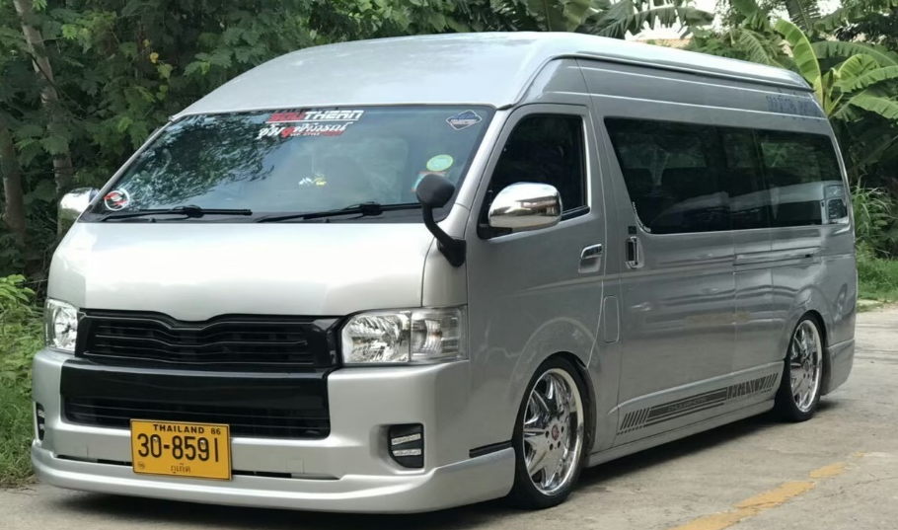

Example Type of Minibus/Van
Final Sport Diving World Cup
5th – 7th September 2022, Phuket Thailand

FLIGHT DETAILS
Flight Details
Team Arrival From _______________________Date:_______________Time:__________Fight No.__________
Team Departure To______________________ Date:_______________Time:__________Fight No.__________

OPTIONAL ONLINE BOOKING FORM VIA QR CODE AND GOOGLE FORM AS BELOW

 | Click here:  PRELIMINARY ENTRY FORM: Final Sport Diving World Cup (Phuket / Thailand) (google.com)

(Responsible Signature / stamp) |  | (Full name in block letters)

