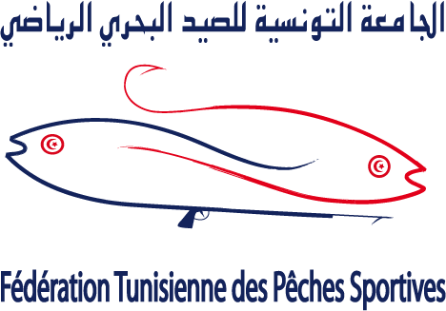


الجامعة التونسية للصيد البحري الرياضي تنظم
تحت إشراف الكنفدرالية العالمية لأنشطة الغوص
البطولة الأورو-إفريقية الثلاث والثلاثين للرجال والثانية للسيدات
في الصيد بالغطس

THE TUNISIAN FEDERATION OF SPORT FISHING (FTPS)
ORGANISES
THE 33rd MEN & the 2nd WOMEN
CMAS EURO-AFRICAN
SPEARFISHING CHAMPIONSHIP

LOGO of the event

بنزرت، تونس \ من 07 إلى 11 سبتمبر 2022
BIZERTE, TUNISIA / from 7th to 11th/09/2022

PARTICULAR RULES
SUMMARY

- WELCOME TO BIZERTE …………………………………………………………………………………………… P: 3

- ORGANIZATION AND CONTROL ……………………………………………………………………………… P: 4

- REGISTRATION…………………………………………………………………….…………………………………. P: 5

- PROGRAM…………………………………………………………………………………….………………….……. P: 7

- THE CHAMPIONSHIP ……………..…..……………………………………………………………..……….…. P: 8

- ALLOWED APPAREL…………………………………………………………………………………………..……. P: 9

- METHODS OF CONTROL.………………………………………………………………………………....……. P: 10

- THE COMPETITION.…………………………………………………………………………………..……….…… P: 10

- COMMISSARIES AND JUDGES.…………………………..…………………………………………………… P: 11

- SCORING AND CLASSIFICATION.……….……………………………………………………………….…... P: 11

- VALID, NO VALID AND BANNED PIECES………………………………………………..………………... P: 12

- REGULATORY FRAMEWORK AND SANCTIONS..…………………………………….……………..…. P: 16

- COMPETITION ZONES AND RESERVE ZONE.……………………………………………….……………. P: 18

- ANTI-DOPING CONTROL.………………………………………………………………………….…………….. P: 22

- RULES INTERPRETATION.…………………………………………………………….………………………….. P: 22

- RESPONSIBILITIES .………………………………………………..…………………………………………….…. P: 22

- ORGANIZATION CONTACT DATA.……………………………………………………………………..….…. P: 22

- ANNEXE 1: INITIAL ENTRY FORM………………………….…………………………………………..….…. P: 23

- ANNEX 2: FINAL ENTRY FORM………………………………………………………………..………..….…. P: 24

- BOAT RENTAL PRICES……………………………………………………………..……………..………..….…. P: 26

- WELCOME TO BIZERTE

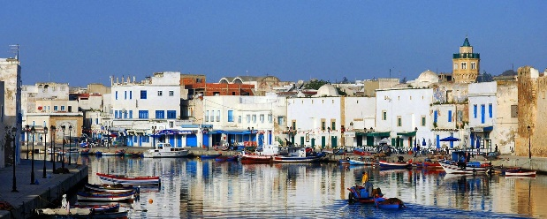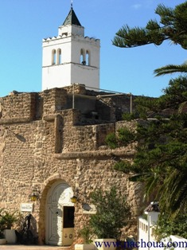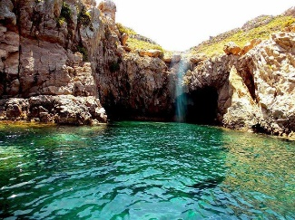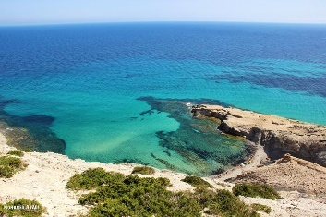

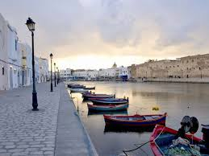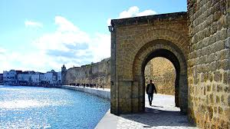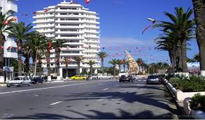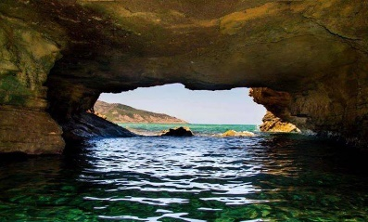

Bizerte is located at 65 kilometres to the Northwest of Tunis, the capital of the country, and five kilometres from cap Blanc, the northern most point of Africa . The city is located at the south-eastern tip of an isthmus on the north shore of the channel of Bizerte connecting the sea to the Lake of Bizerte. It is connected to the rest of its urban area located on the South Bank of the canal, by a Mobile Bridge which leads directly to the A4 motorway leading to Tunis.
Bizerte was founded around 1100 BC by Semitic Phoenicians from Tyre. Initially it was a small Phoenician Harbour for maritime trading in the western Mediterranean. Located 60 km (37 mil) of Carthage, the great city founded by Phoenicians. Around 950 BC the city came under the influence of Carthage under the leadership of Queen Dido/Elissa. In 309 BC, during the Greek–Punic Wars, its port is used by several Carthaginian generals as Hamilcar Barca, Mago, Hasdrubal and Hannibal.
In 149 BC, the city was occupied by the Romans under the name of Hippo Diarrhytus during the period of Julius Caesar reign.
In 439 AD, the Vandals ( East Germanic tribes) invaded the city and they used the port to accomplish their invasions of the rest of the Western Roman Empire, the city of Rome and the islands of Sardinia, Malta, Corsica and Sicily.
From 534 AD to 642 AD, the city returned to eastern Romans under the Byzantine Empire, after a defeat of the vandals in 534, and they build the Fort of Bizerte (now the Fort of Kasbah).
Bizerte was taken by Arabs in 647 in their first invasion, but reverted to Byzantine control until they were defeated and driven from North Africa finally in 695-98, by the troops of Charles V in 1535 and then by the Ottomans in 1574. The city then became a corsair harbour and struggled against the French and the Venetians. Later with the occupation of Tunisia in 1881, France gained control of Bizerte and built a large naval harbour in the city.
Due to Bizerte's strategic location on the Mediterranean, France retained control of the city and her naval base after Tunisian independence in 1956. In 1961, Tunisian forces blockaded the Area of Bizerte and demanded French withdrawal. Meetings at the UN Security Council, and other international pressure moved France to agreement; the French military finally abandoned Bizerte on 15 October 1963.

HOW TO REACH BIZERTE:

The organisation affords free transfer from Tunis Carthage Airport to the hotel in Bizerte and from the hotel to airport only for the official period, which is from the 6th to 11th September 2022.
Out of this period, you can take the bus or better a taxi from Tunis Carthage Airport to go to Bus Main Station for the north at Bab Saadoun, and there you have buses to Bizerte nearly every hour until 06.00 PM. You can also take a “Louage” which is a big size taxi (minivan) that carries 6 to 9 persons. The trip takes one hour and costs by bus or by “Louage” about 5 TND (1,7€). The last option is to rent a car by internet.

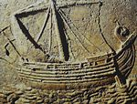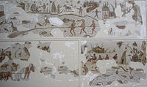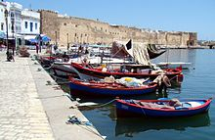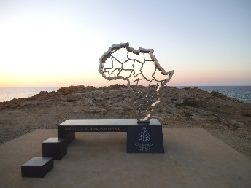

- ORGANIZATION AND CONTROL

The “Confédération Mondiale des Activités Subaquatiques” – CMAS - (world underwater activities
Confederation) has delegated to the “Fédération Tunisienne des Pêches Sportives” – FTPS - (Tunisian Federation of Sport fishing) , the organization of the “CMAS Euro-African Spearfishing championship” Men & Women, that will take place between the days 07th to 11st of September 2022 in the city of Bizerte, Tunisia.

PARTICIPATION CONDITION:
All National European and African Federations affiliated to CMAS and member of the Spearfishing Committee have the right to participate to the Euro-African Spearfishing championship. They must keep up to date their Spearfishing CMAS Committee Membership Payment when formalizing their inscription.

COMPETITION COMMITTEE:
The Competition Committee aims to provide support to the CMAS Technical Delegate under request, and it is constituted by:
- CMAS Technical Delegate: Mr. Sergio Perez Hernandez
- Director of Competition: Mr. Fethi Jebalia
- Three (3) no competitor captains, appointed in the technical meeting.

ORGANIZATION & TECHNICAL CONTROL:
- CMAS Technical Delegate: Mr Sergio Perez Hernandez
- Competition director: Fethi Jebalia
- Technical and Safety Judge: Rifaat Bahri
- General Secretary of the FTPS: Miss Yosra Ben Amor
- Medical assistance: Dr. Mourad Ben Taleb
- Protocol & Ceremonies Commissioner: Dr Nabil Jellazi
- The Boat Commissioners

SECURITY:
The Tunisian Federation is engaged to detail a Safety Plan for the Euro-African CMAS Spearfishing Championship 2022 that will be developed by organizer and approved by CMAS Technical Delegate no later than 6 weeks before EAC, accordingly to requirements in Appendix 2 Safety List.

OTHER BOATS IN THE COMPETITION AREA:
- Committees and Organization
- Press boat

- REGISTRATION

The affiliated National Federations to CMAS Spearfishing Committee can register their Teams by email or in the championship website. The athletes of each Club must be older than eighteen years. The federations must send for every member of the teams: first name, name, CMAS Sports License Number. Each team must bring flags and the anthem of their own country in electronic form or cd.
Each delegation can be officially formed by:
- Three athletes.
- A team captain, who can be one of the athletes.
- A delegate or a doctor of the team.

REGISTRATION FEE:

- MEN:

Team members | Full mode:  WITH accommodation Half Board 4 nights |  |  | Mode 2:  WITHOUT accommodation / with boats
Team members | 1st payment up to May 31th 2022 | 2ndpayment up to July 31th 2022 | Total  fee | 1st payment up to May31th 2022 | 2ndpayment up to July 31th 2022 | Total  fee
4 | 1650 € | 1650 € | 3300 € | 1250 € | 1250 € | 2500 €
3 | 1450 € | 1450 € | 2900 € | 1100 € | 1100 € | 2200 €
2 | 1150 € | 1150 € | 2300 € | 900 € | 900 € | 1800 €
1 | 750 € | 750 € | 1500 € | 600 € | 600 € | 1200 €

Team members | Mode 3:  WITH accommodation / WITHOUT Boats |  |  | Mode 4:  WITHOUT accommodation / WITHOUT Boats
Team members | 1st payment up to May 31th 2022 | 2ndpayment up to July 31th 2022 | Total  fee | 1st payment up to May 31th 2022 | 2ndpayment up to July 31th 2022 | Total  fee
4 | 1400 € | 1400 € | 2800 € | 1050 € | 1050 € | 2100 €
3 | 1250 € | 1250 € | 2500 € | 900 € | 900 € | 1800 €
2 | 1000 € | 1000 € | 2000 € | 700 € | 700 € | 1400 €
1 | 650 € | 650 € | 1300 € | 450 € | 450 € | 900 €

- WOMEN:

A special price will be applied for the women teams (athlete and captain).

Team members | Full mode:  WITH accommodation Half Board 4 nights |  |  | Mode 2:  WITHOUT accommodation / with boats
Team members | 1st payment up to May 31th 2022 | 2ndpayment up to July 31th 2022 | Total  fee | 1st payment up to May 31th 2022 | 2ndpayment up to July 31th 2022 | Total  fee
4 | 1550 € | 1550 € | 3100 € | 1150 € | 1150 € | 2300 €
3 | 1350 € | 1350 € | 2700 € | 550 € | 550 € | 2100 €
2 | 900 € | 900 € | 1800 € | 700 € | 700 € | 1400 €
1 | 450 € | 450 € | 900 € | 350 € | 350 € | 700 €

Team members | Mode 3:  WITH accommodation / WITHOUT Boats |  |  | Mode 4:  WITHOUT accommodation / WITHOUT Boats
Team members | 1st payment up to May 31 ^{th} 2022 | 2ndpayment up to July 31th 2022 | Total  fee | 1st payment up to May 31th 2022 | 2ndpayment up to July 31th 2022 | Total  fee
4 | 1 | 1400 € | 2600 € | 950 € | 950 € | 1900 €
3 | 1100 € | 1150 € | 2250 € | 825 € | 825 € | 1650 €
2 | 750 € | 750 € | 1500 € | 550 € | 550 € | 1100 €
1 | 350 € | 400 € | 750 € | 250 € | 300 € | 550 €

Full registration cost includes:
- Organization and general expenses of the Euro-African championship.
- Hotel accommodation / Inn: bed & breakfast for four (4) nights + half board meals. An extra charge of 20 € per day will be applied for single room.
- Two main dinners: Closure day and Opening day.
- Internal transfers from hotel to the Marina and weighing zone.
- Souvenirs kit
- Ice for catches, fresh fruit, sandwich and water for the competitors on the days of competition.
- Boat for each athlete, in two (2) competition days.
- Participants who have registered in full mode or mode 2 and wish to keep the same boats that they have rented during scouting for the 2 competition days must state this latest when registering on September 7th 2022, a discount of 200 € will be applied for each boat. This would mean that those boats will be treated as own boats and not included in the boats drawing and not be fuelled and payed for by the organisation. An organisation commissioner will be appointed to each one of the own boats accepted from the organisation.

Additional participant:
- The fee for additional members of delegations not competing or companions (family, supporters, other team members …) is 350 € per person, including: Hotel accommodation (four (4) nights half board + extra charge of 20 € per day if single room) + Opening Dinner + Award & Closure Dinner.
- For those who choose not to stay in the official hotel, they have to pay only the Opening + Closure Dinner cost which is fixed at 120 € for both.

Accommodation and lodging:
The Head quarter of the organisation will be installed in the “Bizerta Resort” hotel.
Teams, which register in full mode or in mode 3, will stay at the official hotel.
Teams, which choose the modes 2 or 4, have many options:
- other hotels not so far from the marina and from different categories (from** to ****) with prices fluctuating between 25 € and 75 € pax/night
- guesthouses and apartments in the city with prices fluctuating between 35 € and 75 € pax/night.
Due to the difficulty to make an arrangement with hotels about the prices one year and half in advance without guarantee of sufficient number of clients, we advise to teams which choose the modes 2 or 4 to book by internet.

MODALITY OF REGISTRATION:
To register for the Euro-African championship, Federations with right to participate must fill in and send the Initial Entry Form to the Tunisian Federation of Sport fishing “FTPS” (ftps@ftps.ogr.tn) by email or via the dedicated championship website not later than May 15th 2022.
Also, participating Federation must finalize their registration, by filling in and sending the Final Entry Form to the Tunisian Federation of Sport fishing “FTPS” (ftps@ftps.ogr.tn) by e-mail or via the dedicated championship website, with the transfer slip of the 1st instalment of the Participation Fee, before May 31th.
The second instalment of the Participation Fee must be done before July 31th.
Payment of the Participation Fee will be performed by Bank Transfer to the account of the Tunisian Federation of Sport fishing (FTPS) in the “Banque de Tunisie” (BT). Account number 05 001 0000275037486 92; IBAN: TN59 0500 1000 0275 0374 8692 ; BIC: BTBKTNTT. Only Banque de Tunisie costs will be deducted from payment amount. All other bank transfer cost to be held by participating federations.
NB: Federations that waive participation after making the first payment cannot claim the restitution of the amount transferred, because of the commitment made by the federation to the hotel, boat owners and others stakeholders.

4. PROGRAM:

- WEDNESDAY, September 7th
12:00 AM → 18:00 PM: Arrival to the official Hotel and registration.
20:00 PM: Dinner

- THURSDAY, September 8th
08:00 AM: Breakfast
10:00 AM: Captains technical meeting, boats drawing and commissaries inscription.
12:00 AM: Commissars meeting
18:00 PM: Opening parade.
19:00 PM: World Cup presentation ceremony at the old port of Bizerte.

- FRIDAY, September 9th - First day of competition
06:00 AM: Breakfast
07:00 AM: Concentration in Bizerte Marina.
08:00 AM: Leaving to zone of competition
08:30 AM: Competition Start, First day of competition.
14:30 PM: End of the first day of competition.
15:00 PM: Arrival to the Marina, food and drinks.
17:00 PM: weighing process start at Bizerte Marina.
21:00 PM: Dinner at the hotel

- SATURDAY, September 10th – Second day of competition
06:00 AM: Breakfast
07:00 AM: Concentration in Bizerte Marina
08:00 AM: Leaving to zone of competition
09:00 AM: Competition start, Second day of competition.
15:00 PM: End of the second day of competition.
16:00 PM: Arrival to the Marina, food and drinks.
18:00 PM: Weighing process start at the hotel.
21:00 PM: Medals official Award.
22:00 PM: Closure dinner at official Hotel

- SUNDAY, September 11th
08:00 AM: Breakfast
11:00 AM: Leaving hotel.
NOTE- Timetables can be modified due to necessities.

5. THE CHAMPIONSHIP

The Spearfishing Euro-African championship will take place in two consecutive days of competition of five (5) hours each one, in the northern coast of Tunisia.
This geographic area will be divided in three (3) areas named “Competition areas”, two (2) primary areas where competition will take place and one (1) reserve area in case the weather conditions make it unsafe for people and boats to operate in the primary areas. These areas will be named Zone A , Zone B and Reserve zone.
The Men and Women competitions will take place in the same areas, at the same time.
The CMAS Technical Delegate will confirm the order of the competition areas the day preceding the first competition or not later than one hour before the start of the first competition day.
The CMAS Technical Delegate can, if he considers it necessary, reduce the time of the competition day, during the competition or at the start of the competition, for safety reasons, if weather conditions are severe.
Competition in one day will be valid if the time passed exceeds the two thirds of what is the scheduled for the competition in the day.
The championship will be valid when at least one valid competition day is completed.
The total suspension of a competition day is strictly a decision of CMAS technical delegate.
BOATS:
- Athletes can only use the boat provided by the Organization Committee or own boats accepted on registration. Another means of transportation is forbidden during the time of competition.
- Each athlete will be provided with an official boat, taking in account that boats could be of diverse size and power.
- Available boats, excluding athletes with own boat accepted by organizer, will be distributed by draw.
- Captains are allowed to be in one of the boats assigned to own athletes, and they will be free to switch from one boat to another during the day of competition.
- The boatmen act as commissioners.
- In case of breakdown, only boats provided by the organisation will be replaced as far as possible. Complains about the substitute boat will not be accepted.
- Athletes, which bring their own boats, must attach a written notice when registering. Only boats with 150 maximum HP are authorized. Commissioners will be assigned to these boats by the organisation.
- The CMAS Technical Delegate will select the commissioners for the Tunisian athletes among other nations’ available commissioners.
- Each official boat will be assigned a reference number. It will be a reference number when using the radio signal transmitter during the competition.
- Competitors are not allowed to change their boat.

The official visit period without fishing and taking guns in water are two weeks = 14 days + the day before the championship starts = 15 days: since August 24th to September 7th 2022 (both included).

IT IS FORBIDDEN:
- To access the competition areas the day before the beginning of competition to all the competitors, members of delegation, commissaries, captains and other persons related to said persons.
- To visit any competition area during official visit period using scuba diving apparel other than apnea, or using scooters or any underwater mean of propulsion.
WARNING!!
- Concerning athletes who want to spearfish before competition, they need a spearfishing licence. They have to ask for it from the Tunisian federation (send or bring 1 photo, medical certificate, copy of passport, a document to fill and about 100 euros). There is no forbidden area close to the competition zones, but spearfishing in the competition area is forbidden to all competitors during the 60 days preceding the championship. Going to water without a speargun does not require a licence.
- Tunisian legislation BANS THE GROUPER captures by spearfishing (except in the EA championship). During the training days, athletes shall aim other species; the quota allowed is 5kg per spearfisher / day. Commissioners from the Tunisian federation, coast guards or other competent authorities might inspect the boats.
- Organization strongly recommends complying with the Tunisian Fishing legislation.
- Breaking the law will lead to expulsion from the competition as well as the fishing apparel confiscation and an administrative and financial punishment.
- During the competition, the Commissioners are responsible for participants to comply with the Law.

6. ALLOWED APPAREL

The use of an official buoy provided by the organizer committee is obligatory for all competitors in the sea during the time of the competition days.
In the event of losing the official buoy, the boat commissaries will request the organization for a spare official buoy, during that time the athlete must use another own buoy of similar dimensions, if not, he must wait on the boat.

Only the use of following equipment is allowed:
1. One boat for each athlete.
2. Spear guns, loaded by the athlete without help of other competitor or support of people on boat.
3. Diving fins
4. Mask.
5. Snorkel
6. Fast release weights belt.
7. Extra ballast weight that is always retrieved from sea bottom.
8. Gloves.
9. Buoy fish holder.
10. Spare arrows and hooks.
11. Underwater watch and computer.
12. Echo sounder.
13. Isothermal wetsuit.
14. Diving knife.
15. It is recommended to have an icebox to keep the catches fresh.
16. Communication means (mobile phones, VHF transceivers, talky walky radio,…).
17. Global Position System (GPS).
18. Portable scale.
19. Flashlight / underwater torch.
20. Safety jacket* gadget approved by CMAS.

*NB: The volunteer Athletes can wear the safety jacket in competition but once used it is synonym of disqualification for the athlete.

It is forbidden:
- To carry fish in the belt or any other place than the buoy or the boat.
- To be dragged by boat in the water against the current.
- Loaded spear gun out of water.
- To hung loaded spear gun on buoys.
- To use compressed air/oxygen for breathing from any kind of device or container in water or on the boat.

COMPULSORY EQUIPMENTS:
Tunisian Law requires the use of following equipment:
- Homologate safety float (buoy) or a spearfishing board.
- Red flag with a white line signalling underwater activity.

7. METHODS OF CONTROL

Each athlete will be provided with a numbered official buoy when registering at the hotel, the use of that buoy is COMPULSORY during the days of the competition, athletes must not go further than 25 meters from their official buoy.
The organizer committee will give numbered bag or numbered wire to every athlete to keep the fish that will be sealed by the commissaries and delivered at the designated place for the collection of the catches at the end of each competition day, or at the time when an athlete decides to abandon the competition. In this event, it is compulsory that the athlete communicates his intention to the CMAS Technical Delegate or the Director of competition before leaving the competition area.
A number, the correspondent initials of the country and its flag, according to CMAS General Rules, will identify the boat of every athlete.

- THE COMPETITION

The Director of Competition will lead the journey of boats and competitors to the gathering point determined during the technical meeting of captains, in the middle of the zone of competition. The boat of the Director of Competition will leave the port of departure, followed by the boats of the athletes until arriving at the gathering point, where he will indicate the start of the competition with visual or/and sound signals.
All boats must follow the Director of Competition boat to and from the competition area.
Once all boats have arrived at the gathering point, there will be a new recount of the participants and the time for the start and the competition day will be communicated.
The gathering point and the margins of time to arrive to the gathering point and pass the control once the fishing time has expired will also be reminded at that moment.
At the end of the competition, the Director of Competition will signal the end in the same mode. Boats of competitors must arrive to the precise gathering checkpoint 15 minutes after the end of the competition time. The CMAS Technical Delegate can set a different margin if sea conditions require it.
- PENALIZATION FOR THE DELAY ON THE MARGINS OF TIME:
- Up to 5 minutes . . . . . . . . . . . . . . . . . . . . . . . . . . . . 2.000 points
- Every additional minute or fraction………………………500 points
- Over 15 minutes . . . . . . . . . . . . . . . . . . . . ………Disqualification
The movement of the boats during the competition all the zone long must be keeping prudent distances with the other athletes and their buoys and at slow speed and respecting the distance in the radius of 35 meters of the buoy signalling one athlete.

- COMMISSARIES AND JUDGES

All not identified situations in the present rules must be solved according to the international Spearfishing rules of CMAS.
For events not identified in the Particular or the General Rules, a decision will be taken and resolved by the International Jury/CMAS Technical Delegate for the Euro-African championship.
The competition Committee may be consulted by the CMAS Technical Delegate for expert advice at any moment, but the CMAS Technical Delegate will take his own decisions.
Commissaries of boats must fulfil the legal requirements and follow the orders of the CMAS Technical Delegate.
In the event of an athlete becoming tired or other circumstances obliging him to retire from the competition, he can only leave the competition after notifying the commissary in own boat or in the medical boat (if necessary) and the latter has to communicate the information to the CMAS Technical Delegate or the Director of competition.

During the competition, the official Main Boat will have flags in colours meaning:
RED: Emergence/Urgency
WHITE: End of competition.
GREEN: Request for mechanical help.
The official Main Boat may hoist a flag with the CMAS or the Euro-African championship logo to be recognizable.

After White flag and sound signal, all competitors must stop fishing activity and go on board the boat. If an athlete has to stay in water, he must stop the fishing activity and remove his mask from his face.

- SCORING AND CLASSIFICATION

- The calculation is done in two steps:

STEP 1: Traditional Points (P.T.)
The amount of points obtained by the captures in groups, calculated as follows: one point per gram of each valid catch plus the established bonuses.
The max valid weight for the scoring of the catches of any group will be 12500 g.
Catches that weigh more than 12500 gr will score this maximum value plus the bonus, although total real weight will be considered in the event of the existence of an award for the Biggest Catch.

BONUSES:
· Each valid catch will have a 500 points bonus.
· Each different species will have a 500 points bonus.
· Additional bonus of 1000 points when the full quote of catches of a certain species is completed.

STEP 2: Percent Punctuation (P.P. %)
The total punctuation of each athlete on each day will be a percentage taking as reference the punctuation of the athlete with the highest score in that day of the competition.
The athlete who obtains the best punctuation will be credited with the 100% and the points of the rest of the athletes will be calculated as a prorata percentage of that punctuation. The percent values will be rounded up to the third decimal.
- Formula for calculation the individual points:

Punctuation of each athlete x 100

Punctuation of the first classified of the day

The classification will be calculated in points, following the precedent rules.
The athlete who presents his catches in a bag other than the official one provided by the organization, will be penalized by removing them from bag and water and will be the last at the order of weighing.
- PENALTIES:
· Any catch not reaching two thirds of the minimum weight of their category, will generate a penalty (negative points), equal to the minimum weight of the category/group.
· In the event of one fish exceeding the established limit of catches of one species, the two heavier catches of the species will be removed and the bonus per species will not be awarded.
· In the event of the established limit of catches in Group 3 and Group 5 have been exceeded, the penalty will be disqualification from the championship.
· If a competitor exceeds by two or more the limit of catches of one species, all the catches of the concerned species will be disqualified for the day of competition.
· Any catch that is not in the boat at the finish time of the competition is not considered a valid piece.

11. VALID, NON VALID AND BANNED SPECIES

BANNED SPECIES

Athletes are not allowed to fish any banned species by Tunisian law, as:
- Red Tuna : Thunnus Maccoyii
- Bluefin Tuna : Thunnus Thynnus
- All kind of Octopus
Athletes are also not allowed to fish:
- Cuttlefish : Sepia Lycidas
- Squid: Decapodiformes
- All kind of sharks
- Swordfish : Xiphias gladius
- Moonfish (Mola mola)

VALID SPECIES

Six (6) groups are established according to specific minimum weight and maximum number of catches allowed in these Particular Rules.
Is considered valid species, any fish, caught alive and in freedom, and is included in the Groups lists 1-2-3-4-5 as below. If a species does not appear in the group lists, it is NON-VALID species.
The highest weight that provides points will be 12,5kg for each piece.

GROUP 1

- Minimum weight for the catches of this group is 500 grs.
- Allowed maximum number of capture: ten (10) pieces per day for each species.
- Points:
  - One point for every gram
  - 500 points bonus for each catch
  - 500 points bonus for each species.
  - 1000 points bonus for full quota (10 valid) of same species.
- Min. weight without penalty: 335 grs.
- Penalty if weighing under 335 grs: -500 points.
- Species are detailed in the following table:
ENGLISH NAME | SCIENTIFIC NAME | ARABIC NAME
White Seabream | DIPLODUS SARGUS | صارقي / فولية / ليفي
Sharpsnout Seabream | DIPLODUS PUNTAZZO | معزة
Saddled Seabream | OBLADA MELANURA | كحلاية
Seabream | DIPLODUS VULGARIS | شرقوت
Gilthead Seabream | SPARUS AURATUS | وراطة / جراف / ورقة
Zebra seabream | DIPLODUS CERVINUS | سردوك / عروس
Mullets | MUGILIDAE (FAMILLE) | بوري بأنواعه
Bass | DISCENTRARCHUS | قاروس بنوعيه
Brown Meagre | SCIAENA UMBRA | غراب
Shi Drum | UMBRINA CIRROSA | غراب أبيض
Mediterranean horse mackerel | TRACHURUS TRACHURUS | شورو
Salema | SARPA SALPA | شلبة
Slender Rockfish | SCORPEANA | بوكشاش
Mackerel | SCOMBER (scombrus, japonicus) | سكمبري / غزال
Atlantic bonito | SARDRA SARDA /AUSTRALIS | بالاميت
John Dory | ZEUS FABER | حوت سيدي سليمان
All Wrasses | LABRIDAE (FAMILLE) | خضراية
Stripped Seabream | LITHOGNATUS MORMYRUS | منكوس
Black Seabream | SPONDYLOSOMA CANTHARUS | طنوت / وراطة كحلة
Forkbeard | PHYCIS PHYCIS | مزداية
Pandora | PAGELLUS (erythrinus, acarne...) | مرجان
Mullus Surmuletus | MULLUS (surmuletus, barbatus) | تريلية
Parrot Fish | SPARISOMA CRETENSE | بباغيو
Largeye Dentex | DENTEX MACROPHTHALMUS | جغالي بوالعينين

GROUP 2

- Minimum weight for the catches of this group is 1000 grs.
- Allowed maximum number of capture: five (5) pieces per day for each species.
- Points:
  - One point for every gram
  - 500 points bonus for each catch
  - 500 points bonus for each species.
  - 1000 points bonus for full quota (5 valid) of same species.
- Min. weight without penalty: 667 grs.
- Penalty if weighing under 667 grs: -1000 points.
- Species are detailed in the following table:
ARABIC NAME | SCIENTIFIC NAME | ENGLISH NAME
أمبوكة | CORYPHAENA HYPPURUS | Common Dolphinfish
شولة / بشليمون / صفراية | SERIOLA DUMERILI | Amberjack
قربة / قلعاية | LICHIA AMIA | Lichia Amia
بيشي شورو/ شباط / شرب | CِARANX SEXFASCIATUS | Bigeye Jack / Bigeye Trevally
قراض / سرة | POMATORMUS SALTATOR | Bluefish
بارا كودا | SPHYRAENA SPHYRAENA | Barracuda
حلوف / فارة | BALISTE (capriscus, carolinensis) | Grey triggerfish
جغالي بوراس | DENTEX GIBBOSUS | Dentex Gibbosus
دنديق / قرفال / قطوس | DENTEX DENTEX | Common Dentex
جغالي بأنواعه (باقري/ عروس) | PAGRUS (FAMILLE) | Seabream

GROUP 3

- Minimum weight for the catches of this group is 2000 grs.
- Allowed maximum number of capture: five (5) pieces per day for allspecies.
- Points:
  - One point for every gram
  - 500 points bonus for each catch
  - 500 points bonus for each species.
  - 1000 points bonus for full quota (5 valid) from group 3.
- Min. weight without penalty: 1334 grs.
- Penalty if weighing under 1334 grs: -2000 points.
- Species are detailed in the following table:
ARABIC NAME | SCIENTIFIC NAME | ENGLISH NAME
باداش \ ذيب | EPINEPHELUS ALEXANDRINUS | Blacktip Grouper
باداش \ ذيب | EPINEPHELUS COSTAE | Goldblotch Grouper
باداش \ ذيب | EPINEPHELUS CANINUS | Long-tooth Grouper
باداش \ ذيب | MYCTEROPERCA RUBRA | Motled Grouper
مناني أبيض | EPINEPHELUS AENEUS | White Grouper

GROUP 4

- Minimum weight for the catches of this group is 2000 grs.
- Allowed maximum number of capture: two (2) pieces per day for each species.
- Points:
  - 1000 points for each catch, whatever the valid weight.
  - 500 points bonus for each catch.
  - 500 points bonus for each species.
  - 1000 points bonus for full quota (2valid) of same species.
- Min. weight without penalty: 1334 grs.
- Penalty if weighing under 1334 grs: -2000 points.
- Species are detailed in the following table:

ARABIC NAME | SCIENTIFIC NAME | ENGLISH NAME
مرينة | MURAENA HELENA | Moray Eel
قرنقو | CONGER CONGER | Conger Eel

GROUP 5

- Minimum weight for the catches of this group is 7000 grs.
- Allowed maximum number of capture: two (2) pieces per day for each species.
- Points:
  - One point for every gram
  - 500 points bonus for each catch
  - 500 points bonus for each species.
  - 1000 points bonus for full quota (2 valid) of same species.
- Min. weight without penalty: 4666 grs.
- Penalty if weighing under 4666 grs: -7000 points.
- Species are detailed in the table:
ARABIC NAME | SCIENTIFIC NAME | ENGLISH NAME
مناني أحمر | EPINEPHELUS MARGINATUS | Dusky Grouper

GROUP 6

- Minimum weight for the catches of this group is 5000 grs.
- Allowed maximum number of capture: five (5) pieces per day for each species.
- Points:
  - One point for every gram
  - 500 points bonus for each catch
  - 500 points bonus for each species.
  - 1000 points bonus for full quota (2 valid) of same species.
- Min. weight without penalty: 3333 grs.
- Penalty if weighing under 3333 grs: -5000 points.
- Species are detailed in the table:
ARABIC NAME | SCIENTIFIC NAME | ENGLISH NAME
فيغو / لاج | ARGYROSOMUS REGIUS | Meagre / Jewfish / Corvina

FINAL RANKING

Only Individual and Nation classification is awarded by CMAS. Other classification, if made by the organisation, will be honorific and non-official.

Individual ranking: It is determined by the sum of the percentage points obtained in the two competition days. In case of a tie in points, the athlete with the highest number of catches is advantaged. If the number of catches is equal, the athlete with the highest number is advantaged.

Nation ranking: It is determined by the sum of the points obtained by all the athletes of a nation team in the two competition days. In case of a tie in points, the team with the highest number of catches is advantaged. If the number of catches is equal, the team with the highest number is advantaged.

12. REGULATORY FRAMEWORK AND SANCTIONS

During the Euro-African Spearfishing championship, the national teams and their members must follow these Particular Rules and the CMAS Spear Fishing General Rules. They also must observe the local Tunisian laws.
The CMAS Technical delegate, Director of Competition and commissaries, will be in charge to enforce respect of the rules. Following the boat commissaries or the competition director report to the CMAS Technical Delegate of any wrongful behaviour, the latter can decide a WARNING or a DISQUALIFICATION (for the day OR the whole Euro-African championship).

DISCIPLINE:

Behaviours punishable with a WARNING:
- To arrive late at the control points planned by the Organization.
- For incorrect behaviour towards other competitors or the Judges.
- To move away more than 25 meters from his official buoy.
- To load or to maintain his spear gun in loaded position on ground or on the boat.
- To have a means of signal indication not in conformity with the Rules.
- To not declare to have caught the total number allowed for a certain species of fish, as stated in the Particular Rules.
- During the time of competition, going out of the limits of the competition zone up toa distance where this could be considered as accidental and not intentional.
- To have obtained help to recover the official buoy from anyone on board of own boat, during the time the competitor is diving or in surface (no warning for any help when competitor is on board of own boat).
- To present for weighing a fish speared by another competitor and left at the surface or at the bottom with evident signalization or a fish that was brought to the surface after the lapse of the competition time. The fish will not count and will be invalid.
- To present the catch in a bag, with or without water, different than the one provided by the organization. Apart from the warning, the catch will be weighed at the end of the weighing after removal of the bag and the water.
- To violate any other provision in the rules not specifically provided for in this Discipline Rules.

Behaviours punishable with DISQUALIFICATION FOR THE DAY:
- Two warnings of CMAS Technical Delegate for any reason in the same day, leads to immediate disqualification in the day.
- Carrying fish in the belt or keeping catches at any place out of boat or official buoy.
- To return after the finish time for the end of the competition without major force justification: time to return to be established according to length of zone and sea conditions.
- During the time of competition, going out of the limits of the competition zone beyond a distance where this is considered as intentional.
- The athlete that presents a higher number of catches with penalty than valid catches weighed.
- Leaving the competition zone before scheduled ending time or without passing check control of arrival, without getting permission of CMAS Technical Delegate or Director of the competition, through Boat Commissar demand.
- To stay in sea after the official time of day of competition, even not accepting the signals of end of time from Boat Commissar.
- To be dragged by boat in the water against the current.
- To use the Freediver Recovery Vest without previous notification of the CMAS Technical Delegate and initialling of its gas capsule..
- To inflate the Freediver Recovery Vest (even if by accident) or not to present its gas capsule for inspection after the end of each competition day..
- To use electric winch or other electric device to lift the weight from the bottom.
- To use gps/motor (Minn Kota) machine that keeps boat at the same spot (electric anchor).

Behaviours punishable with TOTAL DISQUALIFICATION (Deleted from official classification):
- To fish species prohibited by the national legislation or infringement of any fishing local law.
- Return or leave in water catches of any kind / category: not valid, forbidden or valid species of any weight.
- To be in the Competition Zone, with or without speargun, before the Official start time in the days of competition or precedent day.
- All those who committed offences before the beginning of the competition will not be allowed to take part in the competition.
- To dive clearly out of limits of the official zone during the competition.
- Weighing fraud.
- The use, during official time of competition as well as along the official period of zone visit before the Euro-African championship:
· of exploding head and / or any gadget with explosive power.
· of spearguns with explosive gas or any system which is not loaded by human physical effort.
· of any diving breathing system.
· of any submarine propeller gadget.
- Aggression towards other Competitors, the Judges or the Members of the Organization before the start or during the competition.
- Replacement of the catches of the regulated species or exchanged between athletes.

COMPLAINTS

· Participants have the right to make a complaint to the Jury.
· Only the team's Captain can make the complaint.
· All complaints must be accompanied by a 100 € deposit, fixed by CMAS.
· A complaint must be submitted in writing to the CMAS International Judge (using English, French or Spanish) during the following periods:
1) Before the weighing start time (complaints about competition).
2) During the weighing operations (complaints about weighing).
3) After the classification publication (complaints about classification).
The complaint about classification must be notified to the CMAS International Judge (with 100 € deposit) within 30 minutes following the Classification publication in order to postpone the award ceremony.
If the complaint is accepted, the 100 € deposit will be refunded. If not, the cash deposit will remain with CMAS.

13. COMPETITION AND RESERVE ZONES

The CMAS Euro-African Spearfishing championship will take place in the days 07, 08, 09 and 11th of September 2021.
It will be held in Bizerte, on the northern coast of Tunisia.
The competition will take place in two different zones (A & B) situated in the N/W of Bizerte. In case of inconvenient weather, a reserve zone is planned at the East of Bizerte.
The Men and Women competitions will take place in the same areas, at the same time.

ZONE A: First day of competition, the zone will be that detailed in map:

- EAST STRAIGHT LINE LIMIT
N 37° 20.86´— E 09 50.24´
N 37° 21.93´— E 09 50.24´
- WEST STRAIGHT LINE LIMIT
N 37° 21.47´— E 09 44.45´
N 37° 22.21´— E 09 44.45´

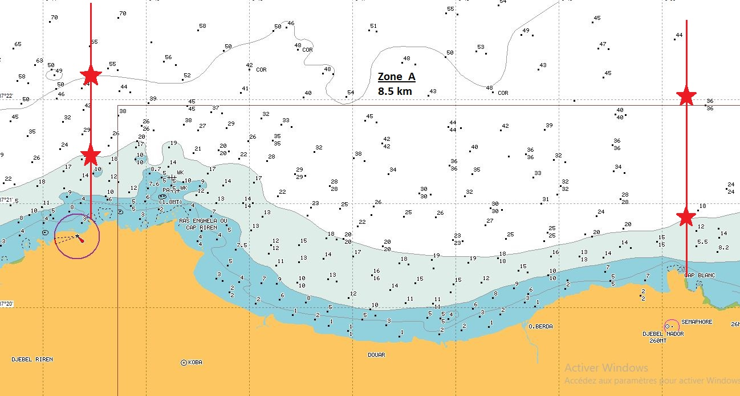

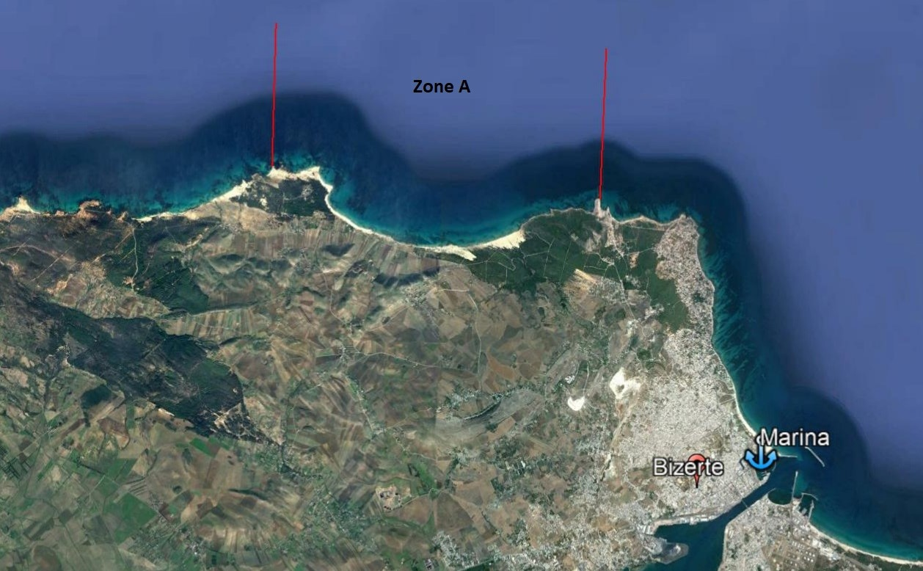

ZONE B: The second day of the competition will be as detailed:

- EAST STRAIGHT LINE LIMIT
N 37°21.46´—E 09 44.45´
N 37°22.20´—E 09 44.45´
- WESTSTRAIGHT LINE LIMIT
N 37° 20.56´— E 09 39.00´
N 37° 21.54´— E 09 39.00´

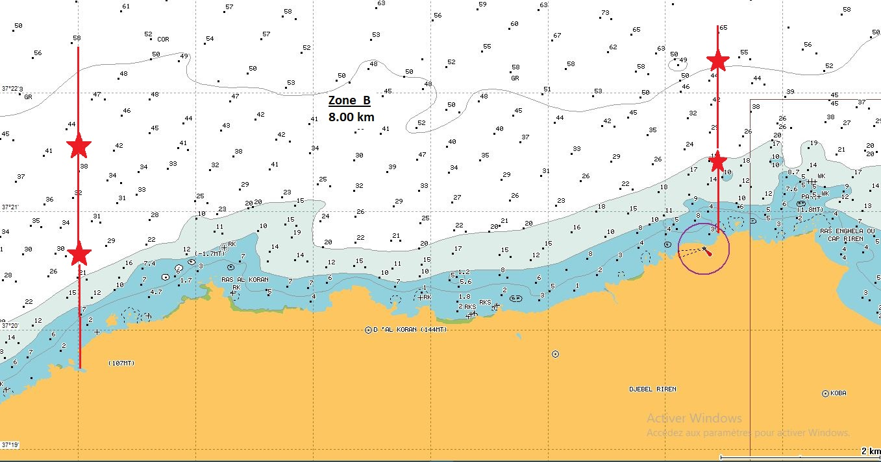
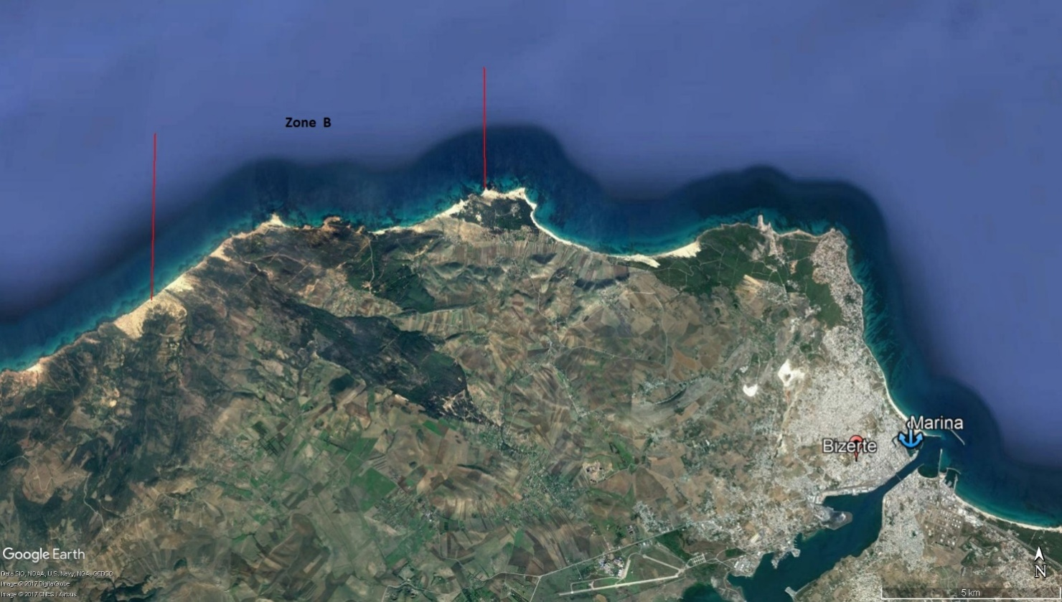

RESERVE ZONE WILL BE EASTZONE,will be as detailed:

- EAST STRAIGHT LINE LIMIT
N 37° 16.30´— E 10 04.26´
N 37° 17.63´— E 1005.16´
- WEST STRAIGHT LINE LIMIT
N 37° 13.33´— E 1010.23´
N 37° 14.42´— E 1010.91´

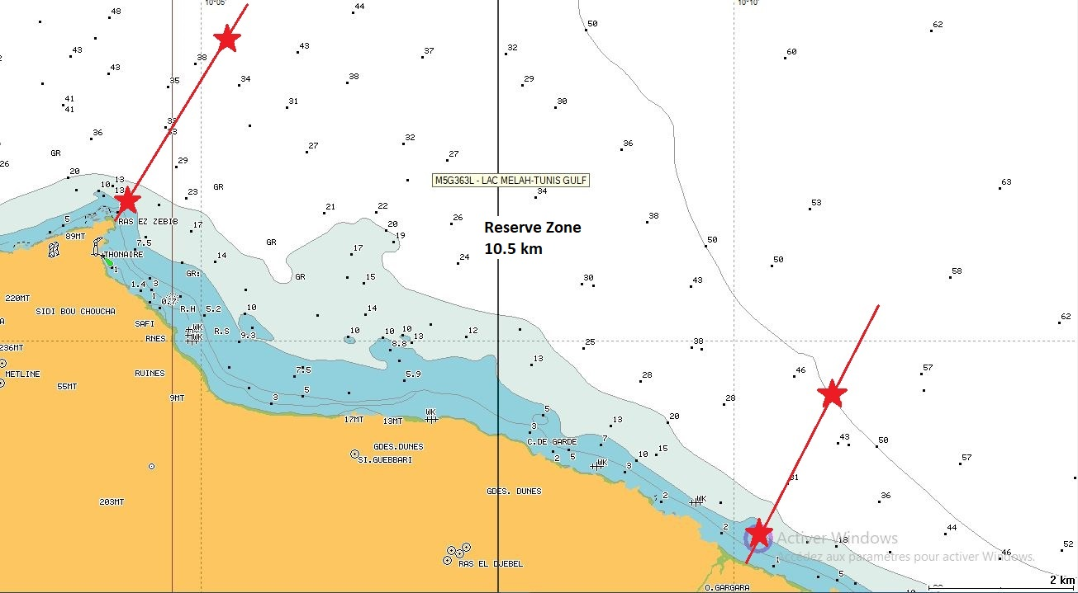
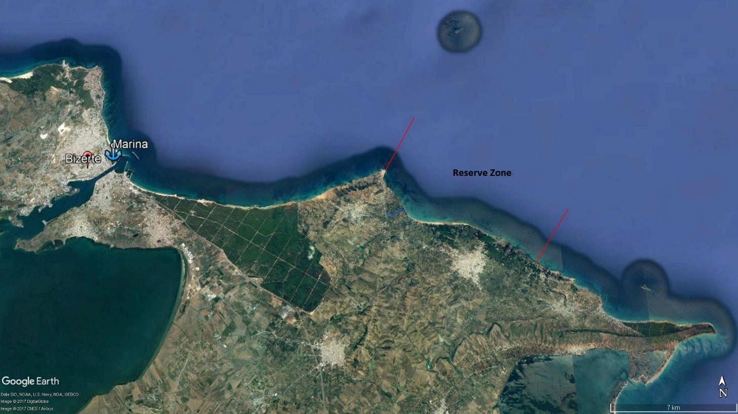

14. ANTI-DOPING CONTROL

During the competition, anti- doping control may take place, according to the rules of the CMAS and the WADA.

15. RULES AND INTERPRETATION

The CMAS general rules for Spear Fishing will be used as the norm for any issue not regulated in this Particular Rules.

16. RESPONSIBILITIES

The Underwater Activities Worldwide Confederation CMAS, FTPS, the CAP Bizerte, the Competition authorities and the organizer committee will not be accountable of eventual accidents, personal or material losses affecting to competitors or third persons that happens before, during and at the end of the Euro-African Spearfishing championship.
Competitors are going to accept all rules and norms detailed in this Particular Rules by signature at the moment of the final inscription, as well as any additional instruction coming from organization committee, FTPS or CMAS Technical Delegate.

17. ORGANIZATION CONTACT DATA

Our federation is honoured to clarify all your doubts; we are at your service.

- “Fédération Tunisienne des Pêches Sportives” (FTPS)
Tel: +216 71 900984
Fax : +216 71 900986
Email : ftps@ftps.org.tn

- Director of the Competition: Mr Fathi Jebalia
Mobile : +216 98 243950
Email : ftps@ftps.org.tn

- Technical Manager: Mr Rifaat Bahri
Mobile : +216 95 533180
Email :rifaat.bahri@gmail.com

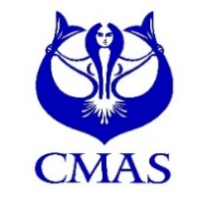

33rd MEN & 2nd WOMEN
CMAS EURO-AFRICAN
SPEARFISHING CHAMPIONSHIP
BIZERTE, TUNISIA / SEPTEMBER 7th – 11th 2022

ANNEX 1:
INITIAL ENTRY FORM

To be filled with block letters and sent by e-mail to the FTPS ( ftps@ftps.org.tn )
and CMAS ( cmas@cmas.org – spo@cmas.org ) no later than
May15th 2022.

COUNTRY
FEDERATION
E-MAIL FEDERATION

Number of athletes
Number of officials
Number of accompanying
TOTAL

We need boats from organization (number)
We don’t need boats

Date: ……………………..………

33rd MEN & 2nd WOMEN
CMAS EURO-AFRICAN
SPEARFISHING CHAMPIONSHIP
BIZERTE, TUNISIA / SEPTEMBER 7th – 11th 2022

ANNEX 2:
FINAL ENTRY FORM

To be filled with block letters and sent by e-mail to the FTPS ( ftps@ftps.org.tn )
and CMAS ( cmas@cmas.org – spo@cmas.org ) no later than
May 30th 2022.

COUNTRY
FEDERATION
E-MAIL FEDERATION
BOATS NEEDED (Number)

OFFICIAL DELEGATION
 | First Name and Last Name | Date of birth | Identity document (passport) | CMAS  Licence n.
1st Athlete:
2nd Athlete:
3rd Athlete:
Reserve athlete :
Captain:
Other member

PARTICIPATION FEE
Official Delegation number | Mode chosen | Total coast

Accompanying number |  | Total coast

FLIGHT
ARRIVAL | Dates : |  | Time :
AIRPORT |  |  | Flight N° :
DEPARTURE | Dates : |  | Time :
AIRPORT |  |  | Flight N° :

Date: ……………………..………

-------------------------------------------
(President’s Signature/stamp)

EURO-AFRICAN SPEARFISHING CHAMPIONSHIP
BIZERTE, September 07th → 11th 2022

BOAT RENTAL
PRICES / DAY (without fuel)

Motorisation | Price advised  according to equipment & length
… ≤ 30 HP (for scouting only) | 250 TND ( ̴80 €)
40 ↔ 100 HP | 300 ↔ 400 TND (100 ↔ 130 €)
110 ↔ 150 HP | 400 ↔ 500 TND (130 ↔ 160 €)

