FINNISH DIVERS’ FEDERATION

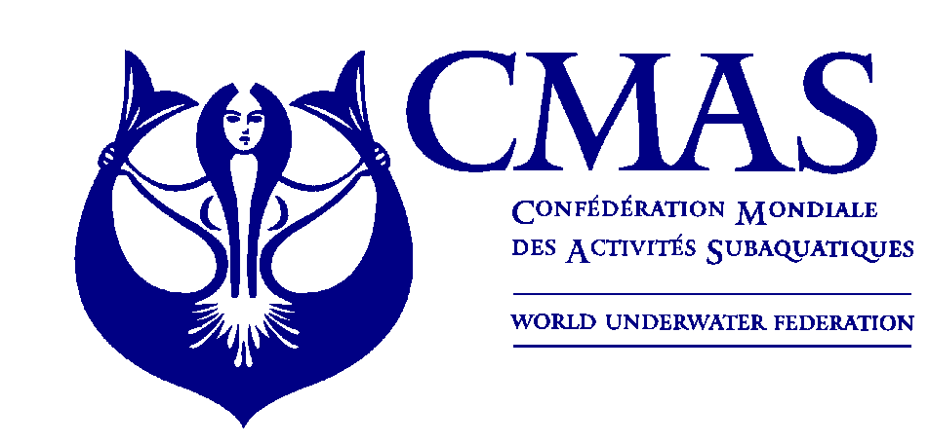
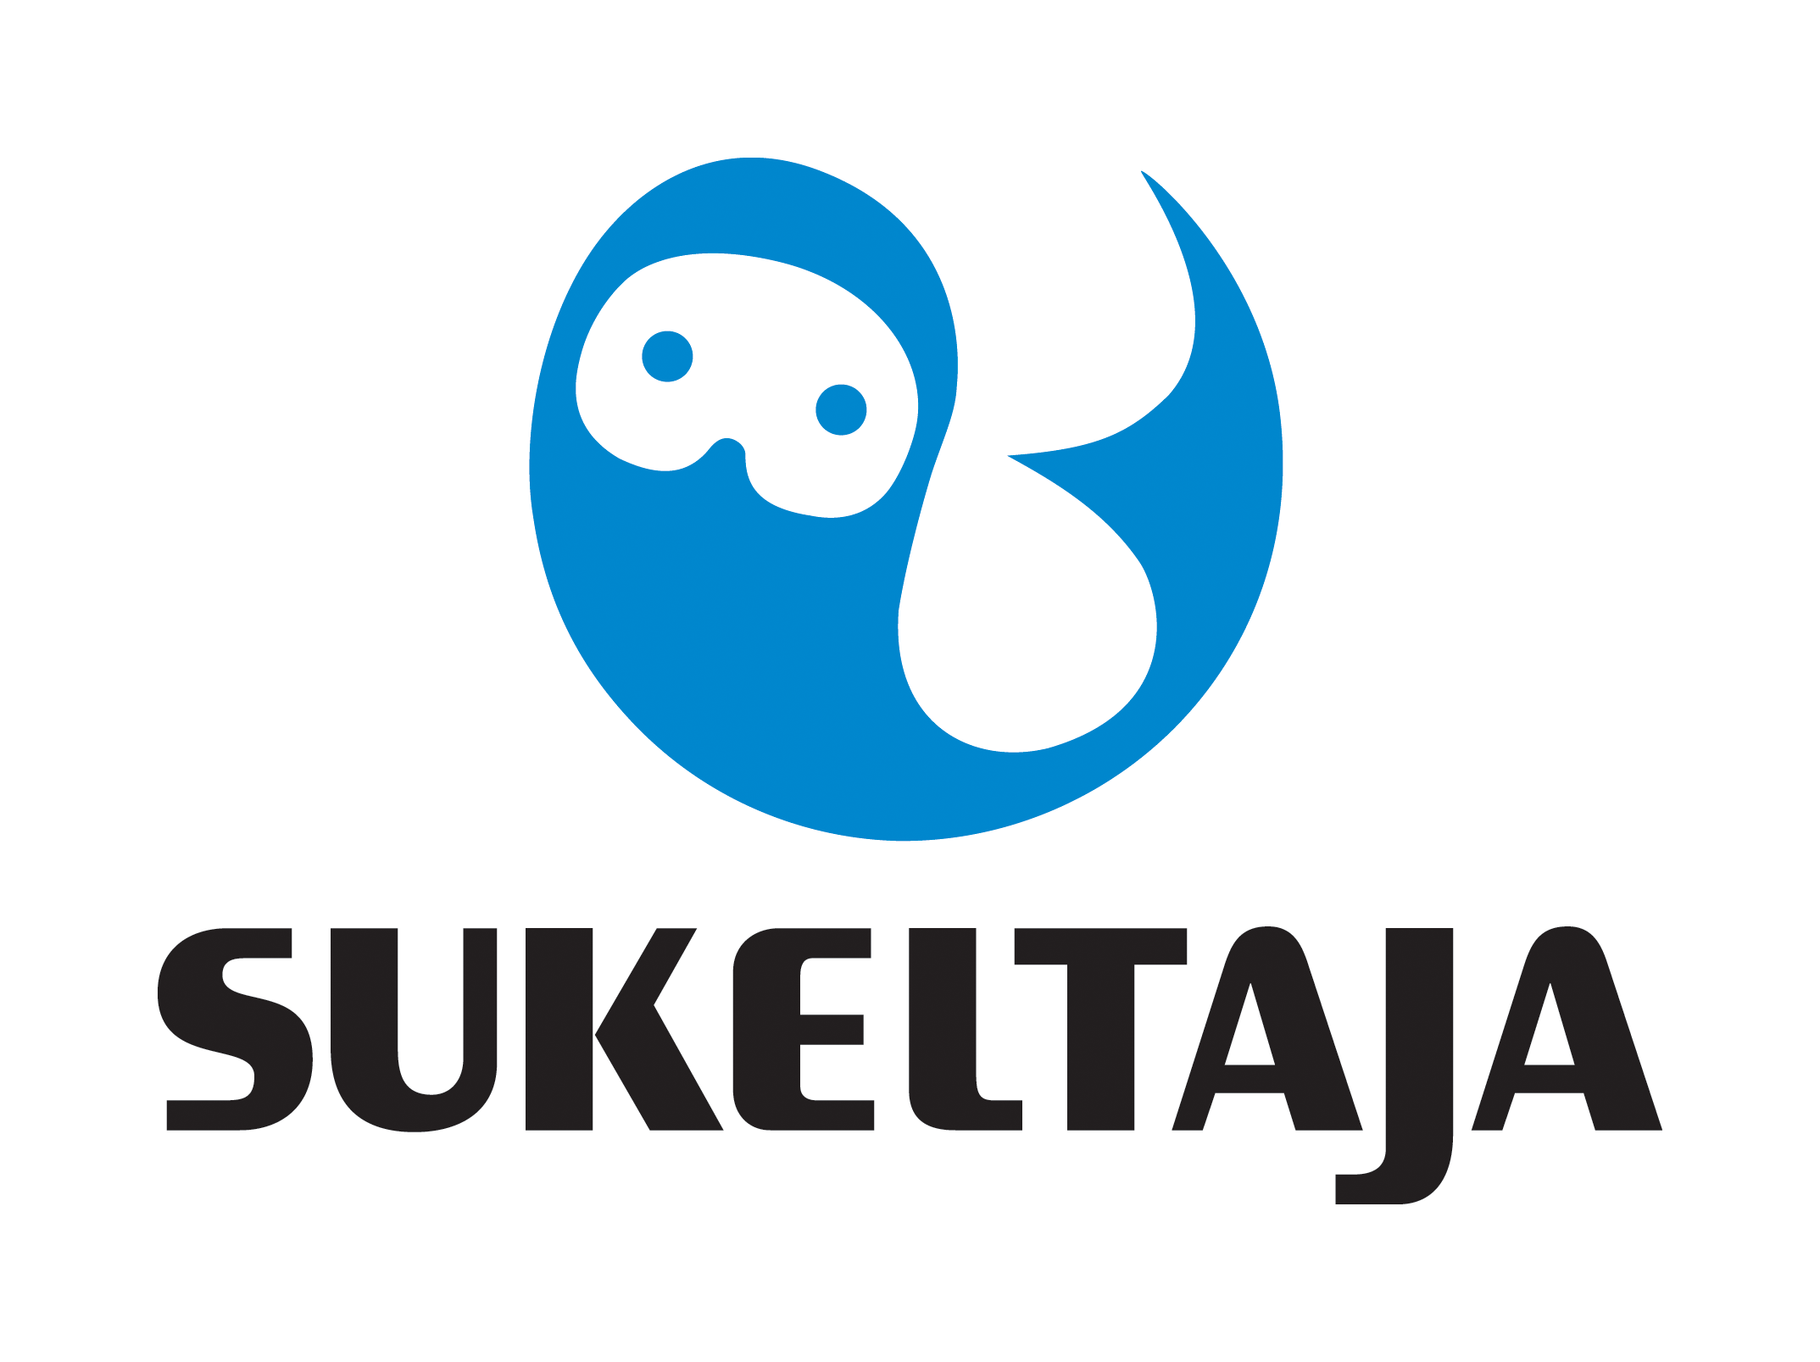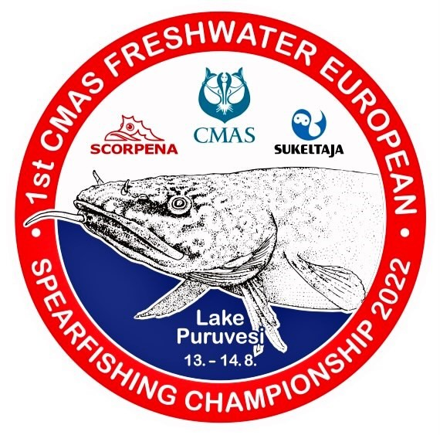

1 st CMAS FRESHWATER
SPEARFISHING EUROPEAN CHAMPIONSHIP
PUNKAHARJU, FINLAND
From 11 to 15 August 2022

ANNEX 1
INITIAL ENTRY FORM

Please let us know your intention of participating in the Championship as soon as possible, but no later than 31.12.2021 by completing the form and sending it to CMAS HQ and Finnish Divers’ Federation by e-mail spo@cmas.org, office@sukeltaja.fi, EC2022@sukeltaja.fi

There will be two categories in the Championship: Women and men.
Each team can bring 1-3 competitors in both categories and one reserve (woman/man) + captain.

Country

Federation

Total number of Athletes | Male |  | Female

Total number of Officials | Male |  | Female

Total number of the delegation

e-mail

Boat information :

Please let us know if you plan to bring your own boats.

We plan to bring our own boats | Yes/No |  | How many boats do you estimate to need ?

Declaration of liability:
Release from liability: I/We hereby declare that I/we exonerate of all liability however so arising CMAS, its affiliates, the event Organizing Federation and/or Committee and staff, the venue owners, sponsors, and any other persons that participate at the event in respect of all and every action or clain about accidente that may occur.
This exclusion of liability does not apply in the event of wilful misconduct or gross negligence.

Inscriptions and signatures will only be valid on the presentation by each Federation of the obligatory ACCIDENT INSURANCE COVERAGE POLICY for participants.

Please check CMAS Procedures for participation in CMAS Championship.

Date, …………………. 2021

________________________ _____________________
(President’s Signature/stamp) Full name in block letters)

