FINNISH DIVERS’ FEDERATION

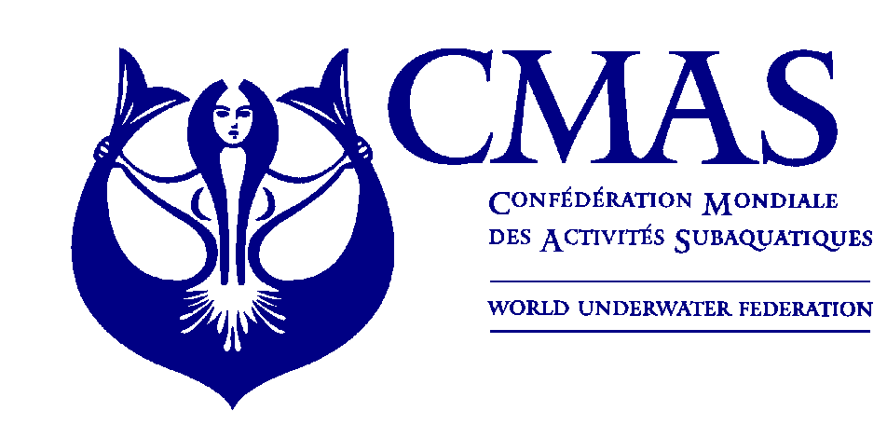
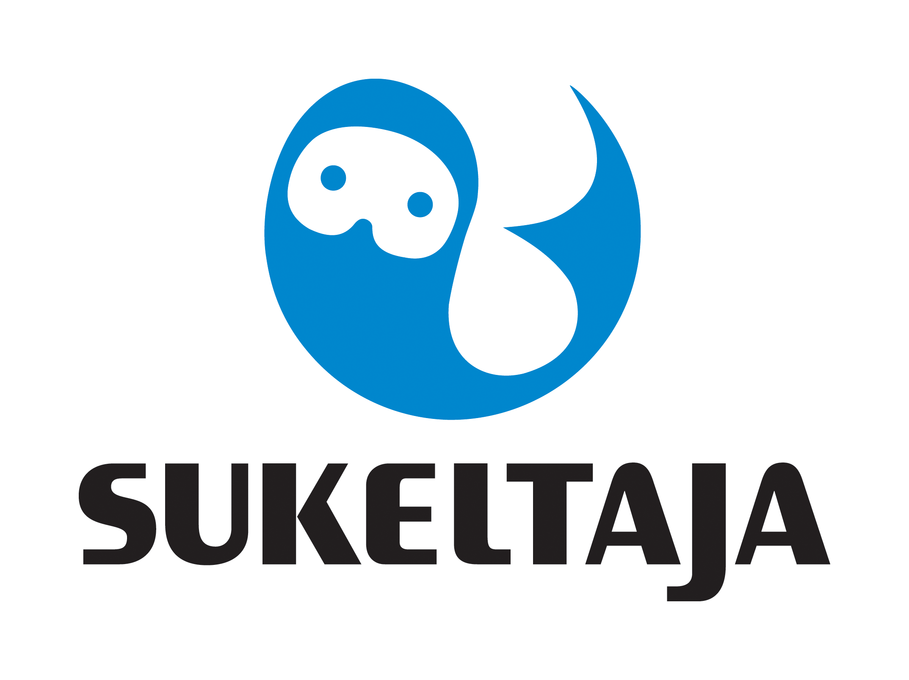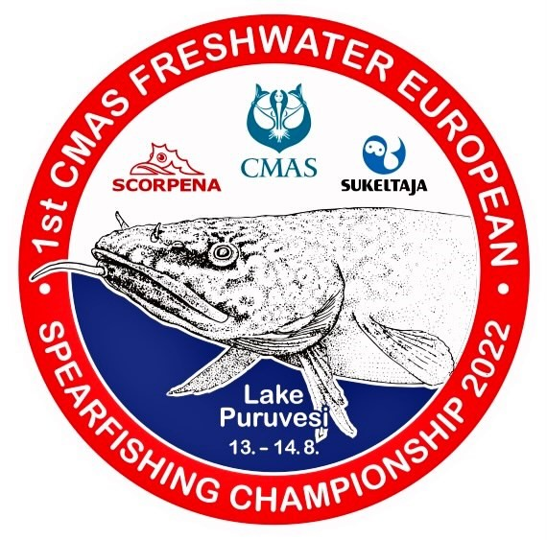

1st CMAS FRESHWATER
SPEARFISHING EUROPEAN CHAMPIONSHIP
PUNKAHARJU, FINLAND
From 11 to 15 AUGUST 2022

ANNEX 2

REGISTRATION FORM

Please complete this form and send it to CMAS HQ and Finnish Divers’ Federation by e-mail to spo@cmas.org, office@sukeltaja.fi, EC2022@sukeltaja.fi not later than 15th March 2022.

Country
Federation
Address
Telephone
e-mail

We hereby register the following athletes and Team members to the event 1 st CMAS Freshwater Spearfishing European Championship in Punkaharju, Finland, 11-15th August 2022.

Women :First athlete |  | Licence nº
Second athlete |  | Licence nº
Third athlete |  | Licence nº
Reserve athlete |  | Licence nº

Men : First athlete |  | Licence nº
Second athlete |  | Licence nº
Third athlete |  | Licence nº
Reserve athlete |  | Licence nº

Captain – Officer

The Captain of the Team has read the Rules of the event and accepts them fully.

Date, …………………. 2022

________________________ _____________________
(President’s Signature/stamp) Full name in block letters)

