FINNISH DIVERS’ FEDERATION


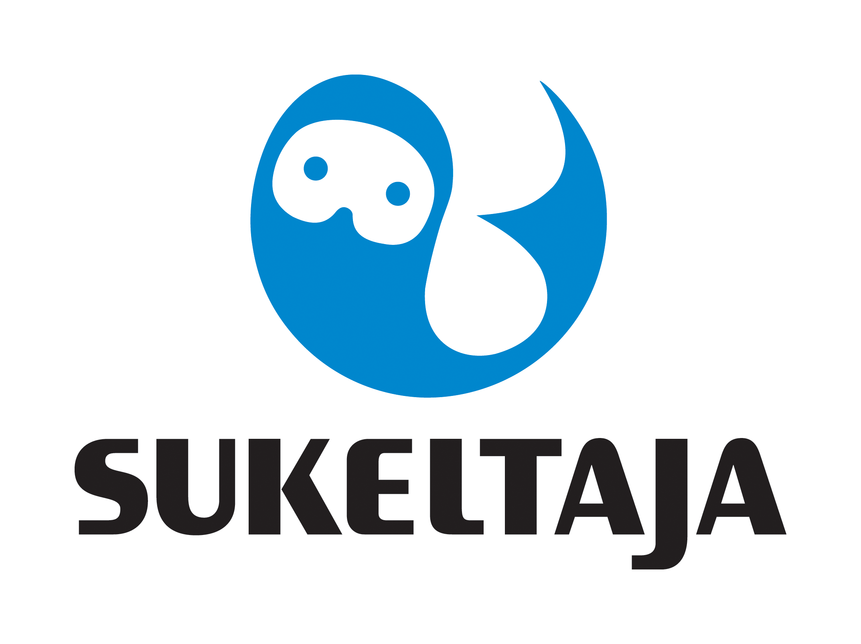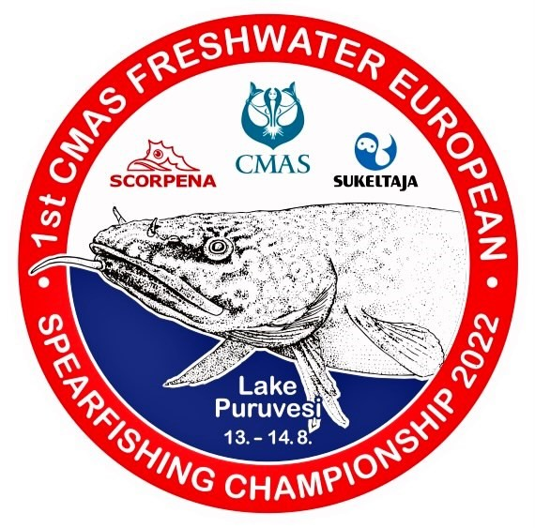

1 st CMAS FRESHWATER
SPEARFISHING EUROPEAN CHAMPIONSHIP
PUNKAHARJU, FINLAND
From 11 to 15 August 2022

ANNEX 3
INSCRIPTION FORM: ACCOMMODATION, BOATS, GALA

Harjun Portti Holiday Resort is offering the official accommodation of the event in nice well equipped cottages. https://www.harjunportti.fi/en/ Arrival 11th August, departure 15th August.

Please fill in the form no later than 15th March.2022 and send it to CMAS HQ and Finnish Divers’ Federation by e-mail spo@cmas.org, office@sukeltaja.fi , EC2022@sukeltaja.fi 50% of the total sum of the inscription needs to be paid by 15th March 2022 and the rest of the payment by 15th June 2022.Finnish Divers’ Federation IBAN FI83 80001300541514, BIC CODE: DAHAFIHH.

Each team can bring 1-3 competitors in both categories and one reserve (woman/man) + captain.

Country

Federation

Number of | INSCRIPTION MODE 1 |  |  | INSCRIPTION MODE 2 |  |  | INSCRIPTION MODE 3
members | Inscription, accommodation |  |  | Insription + boats |  |  | Inscription only
in the team | including breakfast, boats
 |  | women | men |  | women | men |  | women | men
1 | 600 € |  |  | 400 € |  |  | 200 €
2 | 1200 € |  |  | 800 € |  |  | 400 €
3 | 1800 € |  |  | 1200 € |  |  | 600 €
4 | 2400 € |  |  | 1600 € |  |  | 800 €
5 | 3000 € |  |  | 2000 € |  |  | 1000 €
Total sum to be paid (please fill in)
 |  |  |  |  | €
Gala dinner (without alcoholic drinks) and transportation from Harjun Portti to the Gala Dinner venue are included in all inscription modes. Fuel of the boats all teams need to pay themselves.

Date, …………………. 2022

_____________________ _____________________
(President’s Signature/stamp) Full name in block letters)

