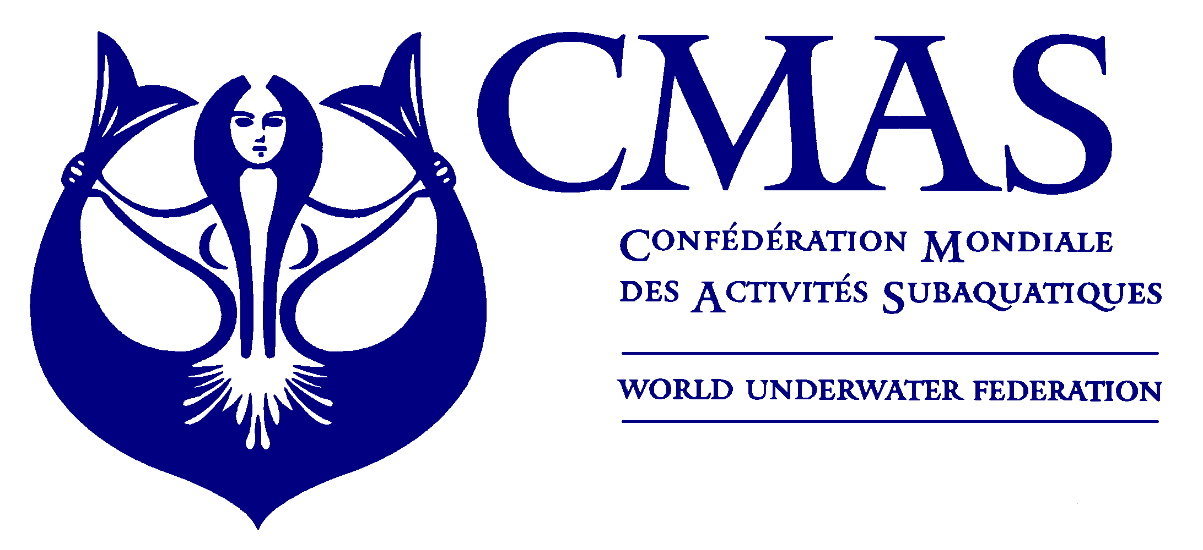

UWH COMMISSION

CANDIDATURE

COACHING COMMITTEE

According to the Internal Regulations of Underwater Hockey Commission, each National Federation under CMAS may appoint one (1) Coach representative to the Underwater Hockey Commission College of Coaches (Article 2 and 7).

To designate your National Federation representative, please complete, sign and return this form as below:

NATIONAL FEDERATION
Name of Federation
Country
Name of Authorizing Person
Title of Authorizing Person
Email of Authorizing Person
APPOINTED PERSON / MEMBER
Name of Appointed Person
Position / Role / Title
Email
Phone (additional)
Date |  | Signature

(National Federation Signature Representative)

E-mail Instructions
Please return completed to cmas.jj@gmail.com and cmas@cmas.org.
E-mail Subject line: UWH Coaching Committee

