Phuket’s Miles 2019
& Sport Diving World Cup


INTERNATIONAL
UNDERWATER SPORTS
FESTIVEL
18 – 22 September 2019
PHUKET THAILAND
ASUS

About phuket

Phuket is one of the southern provinces of Thailand. It consists of the island of Phuket, the country's largest island, and another 32 smaller islands off its coast.It lies off the west coast of Thailand in the Andaman Sea. Phuket Island is connected by the Sarasin Bridge to Phang Nga Province to the north. The next nearest province is Krabi, to the east across Phang Nga Bay.
Population : 386,605
Area: 576 km²
Density: 1,042/km²

Phuket Province has an area of 576 square kilometres (222 sq mi), somewhat less than that of Singapore, and is the second-smallest province of Thailand. It formerly derived its wealth from tin and rubber, and enjoys a rich and colorful history. The island was on one of the major trading routes between India and China, and was frequently mentioned in foreign ship logs of Portuguese, French, Dutch, and English traders. The region now derives much of its income from tourism.

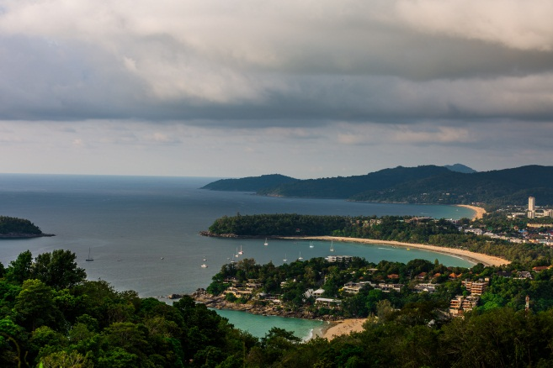

MAP OF PHUKET
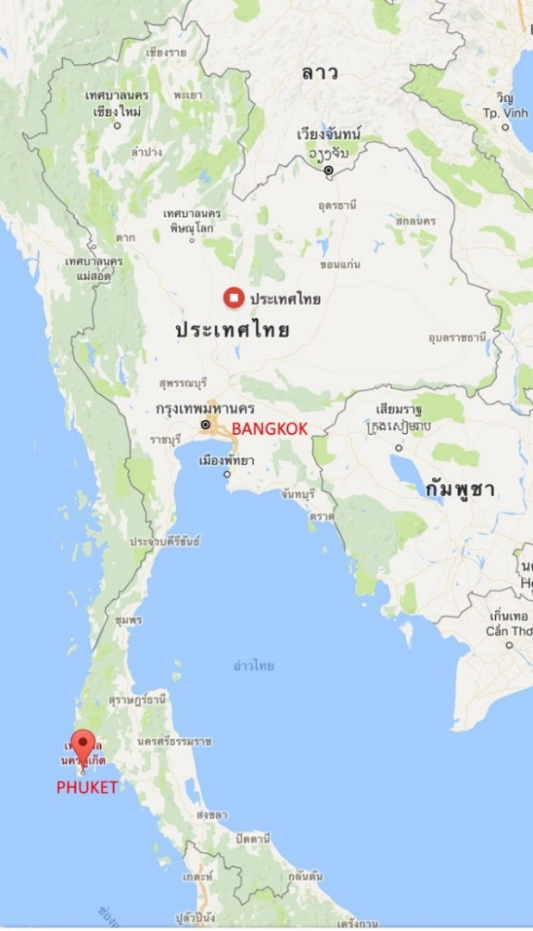
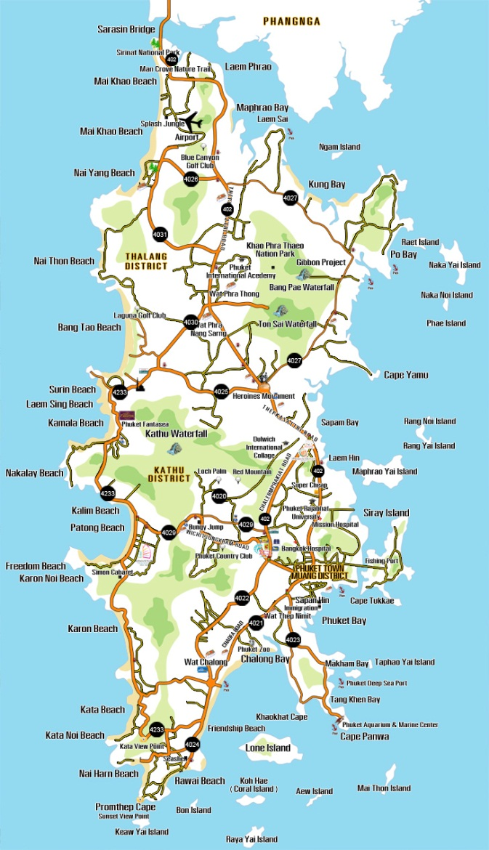

location
Long Distance competition
Sarasin Bridge
Sarasin Bridge (Saphan Sarasin) is a bridge in Thailand, it is a bridge connecting the mainland of Phuket and Phang Nga in southern Thailand, and known as one of the most beautiful bridges and has an unforgettable history of Thailand.
.
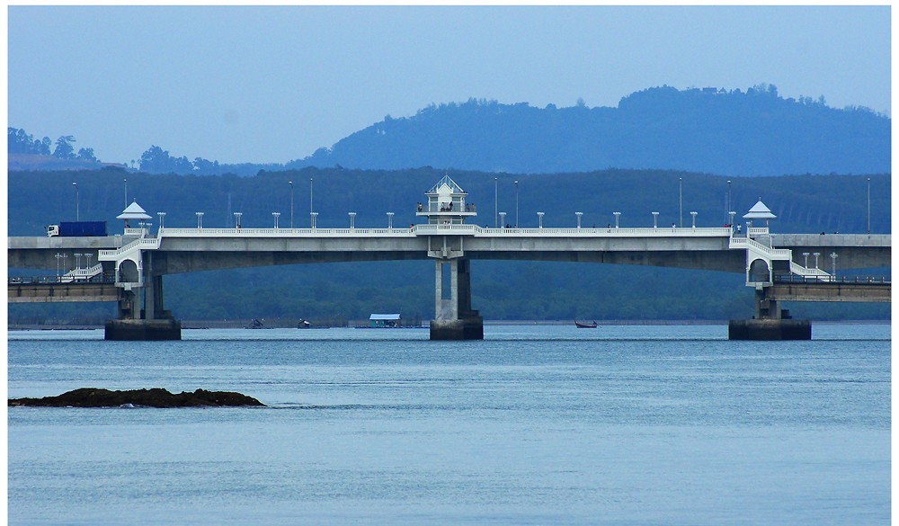
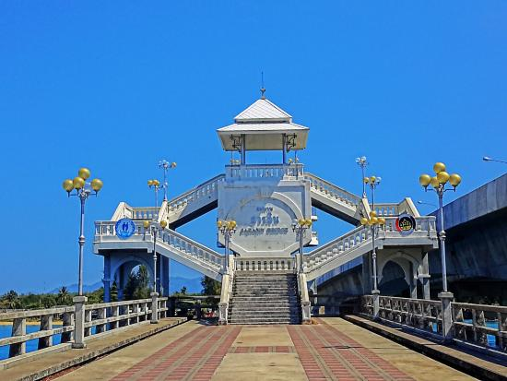
It was buil in 1951 and officially opened on July 7, 1967. It is considered the first bridge linking Phuket and Phang Nga, total length is 660 m.

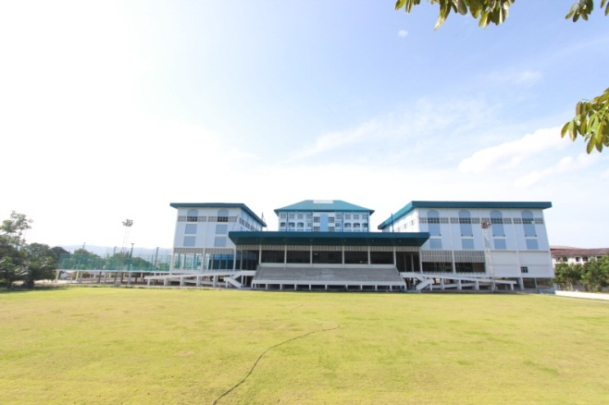
Location
In Hall Competition

PSU Phuket Sport Complex
The swimming pool has a length of 50m, a width of 25 m and ten lanes and a depth of 2-3 m. The temperature of the water is 25°C ( + 1°C).
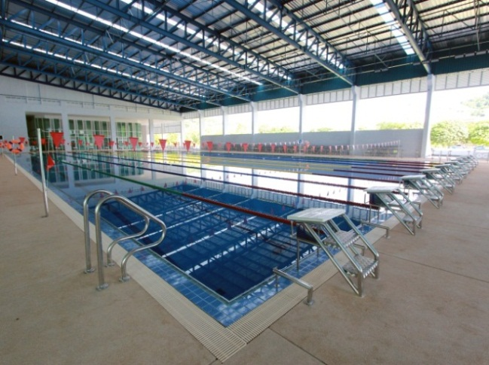
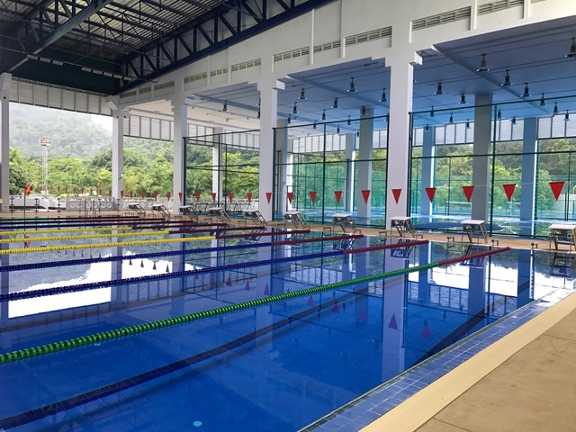

website: http://PSUPKSC.BUSINESS.SITE
ACCOMODATION
4 stars hotel
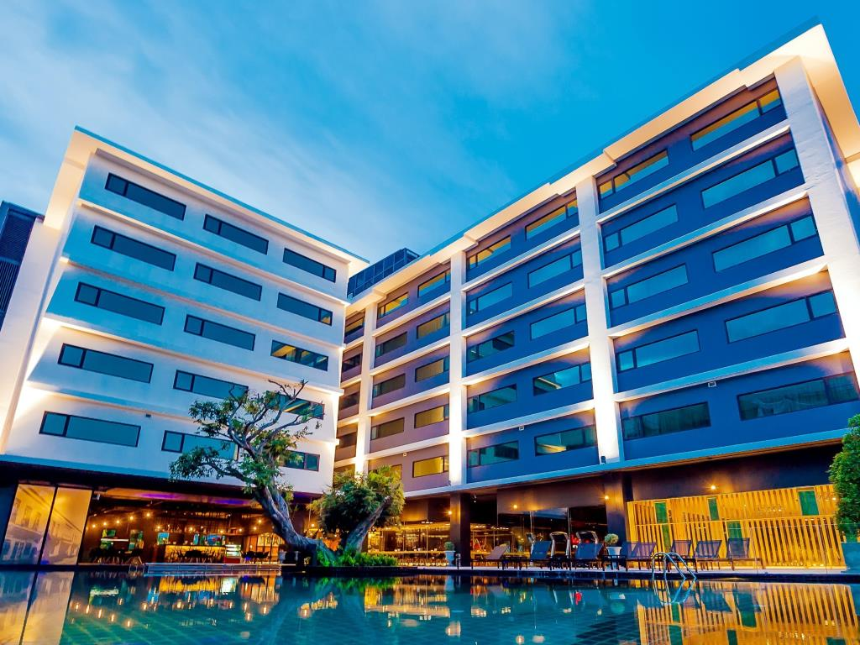
DARA HOTEL

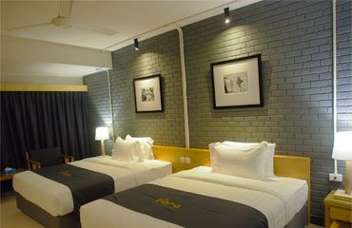

website: http://www.daraphuket.com

PARTICIPATION
Only national federation team a liated to the CMAS and ATUS are eligible to compete in the championships Each national team should respect the rules of championship, the safety condition set by the organizers and CMAS rules.
Current CMAS Sports License for Championship
DISCIPLINES AND DISTANCES
SWIMMING -POOL EVENT: IN 50 M. POOL
FINSWIMMING
- 50 AP Boys/Girls
- 8 x 50 AP Men/Women
- 50 SF Boys/Girls/ Men/Women
- 50 BF Boys/Girls/ Men/Women
- 100 SF Boys/Girls/ Men/Women
- 100 BF Boys/Girls/ Men/Women
SPORT DIVING
- TRIAL 100 M. Boys/Girls/ Men/Women
- MEDLEY 100 M. Boys/Girls/ Men/Women
- 50 M. IMMERSION (Lift Bag) 6 KG. Boys/Girls/ Men/Women
- OCTOPUS 50 M. Boys/Girls/ Men/Women

- 100 M.IMMERSION TORPEDO Boys/Girls/ Men/Women
- RELAY 4X50 M. IMMERSION TORPEDO Boys/Girls/ Men/Women
- RELAY 4X100 M. MEDLEY Boys/Girls/ Men/Women
- 100 M.TRIAL Men/Women
- 50 M. INJURED DIVE TOW (Mixed)
- 50 M. SAFETY BUOY OPEN WATER Men/Women
- 100 M. IMMERSION TORPEDO RELAY OPEN WATER (Mixed)
- 4x50 M. IMMERSION TORPEDO RELAY OPEN WATER (Mixed)
- Underwater Navigation (Mixed)
OPEN WATER LONG DISTANCE
- 1 KM.
Senior
A: 18 years and over
Junior
B: 16-17 years
C: 14-15 years
D: 12-13 years
Masters
V0-V2: 29-54 years
- 2 KM.
Senior
A: 18 years and over
Junior
B: 16-17 years
C: 14-15 years
Masters
V0-V2: 29-54 years
- 4 KM.
Senior
A: 18 years and over
Junior
B: 16-17 years
Masters
V0-V2: 29-54 years
INTERNATIONAL JURY
CMAS Technical Delegate according to the CMAS rules.

AWARDS
Individual / Team Awards
* For Junior Competition: Victory Ceremony will be done in the morning sessions after each event.
* For Asian Championships: Victory Ceremony will be done in the afternoon sessions as the schedule.
In order to prepare for Victory Ceremony, each team have to bring 3 national flags (Size : 180cm x120cm) and one CD of national anthem.

CERTIFICATES
1. Diploma/certificate will be awarded to all record holders.
2. Certificate of participation will be presented to all participants.
BOOKING AND ENTRY FEE
1. TEAM ACCOMMODATION
Accommodations and meals are being ordered as a package to the participating delegations from 18th September (from dinner) to 23th September 2019 (until Breakfast).

2. PACKAGE COST
Organizers offer accommodation possibility during the competition with enrolment deadline of 10th Septembrt 2019 (Enclosure the Booking Forms)

The hotel is DARA HOTEL (The 4 Star) http://www.daraphuket.com/
Single Room 80 Euro (per room / per night)
Double Room 110 Euro (per room / per night) or 55 Euro (per room / per night)

The price is included:
- Hotel accommodation
- All meals (breakfast, lunch and dinner)
- Seasoning Fruits
- Drinking Water
- All transfer (airport – hotel – airport)
- All transfer (hotel – swimming Pool - hotel)
Check-In Time: after 12:00 noon on the day of arrival.
Check-Out Time: before 12:00 noon on the day of departure. Any departures after 12:00 noon will be subject to availability and possible additional charges.

3. SECRETARY AND COMPETITION FEE
Participants who choose to be accommodated in hotels other than arranged hotels will have to pay 200 € per person for secretarial fees, competition, opening and closing gala ceremony. No local transfers will be provided.

PAYMENT INFORMATION
Instructions for bank transfer:
Bank Name: BANGKOK BANK, Thalang Branch
Bank Address: 189 Moo 1,Thepkasattri, Thalang Phuket Thailand 83110
Swift Code: BKKBTHBK
Account Name: Association of Thailand Underwater Sports (ATUS)
Account No: 573-0-23659-2

*Minimum 50% of total entry fee should be deposited at our bank not later than 10th September 2019 to guarantee the booking. The remaining payment should be made upon arrival. The organizer will only accept cash or bank transfers (bank charges will be charged to the remitter).
*Bank cheques and credit card will not be accepted!

SUBMISSION KEY DATES
Application Form Submission Deadline
Enclosure 1 Perliminary Entry Form 05/09/2019
Enclosure 2 Hotel Booking Form 10/09/2019
Enclosure 3 Participant’s List Form 13/09/2019
Enclosure 4 Application Form 13/09/2019

PROGRAM OF THE COMPETITION
Finswimming
Tuesday 18th September (Swimming Pool)
15:00 – 19:00 | - Arriving of Teams,checking of documents,etc..
15:00 – 19:00 | - Check of equipment
15:00 – 19:00 | - Training
20.00 | - Technical Meetings with Team Leaders

Wednesday 19thSeptember (Swimming pool)
07:30 – 08:45 | - Warming Up
09:00 | - Opening Ceremony
09:30 – 12:30 | 100 SF Men/Women  100 SF Boys/Girls  100 BF Men/Women  100 BF Boys/Girls  50 SF Men/Women  50 SF Boys/Girls  Award ceremony
12:30 – 14:00 | Lunch
15:00 – 15:45 | Warming Up
16:00 | 50 BF Men/Women  50 BF Boys/Girls  8x50 AP Men/Women  50 AP Boys/Girls  - Award ceremony

Sport Diving

Wednesday 19thSeptember (Swimming pool)
15:00 – 19:00 | - Arriving of Teams,checking of documents,etc..
15:00 – 19:00 | - Check of equipment
15:00 – 19:00 | - Training
20.00 | - Technical Meetings with Team Leaders

Wednesday 20thSeptember (Swimming pool)
07.30 – 08.45 | - Warming Up
09.00 | - Opening Ceremony
09:30 – 12:30 | TRIAL 100 m Men/Women  TRIAL 100 m Boys/Girls  MEDLEY 100 m Men/Women  MEDLEY 100 m Boys/Girls  50 m IMMERSION (Lift Bag) 6 Kg Men/Women  50m IMMERSION (Lift Bag) 6 Kg Boys/Girls  OCTOPUS 50 m Men/Women  OCTOPUS 50 m Boys/Girls
12.30 – 14.00 | - Lunch
15:00 – 15:45 | 100 m IMMERSION TORPEDO Men/Women  100 m IMMERSION TORPEDO Boys/Girls  Relay: 4x50m IMMERSION TORPEDO Men/Women  4x50 m IMMERSION TORPEDO Boys/Girls  4x100 M. MEDLEY Men/Women  4x100 m MEDLEY Boys/Girls  - Award ceremony

Wednesday 21thSeptember (Swimming pool)

07.30 – 08.45 | - Warming Up
09:00 – 12:00 | 100 m Trial (Men/Women)  50 m Injured Diver Tow (Mixed)  50 m Safety Buoy Open Water (Men/Women)
12:00 – 13:30 | Lunch
14:00 – 16:00 | 100 m Immersion Torpedo Relay Open Water (Mixed)  4x50 m Immersion Torpedo Relay Open Water (Mixed)  Underwater Navigation (Mixed)  - Award ceremony
Wednesday 22thSeptember (Open Water)
08:00 – 09:00 | Warming Up
09:15 | Opening Ceremony
09:30-13:00 | Distance of 4 km (Men/Women)  Distance of 2 km (Men/Women)  Distance of 1 km (Men/Women)  Distance of 2 km (Boys/Girls)  Distance of 1 km (Boys/Girls)  Award Ceremony

Groups | AGE Groups | 4 KM. |  |  | 2 KM. | 1 KM.
1 | Senior & Masters |  | / | / |  | /
2 | Junior B: 16- 17 Years |  | / | / |  | /
3 | Junior C: 14–15 Years |  |  | / |  | /
4 | Junior D: 12-13 Years |  |  |  |  | /
Remark: 1 Athlete per 1 Long Distance

Wednesday 23thSeptember
08:00 – 09:00 | Departure Day

International Underwater Sports Festival “Phuket’s Mile 2019”
18 – 22 September 2019 / Phuket Thailand

Preliminary Entry Form
Name of Federation |  | NOC Code
Contact Person |  | Phone No.
Function |  | Mobile No
E-mail Address |  | Fax No.

Confirmation
We want to participate. (YES / NO)

If YES, please fill out the following.
Number of Participants in International Underwater Sports Festival “Phuket’s Mile 2018”
Team Officials
Athletes

Number of Participants in International Underwater Sports Festival “Phuket’s Mile 2018”
Team Officials
Athletes

Date | NF Signature and Stamp

Please E-mail completed forms before 05thSeptember 2019 to: atus@atus-thailand.org
International Underwater Sports Festival “Phuket’s Mile 2019”
18– 22 September 2019 / Phuket Thailand

Hotel Booking Form
Closing Date for This Form Submission: 10 September 2019
Country: | Country Code:
Name of Contact:
Address:
Cell phone: | Fax:
Telephone: | Email:

Reservations
Please complete the following information in order to make package reservations
Type of room | No of rooms | Date
Type of room | No of rooms | From | To
Single
Double/Triple

Extra Nights: if you need extra nights, please fill in the following
Type of room | No of rooms | Date
Type of room | No of rooms | From | To
Single
Double/Triple
Flight Details
Team Arrival Date: _________ Time: _________ Flight No: _________
Team Departure Date: _________ Time: _________ Flight No: _________

We will send booking deposit on ______________, 2019 (before 10th September 2019)

Please E-mail completed forms before 10thSeptember 2019 to: atus@atus-thailand.org
International Underwater Sports Festival “Phuket’s Mile 2019”
18 - 22 September 2019 / Phuket Thailand

Participant’s List Form

Federation Name: __________________________________________________
No | Name |  | Male/Female | Position
 | Surname, Given | Date of Birth | M/F | Athlete = A  Coach = C  Team Official = TO  Team Support = TS
1
2
3
4
5
6
7
8
9
10
11
12

Team Manager: ________________________Email:__________________________

Please E-mail completed forms before 13thSeptember 2019 to: atus@atus-thailand.org
International Underwater Sports Festival “Phuket’s Mile 2019”
18 – 22 September 2019 / Phuket Thailand

Application Form
Federation Name: ________________________________________________
No. | Swimmer’s Name | Date Of Birth  (dd/mm/yyyy) | Event No. | Event | Best.Time
1
2
3
4
5
6
7
8
9
10
11
12

Team Manager: ________________________Email:_______________________
(Please use separate forms for Male, Female and Senior, Junior)

Please E-mail completed forms before 13thSeptember 2019 to: atus@atus-thailand.org

