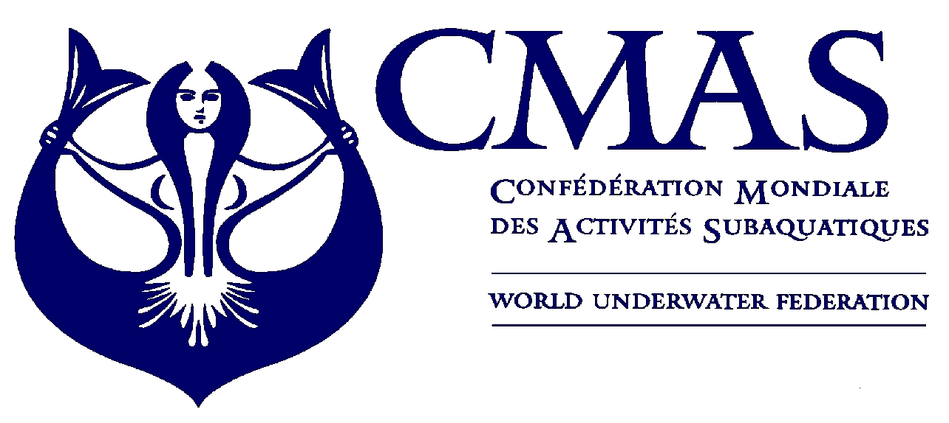
10 th Underwater Rugby
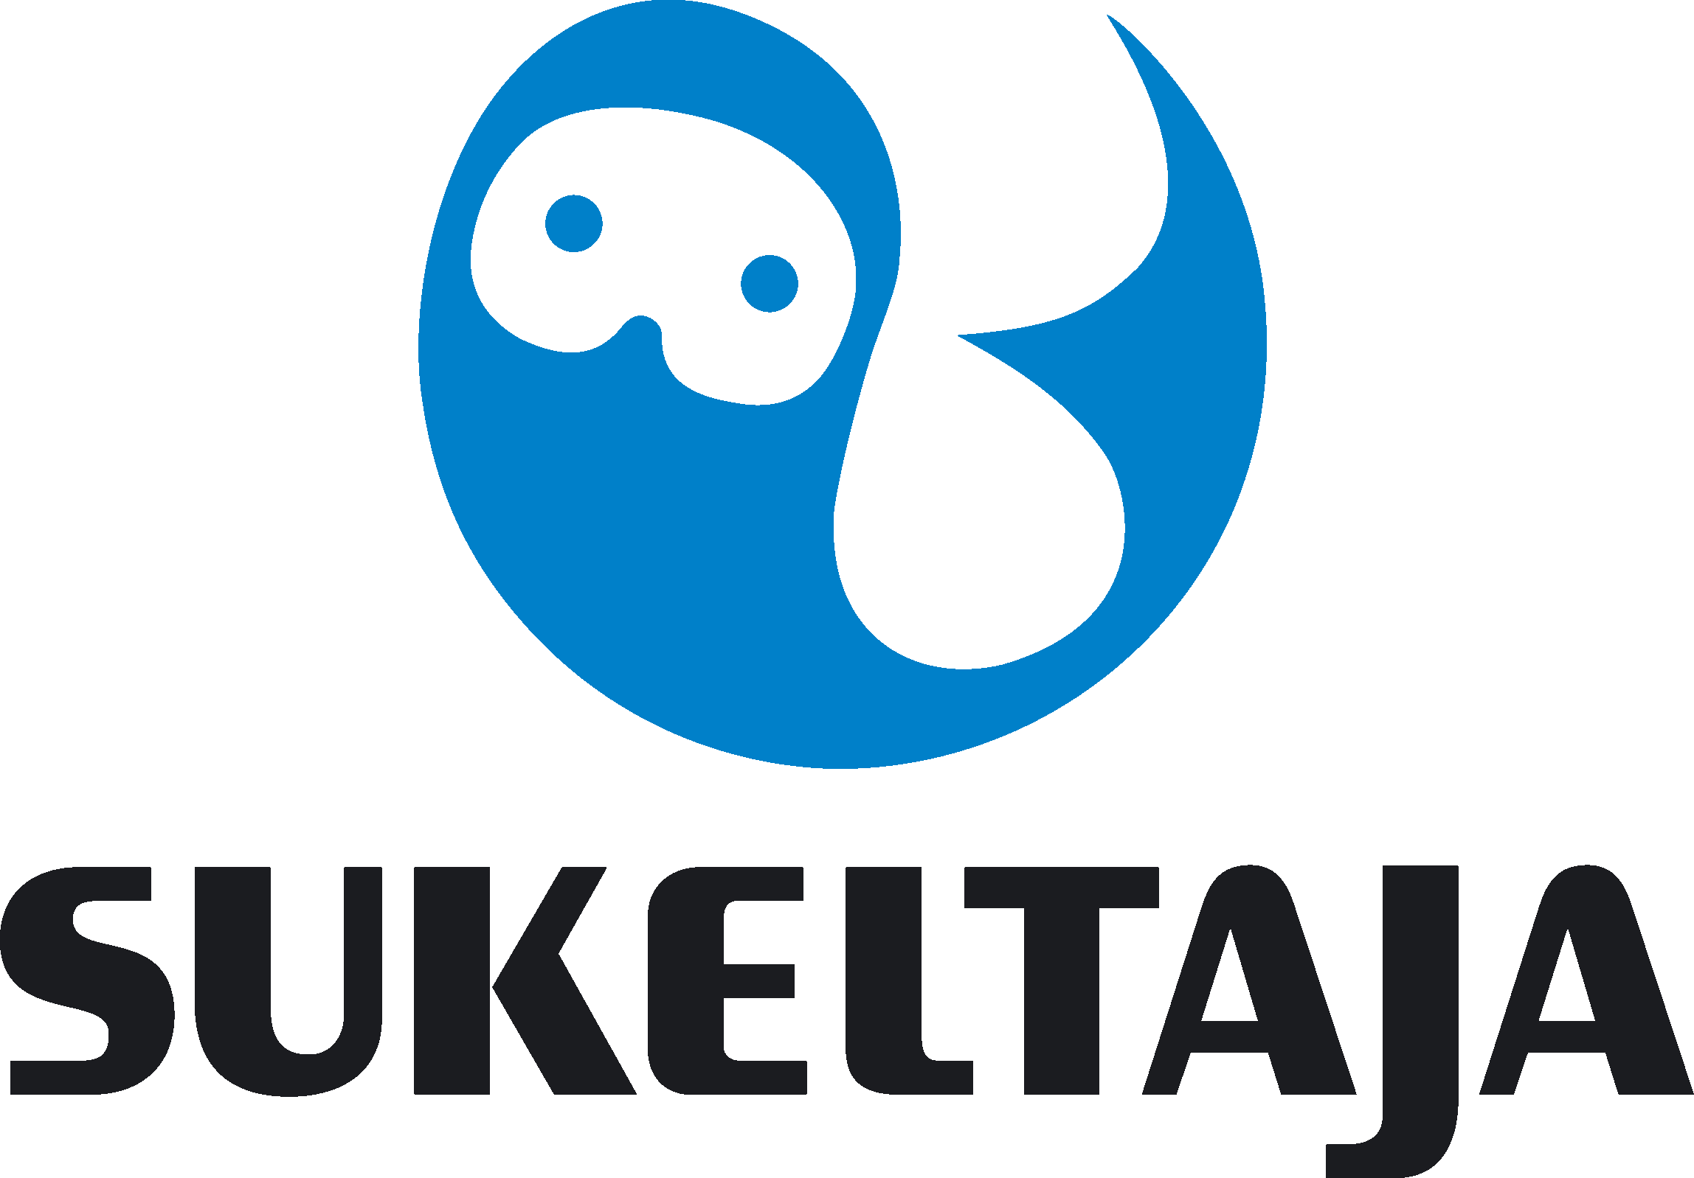
European Championship
Helsinki 2017

Annex 1.
INITIAL ENTRY FORM
immediately
Dear friends,
You all understand arranging European Championships on such a short notice time after the Hungarian Federation withdrew their offer to host the Championships in Budapest we need a quick answer from all teams immediately.
We need to know if it’s a YES or NO – do you want us to go forward with arranging the CMAS 10th UNDERWATER RUGBY EUROPEAN CHAMPIONSHIP 2017 in Helsinki, Finland during 26.6. – 1.7.2017. (this is the only pool time we can offer – no other option)

We don’t need any forms – we need an email from you as soon as you have received the invitation and talked with your teams, please not later than 8th of March.

Please let us know your answer by sending an email to:
sari.nuotio@sukeltaja.fi (Executive Director of Finnish Divers’ Federation) and
hannu.ahonen@sukeltaja.fi (Head of the Organizing Committee) and
spo@cmas.org

and let us know if you want us to continue the work and have the intention to participate – and if you would come with female team/male team or both. If we don’t see enough teams coming to make a proper Championships we will stop putting any more efforts into this.

Finland is celebrating it’s 100 years anniversary this year and Helsinki area is full of different events and seminars during summer. The hotels are giving us hard times with their limits for cancellations. We can’t take any financial risks by doing voluntary work for organizing an event. Deadline for paying the entry fees and paying 50% of hotel package reservation is 7th April. (annexes 2-3.) Second part of the hotel booking shall be paid by the end of May and the name list of the team should be sent also by the end of May.

Finnish Divers’ Federation has been successfully hosting the following events:
- CMAS European Championship in UW-Rugby 2005
- CMAS World Championships in UW-Rugby 2011
- CMAS Euro-African Championships in Spearfishing 2013
- AIDA pool World Championships in freediving in 2016

We know that we can make a good Championships for athletes, but we need your communication soonest!

Thank you for your co-operation and we wish you warmly welcome to Helsinki!

Please check the CMAS Procedures for participation in CMAS Championship. CMAS fee from the participating federation and CMAS licences for the athletes are required. The participants need to have a valid accident insurance.

