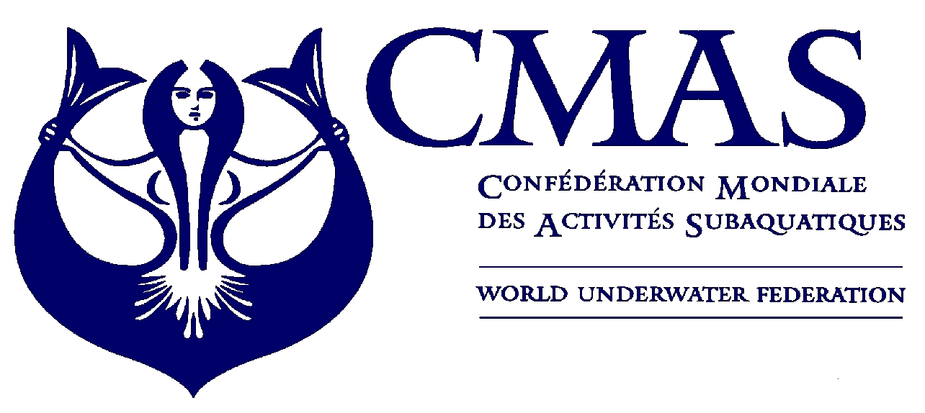
10 th Underwater Rugby
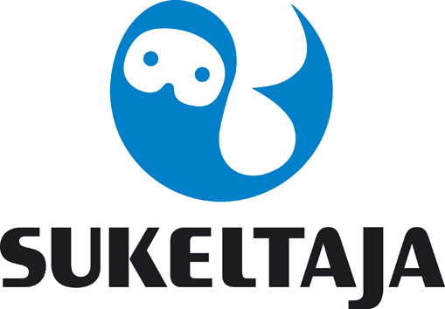
European Championship
Helsinki 2017

Annex 2.
FINAL ENTRY FORM
By 7 th April 2017
We will participate in the CMAS UNDERWATER RUGBY EUROPEAN CHAMPIONSHIP 2017 in Finland, Helsinki during 26.6.-1.7.2017.
Final Entry Form: Please complete this form (type or print) and send by e-mail to the Organizing Committee office@sukeltaja.fi and to spo@cmas.org not later than 7 th April 2017.

Country

Federation

Total No. of Competitors | Male |  | Female

Total No. of Officials | Male |  | Female

Total number of the delegation

Please check the CMAS Procedures for participation in CMAS Championship. CMAS fee from the participating federation and CMAS licences for the athletes are required. All participants shall have a valid accident insurance.

The registration is complete when the payment has been done.
Payment for the participation must be done by 7th April, by paying 3000 euros/team to:
Finnish Divers´ Federation, DanskeBank IBAN: FI8380001300541514, BIC-code: DABAFIHH.

Please mark sum and the date of your payment
Bank transfer sum: |  | Date of transfer:

In order to avoid extra bank fees you can pay the participation fee and accommodation in one payment, but mark clearly in these annexes what you are paying for.

Date,

(President Signature/ stamp) (Full name in block letters)

