
10 th Underwater Rugby
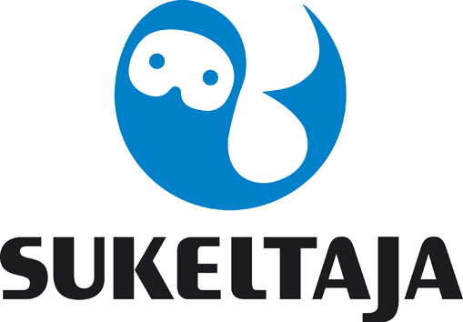
European Championship
Helsinki 2017

Annex 3.
HOTEL BOOKING FORM
By 7 th April 2017

Please complete this form (type or print) and send by e-mail office@sukeltaja.fi to the Organizing Committee before 7th April 2017.

Country

Federation

Telephone

Fax |  | e-mail

Please complete your hotel package reservation for Scandic Hotel Flamingo. The package includes accommodation with breakfast and sportbuffet in the evening. Accommodation is offered for 7 days: arrival Sunday 25.6. – departure Sunday 2.7. or 6 days: arrival Monday 26.6. -departure Sunday 2.7. Teams will get rooms in all categories twin/triple/quadruple rooms according to availability. Please choose the package according to the number of team members.

 | Price for the package  per day | arrival 25.6. arrival 26.6.  departure 2.7. departure 2.7.
 | accomm, breakfast, buffet | 7 days package | 6 days package
Package team 15 persons | 1000 €/day  (average ~ 66,6 €/person/day) | total 7000 € | total 6000 €
Package team 16 persons | 1067 €/day | total 7469 € | total 6402 €
Package team 17 persons | 1134 €/day | total 7938 € | total 6804 €
Package team 18 persons | 1201 €/day | total 8 407 € | total 7206 €

50 % of the payment must be done by 7th April to the Bank Account of the Finnish Divers´Federation Bank Account: Danske Bank IBAN account: FI8380001300541514, BIC-code DABAFIHH and the second part 50% latest 31st May.

Please mark sum and the date of your payment
Bank Transfer sum: |  | Date of transfer:

Please mark clearly in these annexes what you are paying for.

The full name list of the team should be sent to office@sukeltaja.fi by 31 st of May in order to get the rooms properly and equally devided to all teams.

Date,

(President Signature/ stamp) (Full name in block letters)

