CMAS 5th APNEA INDOOR
OPEN EUROPEAN CHAMPIONSHIP 2017

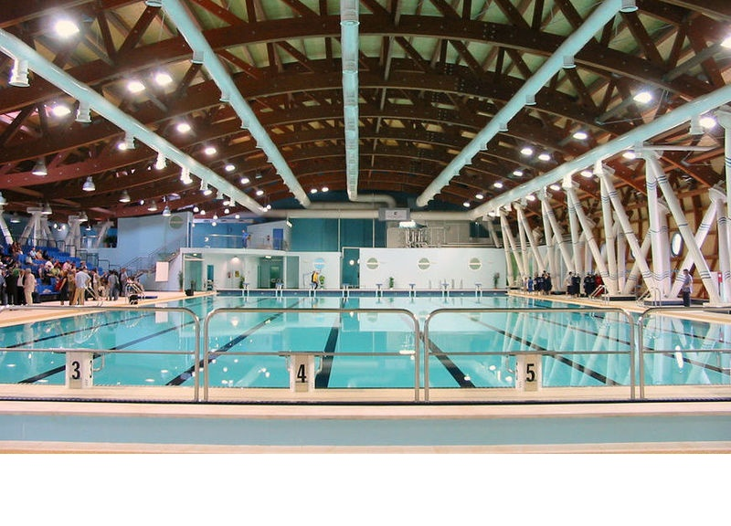
SPECIAL RULES

ARTICLE 1: GENERAL
  - CMAS has entrusted to the Italian Sport Fishing, Underwater Activities and Finswimming Federation (hereafter FIPSAS) the organisation of the 5th edition of the Apnea Indoor Open European Championship. The Championship will be staged with the supervision of CMAS in Cagliari, in the “G. Sicbaldi” Municipal Swimming Pool, from 12 to 18 June 2017.
  - The Championship shall be comprised of six specialities: Dynamic with Monofin (DYN), Dynamic with Bi-Fins (DYN BF), Dynamic without Fins (DNF), Static (STA), Speed 100 m. and Endurance 16x50 m. Only the Final stage will take place for each of the planned specialities.
  - These articles supplement and complete the International Rules drawn up for the single specialities.

ARTICLE 2: PARTICIPATION
The event is open to athletes aged 14 and over and belonging to National Teams fully complying with the provisions of CMAS Regulations, these Special Rules and the Safety Requirements established by the Organisers.

National Teams may be made up of a minimum of one to a maximum of six athletes for each men’s event and a minimum of one to a maximum of six athletes for each women’s event.
National Teams will have to bring with them two flags of their respective countries, 2x1m in size, and a CD containing their national anthem.

ARTICLE 3: CLASSIFICATIONS AND PRIZE-GIVING

Classifications and Prize-giving shall be performed in agreement with CMAS Procedures.
The Prize-giving ceremony will be held in the “G. Sicbaldi” Municipal Swimming Pool at the conclusion of each competition session.

ARTICLE 4: INTERNATIONAL JURY

CMAS Technical Delegate: pursuant to CMAS Regulations.

ARTICLE 5: CLAIMS

Pursuant to CMAS Regulations.

ARTICLE 6: ENTRIES

6.1 Deadlines
- By 12 March 2017
Initial Entry Form to be sent to CMAS and to the Organising Committee (Attachment 1).

- By 12 March 2017
The CMAS Apnea Championship Registration form to be sent to CMAS (Attachment 5).

- By 12 April 2017
The following must be sent to CMAS and to the Organising Committee:
  - Preliminary Hotel Booking Form (Attachment 2) and a copy of the receipt of payment of 50% of the participation fee;
  - letter of proof of the bank transfer (Attachment 3).

- By 12 May 2017
The following must be sent to CMAS and to the Organising Committee:
- the Competitor’s List Form (Attachment 4);
- the Final Hotel Booking Form (Attachment 6) and a copy of the receipt of payment of 50% of the remaining participation fee;
- the letter of proof of the bank transfer (Attachment 3).

Failure to pay the participation fee by 12 May 2017 will result in a 10% increase in the fee in respect of the global amount due.

  - Ratification of entries

Athletes’ entries will be ratified on 12 June 2017, starting at 11 a.m., at the secretariat situated in the Hotel, attended by the Head of the delegation of each Nation present (or his deputy), by means of the presentation of documentation from all members of entered National Teams.
The make-up of Teams will be specified in the list of athletes registered on the CMAS website (http://www.cmasoffice.org/federation/). The final composition of Teams must be decided by 12 May 2017, one month prior to the start of the event. Entries received beyond the set deadline will not be accepted, nor can there be late changes to the make-up of Teams, on the day on which documents are checked.
Athletes must be in possession of:

- the original entry form signed by the Federation President;
- a valid medical certificate attesting to the athlete’s fitness to take part in the competitive sporting discipline in question;
- a valid CMAS Apnea sports licence;
- an ID document.

Athletes that fail to produce the above documents will not be allowed to take part in the competitions, and their participation fee will not be returned.

6.3 The entry fee of Euro 71.00 must be paid to CMAS by 12 March 2017, following the procedure set forth at: http://www.cmasoffice.org/federation/

ARTICLE 7: PROGRAMME
Monday 12 June

11:00 – 12:30 Arrival and check-in of Delegations; checking of documents and issue of badges

12:30 – 13:30 Lunch

13:30 – 17:00 Arrival and check-in of Delegations; checking of documents and issue of badges

17:00 – 18:30 Technical meeting

19:30 – 21:00 Dinner

Tuesday 13 June

7:00 – 9:00 Breakfast

9:00 – 12:00 Practice (50m pool)

12:30 – 13:30 Lunch

15:00 – 17:00 Technical meeting

18:00 – 19:30 Opening Ceremony

19:30 – 21:00 Dinner

Wednesday 14 June

7:00 – 8:00 Breakfast

8:00 – 13:30 European Championship: Dynamic Apnea without Fins (50m pool)

13:30 – 14:30 Lunch

15:00 – 18:00 Practice (50m pool)

17:00 – 18:00 Technical meeting

18:30 – 19:30 Prize-giving Ceremony

19:30 – 21:00 Dinner

Thursday 15 June

7:00 – 8:00 Breakfast

8:30 – 10:00 European Championship: Speed Apnea 100m (50m pool)

10:15 – 13:15 European Championship: Static Apnea

10:30 – 13:30 Practice (50m pool)

13:30 – 14:30 Lunch

14:30 – 17:30 European Championship: Endurance Apnea 16x50m (50m pool)

17:00 – 18:00 Technical meeting

18:30 – 19:30 Prize-giving Ceremony

19:30 – 21:00 Dinner

Friday 16 June

7:00 – 8:00 Breakfast

8:00 – 13:30 European Championship: Dynamic Apnea with Bi-Fins (50m pool)

13:30 – 14:30 Lunch

15:00 – 18:00 Practice (50m pool)

17:00 – 18:00 Technical meeting

18:30 – 19:30 Prize-giving Ceremony

19:30 – 21:00 Dinner

Saturday 17 June

7:00 – 8:00 Breakfast

8:00 – 13:30 European Championship: Dynamic Apnea with Monofin (50m pool)

13:30 – 14:30 Lunch

17:00 – 18:00 Prize-giving Ceremony

18:30 – 19:30 Closing Ceremony

19:30 – 21:00 Dinner

21:00 – 24:00 Final party

Sunday 18 June

8:00 – 9:00 Breakfast

9:00 Check-out and Departure of Delegations

N.B. The organisers reserve the right to modify the order and times of events to meet technical and organisational needs.

ARTICLE 8: HOTEL RESERVATIONS AND PARTICIPATION FEES
Option 1: The fee for each participant is Euro 740,00.
This fee includes:

- stay in Hotel in double or triple room;
- full board, from lunch of 12 June to breakfast of 18 June;

- opening and closing ceremony;
- secretariat services;
- official practice;
- participation in competitions.
Option 2: The fee for each participant is Euro 450,00.
This fee includes:

- opening and closing ceremony;
- secretariat services;
- official practice;
- participation in competitions.

Supplement for single room: Euro 25.00 per day
Extra days: Euro 100.00 per person per day in double or triple room, full board.
Transfer: Cagliari Airport – Hotel and return: Euro 60.00 per person. This fee includes travel from the Hotel to the Pool and return journeys.

50% of the participation fee must be paid to the Organising Committee by 12 April 2017, to secure the booking.
The remainder of the participation fee must be paid by 12 May 2017. Failure to pay the participation fee by 12 May 2017 will result in a 10% increase in respect of the global amount due.
The participation fee must be paid via bank transfer, to:

UNDERWATER ACTIVITIES INTERNATIONAL EVENTS
Bank: UniCredit
IBAN code: IT35C0200805314000104162924
BIC SWIFT: UNCRITM1B41
(Reason for payment: Fee for participation of ………………….. National Team in Apnea Indoor Open European Championship 2017)

ARTICLE 9: VISAS
If entry visas to Italy are needed, they should be sought from FIPSAS (email: subacquea@fipsas.it) at least 30 (thirty) days prior to scheduled entry in Italy.

ARTICLE 10: CONTACTS
Federazione Italiana Pesca Sportiva Attività Subacquee e Nuoto Pinnato (FIPSAS)
Viale Tiziano, 70 – 00196 Roma
Tel. + 39 06-8798.0513
Fax: + 39 06-8798.0089
Email: subacquea@fipsas.it

