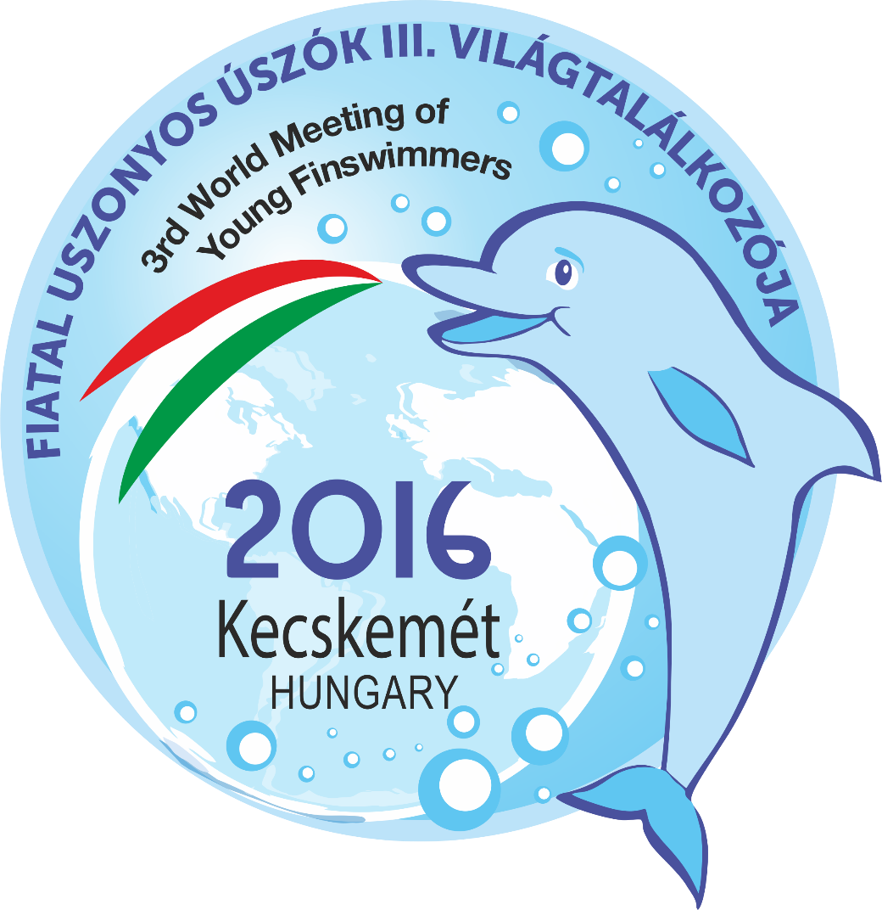
3rd WORLD MEETING OF YOUNG FINSWIMMERS
7th - 9th OCTOBER, KECSKEMÉT
3rd WORLD MEETING of Young Fin-swimmers – “C – D – E category”
Tournament
- Aim:
For the third time, with the will of establishing a new tradition is printed the
3rd Young - 15 years old and younger – Finswimmers World Meeting.
To offer competition possibility on international level for this age group.
– Cat. “C” (14-15 years old); Cat. “D” (12-13 years old); Cat. “E” (11 years old and younger’s) –
Further aim is to popularize our discipline, and to offer competition possibilities.

- Organizers:
- Bácsvíz - Kecskeméti Vízmű SC

- Date:
7th – 9th of October 2016. (Friday – Sunday)

- Place:
Kecskeméti Fürdő; Kecskemét – Hungary (address: 6000. Kecskemét, Csabay Géza krt. 5)
Indoor pool, 50 m long with 10 lanes; Electric time keeping system;
Water temperature: 26±1°C

- Daily programme:
See end of this Tournament.

- Entries:
Entries must be sent by e-mails to: buvarnevezes@gmail.com and juhosg@gmail.com
Entries must be sent filling the entry form!
The list of participants should be written onto the entry form separately by male - female, and by categories.
Pre-entry deadline: 1st of September 2016. (Thursday) – Enclosure 1. –
Headcount: (boy-girl) because of Accommodation demand and Meal request!
Entries on site are not possible!!!!
Final entry deadline: 30th of September 2016. (Friday) – Enclosure 2. –
Entry fee: by Individual event: 5 €/participant/even; Relay event: 10 €/relay
Entry fee payment: at competition site in cash!

- Conditions of entries and participation:
- Only Clubs of those countries can participate which countries are affiliated to CMAS.
- Those Clubs can participate who sent back the entries before the deadline. (Enclosure 2) and paid the entry fees on competition site.
- Those who prove the appropriate health condition of their athletes.
- On individual event each competitor can participate only in his or her own category!
- In relays is allowed to swim in different category as the age category of the athlete, but each competitor allowed to swim only in one age category’s relay event!
- Competitors will be affiliated to the heats – on the basis of their entry times - by events.
- Competitors will be awarded on Medal ceremonies separately by age categories.
- One Club can enter more than one relay team.
- Each athlete takes part of the trainings and competition for his/her own risk.
- Withdrawals must be announced to the secretary of competition in written form 30 minutes before the start.

- Financial conditions: Organizing costs are covered by the organizers, participating cost (accommodation, meals, travel) are covered by Clubs.

- Technical conditions: For the safety and use of equipment during the championship is responsible the team leader of each club.

- Events:
Cat. C: - AP/ Apnea: 50 m
- SF/ Surface: 50 m, 100 m, 200 m, 400 m, 4x100 m
- BF/ Bifins: 50 m, 100 m, 200 m
Cat. D: - SF/ Surface: 50 m, 100 m, 200 m, 400 m, 4x100 m
- BF/ Bifins: 50 m, 100 m, 200 m
Cat. E: -SF/ Surface: 50 m, 100 m, 200 m, 400 m, 4x100 m
- BF/ Bifins: 50 m, 100 m, 200 m, 400 m, 4x100 m

- Rating: Rating is by age categories on the basis of achieved results in the time heats.

- Awards: By age categories by events medals will be awarded for the 1st-2nd-3rd places.

- General conditions:
- The Competition is organized on the basis of current Tournament, and Rules of CMAS.
- The Competition will be organized with one start!
- Athletes should take part of the Opening and Closing ceremonies and the Award ceremonies in their unified suit.
- Protest can be presented until 30 minutes after the official result has been announced. Protest fee is 5000 HUF. In case of acceptance of the protest, protest fee will be refunded. Regarding the presented protest the Supervisor - appointed by the Hungarian Divers Federation - makes decision.

The organizers keep the right to make any modification in case of unforeseen obstacles. About any changes organizers will inform participants in time.

- Accommodation, meals - Information and booking information: zoltan.ludvigh51@gmail.com
The deadline for accommodation and meals are: 1st September 2016 (Thursday).

Full board accommodation is offered in the following category:

2 nights (Friday – Saturday), and from Friday 7th October dinner - until Sunday 9th October lunch

Hostel: 80 € / person (rooms with 3-4 beds)
Hotel***: 100 € / person (rooms with 2-3 beds)

Hotel and Hostel bookings after 1st September 2016 carry a 10% late booking surcharge!

- Single room extra price is Hotel: 25 €/person/night

- Extra day (only in the Hotel possible) cost with full board accommodation
Hotel***: 55 €/person (rooms with 2-3 beds)

Those athletes who do not accept one of the full board accommodations offered by the Organizing
Committee - but arrange their accommodation by themselves - are supposed to pay 30 €/person as
organizing fee.

- Airport transfer: those teams who travel by airplane - airport transfer is available. The fee of the transfer depends on the number of the team members.
Kecskemet, 20th July 2016.
Gergely Juhos
Head of the Finswimming Section
BÁCSVÍZ-Kecskeméti Vízmű SC
Programme:

7th Octobery 2016. Friday
14.00 - arrival of teams, (Kecskeméti Fürdő)
payment of participant fee and accommodation fee.
17.00 - 19.00 training possibility

8th October 2016. Saturday
09:30-10:20 warming up
10:30 Opening Ceremony
10.45 Competition
50 m Apnea boys /girls Cat. „C”
100 m Bifins boys /girls Cat. „E”, „D”, „C”
100 m Surface boys /girls Cat. “E”, „D”, „C”
Award Ceremonies

50 m Bifins boys /girls Cat. “E”, „D”, „C”,
50 m Surface boys /girls Cat. “E”, „D”, “C”
200 m Bifins boys /girls Cat. “E”, “D”, “C”
200 m Surface boys /girls Cat. “E”, “D”, “C”
4x100 m Bifins boys /girls Cat. „E”
Award Ceremonies

9th October 2016. Sunday
09:30-10:20 warming up
10:30 Competition
400 m Bifins boys /girls Cat. „E”
400 m Surface boys /girls Cat. “C”, “D”, “E”,
4x100 m Surface boys /girls Cat. “C”, “D”, “E”
Award Ceremonies

