XXX CMAS WORLD SPEARFISHING CHAMPIONSHIP

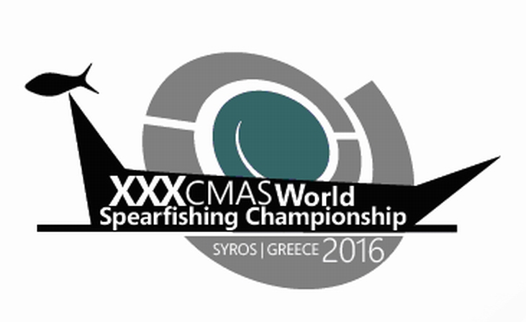

SYROS ISLAND, GREECE, 15-19 SEPTEMBER 2016

PARTICULAR RULES

- ORGANIZATION AND CONTROL

- REGISTRATION

- CHAMPIONSHIP

- ALLOWED APPAREL

- CONTROL METHODS

- COMPETITION START AND FINISH

- COMMISSARIES AND JUDGES

- SCORING AND CLASSIFICATION

- VALID, NO VALID AND BANNED PIECES

- REGULATORY FRAMEWORK AND SANCTIONS

- COMPETITION ZONES AND RESERVE ZONE

- ANTI-DOPING CONTROL

- RULES INTERPRETATION

- RESPONSIBILITIES

- ACTIVITIES PROGRAM

- ORGANIZATION CONTACT DATA

- GENERAL INFO ABOUT THE VENUE OF THE CHAMPIONSHIP

- ORGANIZATION AND CONTROL

The “Confederación Mondial de Actividades Subacuáticas” CMAS (world underwater activities confederation) has delegated to the “Hellenic Federation of Underwater Activities & Sportfishing” HFUAS ( Greek underwater activities federation ) , the organization of the “XXX CMAS World Spearfishing Championship” (The Thirtieth CMAS World Spear Fishing Championship) , that will take place between the days 15th to 19th of September 2016 in the city of Hermoupolis, Syros island, Greece.

WORLD CHAMPIONSHIP PARTICIPATION RULES
Classified countries that will participate in the XXVIII Spearfishing Championship are the
following:

A ZONE - EURO-AFRICAN
Greece (host)
Spain
Croatia
Portugal
Italy
Bulgaria
Turkey
Ukraine
Finland
Cyprus
Russia
Great Britain
Tunisia
B ZONE - PAN AMERICAN
Brazil
Chile
USA
Mexico
Argentina
C ZONE- PACIFIC
Australia
New Zealand
Tahiti

WAITING LIST:
Colombia
Denmark
Slovenia
S. Marino

List given by CMAS Spearfishing Committee. Valid for registered National Federations
keeping up to date their Spearfishing CMAS Committee Membership Payment when
formalizing their inscription

Competition Committee:

CMAS Technical Delegate – Mr. Lourenco Silveira
Director of Competition– Mr. Michalis Houlis
Three (3) no competitor captains, appointed in the technical meeting.

TECHNICAL CONTROL:
- CMAS Technical Delegate
- Competition director
- Technical and Safety Judge – Vassilis Zonomessis
- General Secretary - Nikos Kambanis
- Judge for the Protocol Ceremonies – Michail Isidorou
- The Boat Commissioners
- Medical assistance on shore (coordinator) – Giorgos Kapellas (Pathologist)
- Medical assistance on boats - Dimitrios Louloudis (otorhinolaryngologist), Alexandros Limneos (Orthopedic), Emmanouil Fragkakis (Pathologist), Spartacos Iordanidis (emergency medical aid), cardiologist of the Aigean Team aboard the Boat “Minas Ε.”
- Medical Boats – 5 (including the “Minas Ε”, which is a boat equipped as first aid vessel with 2 stretchers, oxygen, Defibrillator etc.). All medical boats will have a physician, oxygen, ABU mask, pharmacy aboard, will bear a medical flag and will be capable of providing immediate CPR assistance.
- Organisation Boats – There will be 6 Organisation boats bearing Yellow Flags. The CMAS Technical Delegate will be in one of them.
- Coast Guard Vessel
- The Hermoupolis General Hospital will be on alert.
- The Hellenic Navy Hospital in Athens with Decompression Chamber will be on alert.
- Α medical transports Helicopter will be on “standby” in Athens.
- A two person private Decompression Chamber will be in Hermoupolis Port with operator (Nikos Anastasiadis, lisenced chamber for therapeutic decompression operator, Biologist, Hyperbaric Physiology Specialist).
- Two professional SCUBA Divers
- Ambulance on shore.

- REGISTRATION

The affiliated federations to CMAS Sports Committee could register their National Teams (up to six persons per delegation) by email. The representatives of each country must be older than eighteen years old and they must have the nationality of the country they represent in championship. They must send for every member of team: first name, name, CMAS Sports License Number. They must bring flags and the anthem of their own country in electronic form or cd.

EACH NATIONAL TEAM CAN BE OFFICIALLY FORMED FROM UP TO SIX PERSONS.
- Three athletes
- A reserve athlete
- A team captain, who could be one of the four athletes.
- A doctor of the team

Registration quotas
Team members | INSCRIPTION WITH HOTEL Half Board 4 nights + Boats + Souvenirs + Opening and Gala Dinner |  |  | INSCRIPTION + Boat s+ Souvenirs + Opening and Gala Dinner
Team members | Reserve by 1st June 2016 | 2nd payment 15th August 2016 | Total  Inscription | Reserve by 1st June 2016 | 2nd payment by 15th August 2016 | Total  Inscription
6 | 1.750 € | 1.750 € | 3.500,00 € | 1.100 € | 1.100 € | 2.200,00 €
5 | 1.675 € | 1.675 € | 3.350,00 € | 1.050 € | 1.050 € | 2.100,00 €
4 | 1.600 € | 1.600 € | 3.200,00 € | 1.000 € | 1.000 € | 2.000,00 €
3 | 1.400 € | 1.400 € | 2.800,00 € | 950 € | 950 € | 1.900,00 €
2 | 1.250 € | 1.250 € | 2.500,00 € | 750 € | 750 € | 1.500,00 €

Registration: covers Organization and general expenses of championship.
Hotel accommodation / Inn: bed & breakfast for four (4) nights + half board meals
Boat: One boat for each competitor.

Additional members of team or companions HOTEL accommodation (bed & breakfast for four (4) nights + half board meals) + Opening Event Dinner + Award & Closure Dinner + lunch on competition days: € 200 per person (always in pairs or three).

Registration cost includes:
- Accommodation, breakfast and half board in the DOLPHIN BAY FAMILY BEACH RESORT ( double room)
GALISSA - 84100
TEL: +30 22810 42924, FAX: +30 22810 42843
http://www.dolphin-bay.gr
LOCATED IN THE GALISSA BAY ON THE WEST SIDE OF THE ISLAND.
- Boat for each competitor, in two (2) competition days.
- Two main dinners: Closure day and Opening day.
- Internal transfers from hotel to the Marina and weighing zone.
- Souvenirs kit
- Ice for catches, fresh fruit and water for the competitors for the days of competition.
- An additional discount of € 200 will be applied for each competitor that uses his own boat, over registration fees of modality 1 or 2.
- Participants / teams that have rented boats during scouting time and wishing to keep the same boats for the 2 competition days (as their portable GPS and Sounder might already be installed and difficult to be reinstalled and tested the day before competition) must state this latest upon registration on 15th September 2016. This would mean that those boats will be treated as own boats and not included in the boats drawing and not be fueled and payed for by the organisation. An organisation commissioner is going to be appointed to each one of the own boats accepted from the organisation. The € 200 discount for each boat will be applied.

Federations with right to participate must no later than 3 months before the start of the championship register their national team electronically via the CMAS website. The CMAS website online registration will no longer be available after such deadline.

To register for the championship, Federations with a right to participate must fill in and send the Initial Entry Form to the Nautical Club of Syros (nosyrou1933@gmail.com) and the Hellenic Federation of Underwater Activities & Sportfishing HFUAS (info@eoyda.gr) by e-mail not later than 31st March 2016. If the Federations with right to participate miss that deadline, countries from the waiting list will be accepted to the championship.

To finalise registration for the championship, participating Federations must fill in and send the Entry Form to the Nautical Club of Syros (nosyrou1933@gmail.com) and the Hellenic Federation of Underwater Activities & Sportfishing HFUAS (info@eoyda.gr) by e-mail not later than 1st June 2016 along with the transfer slip of the 1st installment of the Participation Fee. If the Federations with right to participate miss that deadline, countries from the waiting list will be accepted to the championship (2nd deadline).

Payment of the Participation Fee will be performed by Bank Transfer to the account of the “Hellenic Federation of Underwater Activities & Sportfishing” HFUAS in the National Bank of Greece. Account number GR6001100800000008000139785 BIC: ETHNGRAA. Only National Bank of Greece costs will be deducted from payment amount. All other bank transfer cost to be borne by participating Federations

- CHAMPIONSHIP

The 30th CMAS World Spear Fishing Championship will take place in two consecutive days of competition of five (5) hours each one, in the sea adjacent to the coasts of Syros Island.
This geographic area will be divided in three (3) areas named “Competition areas”, two (2) primary areas where competition will take place, and one (1) reserve area in case the weather conditions make it unsafe for people and boats to operate in the primary areas. These areas will be named Zone A - West Competition area, Zone B - East competition area and Reserve South area.

The CMAS Technical Delegate will confirm the order of the competition areas no later than one hour before the start of the first competition day.

The CMAS Technical Delegate could, if he considered it necessary, reduce the time of the competition day compared to the initially scheduled time, during the competition day or at the start of the competition day, for safety reasons for the competitors, the boat support persons and the boats, if weather conditions are severe.

Competition in one day will be valid if it time passed exceeds the two thirds of the scheduled time for the competition in the day.

The championship will be valid when at least one valid competition day is completed.

The total suspension of a competition day is strictly a decision of CMAS technical delegate.

Competitors can only use the boat provided by the Organization Committee or own boats accepted on registration that will be considered as the official boats. Another means of transportation is forbidden during the time of competition.

Each national team will be provided with a set of three (3) official boats. Taking in account that boats could be of diverse size and power, in this event:
- Boats available, excluding competitors with own boat accepted by organizer, will be distributed in packs of three boats in an equitable and fair manner, and
- The boat packs will be allocated by draw.
- It is the responsibility of the captain of each team to distribute the boats to every one of their athletes.

Team captains will be allowed to be in one of the three boats assigned to own athletes, and they will be free to switch from one boat to another during the day of competition.
- The boatmen act as commissioners.
- In case of breakdown, the boat will be replaced if possible. Complains about the
substitute boat will not be accepted.
- National Teams, which bring their own boats, must attach a written notice when
registering. It will be authorized boats with 150 maximum HP. Commissioners will
be assigned to these boats by the organisation.
- The CMAS Technical Delegate will select the commissioners for the Greek participants among other nations’ available commissioners.
- Each official boat will be assigned a reference number the same as the Competitor. It will
be a reference number when using the radio signal transmitter during the competition.
Competitors are not allowed to change their boat.

The official visit period without fishing and taking guns in the water are two weeks = 14 days + day before the championship starts = 15 days: since 2nd September, 2016 to 16th September, 2015, both included).

It is forbidden:
- To access the competition areas the day before the beginning of competition to all the competitors, members of delegation, commissaries, captains and other persons related to said persons.
- To visit any competition area during official visit period using scuba diving apparel other than apnea, or using scooters or any underwater mean of propulsion.

WARNING!!
GREEK LEGISLATION BANS THE SEAFOOD CAPTURES
During the training days, the HFUAS, Coast Guard or other competent authorities might inspect the boats.
Organization strongly recommends to comply with the Greek Fishing Law, paying special attention to the Decree 373/1975.
Breaking the law will lead to expulsion from the competition as well as the fishing apparel confiscation and an administrative and financial punishment.
During the competition the Commissioners are responsible for participants to comply with the Law.

- ALLOWED APPAREL:

The use of an official buoy provided by the organizer committee will be obligatory for all competitors being in the sea during the time of the competition days.
In the event of losing the official buoy, the boat commissaries will request the organization for a spare official buoy, during that time the athlete must use another own buoy of similar dimensions.

Only the use of following equipment is allowed:

- One boat for each competitor.
- Spear guns, loaded by the athlete without help of other competitor or support of people on boat.
- Diving fins
- Mask.
- Snorkel
- Fast release weights belt.
- Extra ballast weight that is always retrieved from sea bottom
- Gloves.
- Buoy fish holder
- Spare arrows and hooks.
- Underwater watch and computer
- Echo sounder.
- Isothermal wetsuit
- Diving knife.
- It is recommended to have an ice box to keep the catches fresh.
- Communication means (mobile phones, VHF transceivers, walky talkies,…)
- Global Position System (GPS).
- Portable scale.
- Freediver Recovery Vest. In order for this equipment to be permissible, team captains must inform the CMAS Technical Delegate about the athletes of their teams that intend to use this particular equipment during a particular day of the championship. The Compressed gas (CO2) capsule of the vest will be initialled by the CMAS Technical Delegate and inspected after each competition day. If capsule is not presented by athlete for inspection or has released the gas, the athlete will be disqualified for the day.

It is forbidden:
- Carrying fish in the belt or any other place than the buoy or the boat.
- To be dragged by boat in the water against the current.
- Loaded spear gun on board.
- Loaded spear gun hung on buoys
- THE USE OF ARTIFICIAL LIGHT OF ANY KIND, ELECTRICAL OR CHEMICAL IS PROHIBITED IN SPEARFISHING BY GREEK NATIONAL LEGISLATION. VIOLATION OF THIS PROHIBITION WILL LEAD TO IMMEDIATE DISQUALIFICATION FROM CHAMPIONSHIP.
- USE OF COMPRESSED AIR FOR BREATHING FROM ANY KIND OF DEVICE OR CONTAINER.

COMPULSORY EQUIPMENTS:
Use of following safety articles is required by local Sea Authority:
- Homologate safety float (buoy)
- Yellow with a Red line flag signaling underwater activity (Greek Law).

- METHODS OF CONTROL

Each competitor will be provided with a numbered official buoy at the moment of the inscription, the use of that buoy is COMPULSORY during the days of the competition, athletes must not go further than 25 meters from their official buoy.
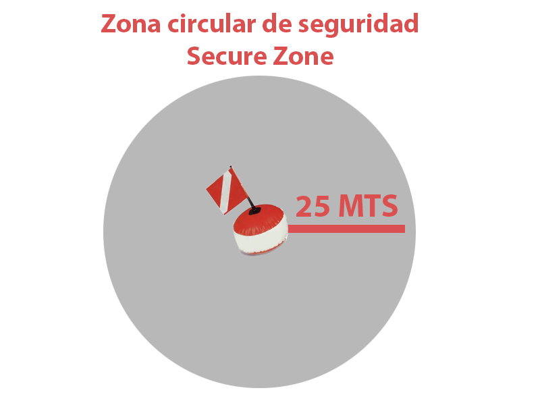

The organizer committee will give numbered bags or numbered wire to every competitor to keep the fish of the catch, that will be sealed by the commissaries and delivered at the designated place for the collection of the catches at the end of each competition day, or at the time when an athlete decides to abandon the competition, in this event it is compulsory that he communicates this intention to the CMAS Technical Delegate or the Director of competition before leaving the competition area.

Every boat with a competitor will be identified by a number and the correspondent initials of the country, with the number of the athlete and the flag of the country, according to CMAS General Rules for Championships.

- THE COMPETITION

The Director of Competition will lead the journey of boats and competitors to the gathering point determined during the technical meeting of captains, in the middle of the zone of competition. The boat of the Director of Competition will leave the port of departure, followed by the boats of the athletes until arriving at the gathering point where he will indicate the start of the competition with visual and sound signals.

All boats must follow the Competition Director boat to and from the competition area.
Once all boats have arrived at the gathering point, there will be a new recount of the participants and the time for the start and the finish of the fishing event will be communicated. The gathering point and the margins of time to arrive to the gathering point and pass the control once the fishing time has expired will also be communicated at that moment.

At the end of the competition the Director of Competition will signal the end in the same mode, both sound and visual signals. Boats of competitors must arrive to the precise gathering check point 15 minutes after the end of the competition time. The CMAS Technical Delegate can set a different margin if sea conditions require it.
PENALIZATION FOR THE DELAY ON THE MARGINS OF TIME
Up to 5 minutes . . . . . . . . . . . . . . . . . . . . . . . . . . . . 2.000 points
Every additional minute or fraction………………………500 points
Over 15 minutes . . . . . . . . . . . . . . . . . . . . ………Disqualification

The movement of the boats during the competition all the zone long must be keeping prudent distances with the other athletes and their buoys and at slow speed and respecting the distance in the radius of 25 meters of the buoy signaling one athlete.

- COMMISSARIES AND JUDGES

All not identified situations in the present rules must be solved according to the international Spear fishing rules of CMAS.
For events not identified in the Particular or the General Rules, a decision will be taken and resolved by the International Jury/CMAS Technical Delegate for the championship.

- The competition Committee may be consulted by the CMAS Technical Delegate for expert advice at any moment, but the CMAS Technical Delegate will take his own decisions.
- Commissaries of boats must fulfill the legal requirements and follow the orders of the CMAS Technical Delegate.

In the event of a competitor becoming tired or other circumstances obliging the athlete to retire from the competition, he can only leave the competition after notifying the commissary in own boat and the latter has to communicate that to the CMAS Technical Delegate or the Director of competition.

During the competition, the official Main Boat will have flags in colors that mean:
RED: Emergence/Urgency
WHITE: End of competition.
GREEN: Request for mechanical help.

After White flag and sound signal, all competitors must stop his fishing activity and go on board the boat. If he has to stay in water, he will stop the fishing activity and remove his mask of his face.

- SCORING AND CLASSIFICATION

The calculation will be in two steps:

PHASE 1: Traditional Points (P.T.)
The amount of points obtained by the captures in groups, calculated as follows: one point per gram of each valid catch plus the established bonuses.

The max valid weight for the scoring of the catches of any group will be 12,5 Kg. (12.500 g)

Catches which weigh more than 12.500 gr will score this maximum value plus the bonus, although total real weight will be considered in the event of the existence of an award for the Biggest Catch.

BONUSES:
- Each valid catch will have a 500 points bonus.
- Each different species will have a 500 points bonus.
- Additional bonus of 1000 points when the full quote of catches of a certain species is completed.

PHASE 2: Percent Punctuation (P.P. %)
The total punctuation of each athlete on each day will be a percentage taking as reference the punctuation of the competitor with the highest score in that day of the competition.
The athlete who obtains the best punctuation will be credited with the 100% and the points of the rest of the competitors will be calculated as a pro rata percentage of that punctuation. The percent values will be rounded up to the third decimal.

Formula for calculation of the individual points:

Punctuation of each athlete x 100
Punctuation of the first classified of the day.

The classification will be calculated in points, following the precedent rules.

The catch of any athlete who presents his catches in a bag other than the official one provided by the organization, with or without water, will immediately be removed from bag and water and be weighted last.

PENALTIES:
- Any catch not reaching two thirds of the minimum weight of their category, will generate a penalty (negative points), equal to the minimum weight of the category/group.
- In the event of one fish exceeding the established limit of pieces of the particular species, it will be ignored in weighing and the two heavier catches of the species will be removed.
- In the event of the established limit of pieces in Group 5 having been exceeded, the penalty will be disqualification from the championship.
- If a competitor exceeds by two or more catches the max number of catches of a species, all the catches of the species will be disqualified for this day of competition
- Any catch that is not in the boat at the time of finish the journey of competition is not considered a valid piece.

- VALID, NON VALID AND BANNED SPECIES

BANNED SPECIES

Athletes are not allowed to fish any banned species by the country or local law, as:
Red Tuna:
Bluefin Tuna | Thunnus Thynnus
Yellowfin Tuna | Thunnus Albacares

VALID SPECIES

Five (5) groups are established according to specific min. weight and max. Number of catches allowed in these Particular Rules. To be considered valid species it will be any kind of fish, caught alive and in freedom, that are included on the Groups 1-5 below. If they are not, they are NON VALID species.

Pictures of all allowed species are published in the official website of the Championship www.syros2016.gr.

The highest weight that provides points will be 12,5kg for each piece. Total weight will be counted for the “heaviest piece” award.
GROUP 1

- Min. weight for catches of this group will be 2000 grs.
- Only four catches per day in total are allowed for all of the species being part of Group 1. Example one: two Goldblotch Groupers and two White Groupers. Example two: four Goldblotch Groupers. Examle three: One Goldblotch Grouper, one White Grouper and two Motled Groupers.
- Points:
  - One point for each gram
  - 500 points bonus for each catch.
  - 500 points bonus for every different species.
  - 1000 points bonus for the full quota of Group 1. The examples above are considered to be a completed quota of Group 1 if all catches are valid.
- Min. weight without penalty: 1.334 grams.
- Penalty: -2000 points
- Species:
Greek name | English name | Scientific name | Common Spanish name
Σφυριδόβλαχος | Blacktip Grouper | Epinephelus fasciatus | mero banderilla
Πίγγα | Motled Grouper | Mycteroperca rubra | rubra
Στήρα | Goldblotch Grouper | Epinephelus Costae | abadejo
Σφυρίδα | White Grouper | Epinephelus aeneus | mero blanco

GROUP 2

- Min. weight for catches of this group will be 2000g.
- It is allowed to capture five (5) catches from each species every day of competition.
- Points:
  - A point for each gram.
  - 500 points bonus for each capture.
  - 500 points bonus for each species
  - 1000 points bonus for the complete quota of 5 valid catches of same species.
- Min. weight without penalization 1334g.
- - 2000 points penalty
- Species:

Greek name | English name | Scientific name | Common Spanish name
Γουρουνόψαρο | Grey triggerfish | Balistes carolinensis | Ballestas
Μαγιάτικο | Amberjack | Seriola Dumerili | pez limón/serviola
Μηλοκόπι | Shi Drum | Umbrina Cirossa | verrugato blanco
Λίτσα | Leerfish | Lichia Amia | Palometón
Ξιφίας | Sword Fish | Xiphias gladius | Pez Espada

GROUP 3

- Min. weight for catches of this group will be 2.000 grs.
- Only three catches per day in total are allowed for all of the species being part of Group 3. Example one: two morays and one conger. Example two: Three morays.
- Points:
  - 1000 points for each catch, whatever the valid weight.
  - 500 points bonus per catch.
  - 500 points bonus per species
  - 1000 points bonus for the full quota of Group 3. The examples above are considered to be a completed quota of Group 3 if all catches are valid.
- Min. weight without penalty: 1.334g
- -2000 points penalty
- Species:

Greek name | English name | Scientific name | Common Spanish name
Μουγγρί | Conger Eel | Conger Conger | Congrios
Σμερνα | Moray Eel | Muraena Helena | Morenas

GROUP 4

- Min. weight for the catches of this group will be 500 grs.
- It is allowed the capture of a maximum of ten (10) pieces per day for each species.
- Points:
  - One point for every gram
  - 500 points bonus for each catch
  - 500 points bonus for each species.
  - 1000 points bonus for full quota (10 valid) of same species.
- Min. weight without penalty: 335 grs.
- -500 points penalty.
- Species:
Greek name | English name | Scientific name | Common Spanish name
Αυλιάς/Κακαρέλος | Common Two-banded Seabream | Diplodus Vulgaris | mojarra
Γοφάρι | Bluefish | Pomatomus Saltatrix | chova
Ζαργάνα | Garpike | Belone Belone | aguja
Καρβούνι, Παλαμίδα, Ρίκι κλπ. | Little Tunny, Atlantic Bonito etc. | Euthynnus Alletteratus, Sarda Sarda etc. | Todos los bonitos
Κέφαλοι | Mullets | Mugil Cephalus | Lisas
Κοκκάλι | False Scad | Caranx Ronchus | Jurel real
Κολιός | Chub Mackerel | Scomber Japonicus | barat
Κυνηγός | Dolphinfish | Coryphaena Hippurus | dorado
Λαβράκι | Bass | Dicentrarchus Labrax | lubina
Λαπίνα - Χειλού | All Wrasses | Labridae | Todos Pintos - tordos
Λούτσος | European Barracuda | Spyraena Sphyraena | barracuda
Λυθρίνι | Common Pandora | Pagellus Erythrinus | breca
Λύχνος | Atlantic stargazer | Uranos copusscaber | sapo
Μελανούρι | Saddled Seabream | Oblada Melanura | doblada
Μουρμούρα | Stripped Seabream | Lithognathus Mormyrus | herrera
Μπαλάς | Largeye Dentex | Dentex Macrophthalmus | cachocho
Μπαρμπούνι | Stripped Red Mullet | Mullus Surmuletus | salmonete
Ούγενα | Sharpsnout Seabream | Diplodus Puntazzo | sargo picudo
Σαλούβαρδος | Forkbeard | Phycis Phycis | brótola
Σάλπα | Salema | Salpa Salpa | salema
Σαργός | White Seabream | Diplodus Sargus | sargo
Σαργός Φαραώ | Zebra seabream | Diplodus Cervinus Cervinus | sargo real
Σηκιός | Brown Meagre | Sciaena Umbra | corva
Σκαθάρι | Black Seabream | Spondyliosoma Cantharus | chopa
Σκάρος | Parrotfish | Sparisoma Cretense | viela colorada
Σκορπίνα | Slender Rockfish | Scorpaena Elongata | escórpora
Σκουμπρί | Mackerel | Scomber Scombrus | caballa
Συναγρίδα | Common Dentex | Dentex Dentex | dentón
Τσιπούρα | Gilthead Seabream | Sparus Aurata | dorada
Φαγκρί | Common Seabream | Pagrus Pagrus | pargo
Γερμανός | Dusky spinefoot | Siganus luridus/Siganus rivulatus | Sigano nebuloso
Καπόνι | Longfin gurnard | Chelidonichthys obscurus | Arete aletón
Σαφρίδι | Mediterranean horse mackerel | Trachurus Mediterraneous | Jurel mediterráneo
Χριστόψαρο | John Dory | Zeus Faber | San Pedro

GROUP 5

- Min. weight for catches of this group will be 5.000 grs.
- Only one catch per day is allowed for each of the species being part of Group 5.
- Points:
  - One point for each gram
  - 500 points bonus for each catch.
  - 500 points bonus for every different species.
- Min. weight without penalty: 3.334 grams.
- Penalty: -5000 points
- Species:
Greek name | English name | Scientific name | Common Spanish name
Ροφός | Dusky Grouper | Epinephelus marginatus | mero
Πεσκανδρίτσα | Monkfish | Lophius Piscatorius | rape
Βλάχος | Wreckfish | Polyprion Americanus | jorna
Κρανιός | Meagre | Argyrosomus Regius | corvina

FINAL CLASIFICATION
Individual classification: It will be equal to the total sum / addition of the total points in percent of the two (2) competition days. In the event of draw, the athlete with higher number of catches will win. If the number of catches is equal, the athlete with the biggest catch will win.

Classification by Nation: It will be the result of the addition of individual points in percent scored by every member of same nation during the valid days of competition.

- REGULATORY FRAMEWORK AND SANCTIONS

During the XXX World championship, the national teams and their members must follow these Particular Rules and the CMAS Spear Fishing General Rules. In particular:

The competitors of the national teams must know and respect Spear fishing CMAS rules, as well as these Particular Rules and local Greek laws.

The CMAS Technical delegate, Director of Competition and commissaries, will be in charge to enforce respect of the rules. After the boat commissaries’ or the competition director’s communication to CMAS Technical Delegate of any wrongfull behavior, the CMAS Technical delegate will decide a WARNING or a DISQUALIFICATION (for the day OR the whole championship).

Discipline.

Behaviors punishable with a WARNING:

- To arrive late at the control points planned by the Organization.
- For incorrect behaviour towards other competitors or the Judges.
- To move away more than 25 meters from his official buoy.
- To load or to maintain his spear gun in load position on ground or on the support boat.
- To have a means of signal indication not in conformity with the Rules.
- To not declare to have caught the total number allowed for a certain species of fish, as stated in the Particular Rules.
- During the time of competition, go out of the limits of the competition zone up to a distance where this could be considered as accidental and not intentional.
- To have obtained help to recover the buoy or the mobile ballast.
- Any athlete that presents his captures in a bag with or without water, different than the one provided by the organization, its fishes should be weighted at the end of the weighing performance after removing the bag and the water.

Behaviors punishable with DISQUALIFICATION FOR THE DAY

- Two warnings of CMAS Technical Delegate for any reason / behaviour in the same day, must be immediate disqualification in the day.
- Carrying fish in the belt or keeping catches at any place out of boat or official buoy.
- To return after the finish time for the end of the competition without major force justification: time to return to be established according to length of zone and sea conditions.
- During the time of competition, go out of the limits of the competition zone beyond a distance where this is considered as intentional.
- The athlete that presents a higher number of catches with penalty than valid catches weighed.
- Leave the competition zone before end of day of competition or without passing check control of arrival, without getting permission of CMAS Technical Delegate or Director of Championship, through Boat Commissar demand.
- To stay in sea after the official time of day of competition, even not accepting the signals of end of time from Boat Commissar.
- To be dragged by boat in the water against the current.
- To use the Freediver Recovery Vest without notification of the CMAS Technical Delegate and initialing of its gas capsule.
- To inflate the Freediver Recovery Vest or not to present its gas capsule for inspection after the end of each competition day.
- The inflation of the Freediver Recovery Vest, even if accidental.

Behaviors punishable with TOTAL DISQUALIFICATION (Deleted from official classification):

- Aggression towards other Competitors, the Judges or the Members of the Organization.
- To fish species prohibited by the Greek national legislation.
- Replacement of the catches of the regulated species or exchanged between athletes.
- Return or leave in water catches of any kind / category: not valid, forbidden or valid species of any weigth.
- To be in the Competition Zone, with or without speargun, before the Official start time in the dates of competition or precedent day.
- To use any type of scuba diving or breathing apparatus.
- Infringement of any fishing local law (artificial light etc.).
- Collaboration (other than communication between the boats of the same team) among participants except for security reasons.
- Weighing fraud.
- To catch more than one fish of the same species of Group 5.

- During official time of competition as well as along the oficial period of zone visit before championship is totally forbidden, under punishment of disqualification in championship:
  - Use of exploding puntas, luparas, and / or any gadget with explosive power.
  - Use of spearguns of explossive gaz or any system wich is not charged by human physicall effort.
  - Use any diving breathing system. This is spear fishing in apnea only.
  - Use of submarine propeller gadgets as “torpedo”.
- All those who committed offences before the beginning of the competition will not be allowed to take part in the competition.

COMPLAINTS

· Participants have the right to make a complaint to the Jury.
· Only the team's Captain can make the complaint.
· All complaints must be accompanied by a € 100 deposit, fixed by CMAS.
· A complaint must be presented in writing to the CMAS International Judge
(using English, French or Spanish) during the following periods:
1) Before the weighing time
2) During the weighing
3) Regarding a classification error, the complaint must be notified to the
Competition Director (with the 100€ deposit) within 15 minutes following the
Classification publication in order to postpone the award ceremony.
4) It will be a fixed period of an hour for writing and presenting the complaint form
to the International Judge, once the oral complaint intention was communicated.
Otherwise the complaint will be null and void, and the money on deposit will not
be refunded.
· The complaint will be valid in case the requirements are met.
· The 100€ deposit will be refunded if the complaint is accepted.

- COMPETITION AND RESERVE ZONES

The XXX World Spear fishing championship will take place in the days 15, 16, 17 and 18th of September, 2016.
The championship will take place on the coast of Syros. The event will take place in two different zones.

WEST ZONE A.- First day of competition the zone for spear fishing will be that detailed in map.

DAY1 WEST ZONE A

NORTH STRAIGHT LINE LIMIT
N37º 30´953—E024º52´889
N37º 31´144—E024º52´782

SOUTH STRAIGHT LINE LIMIT
N37º 23´698—E024º51´261
N37º 23´668---E024º51´236

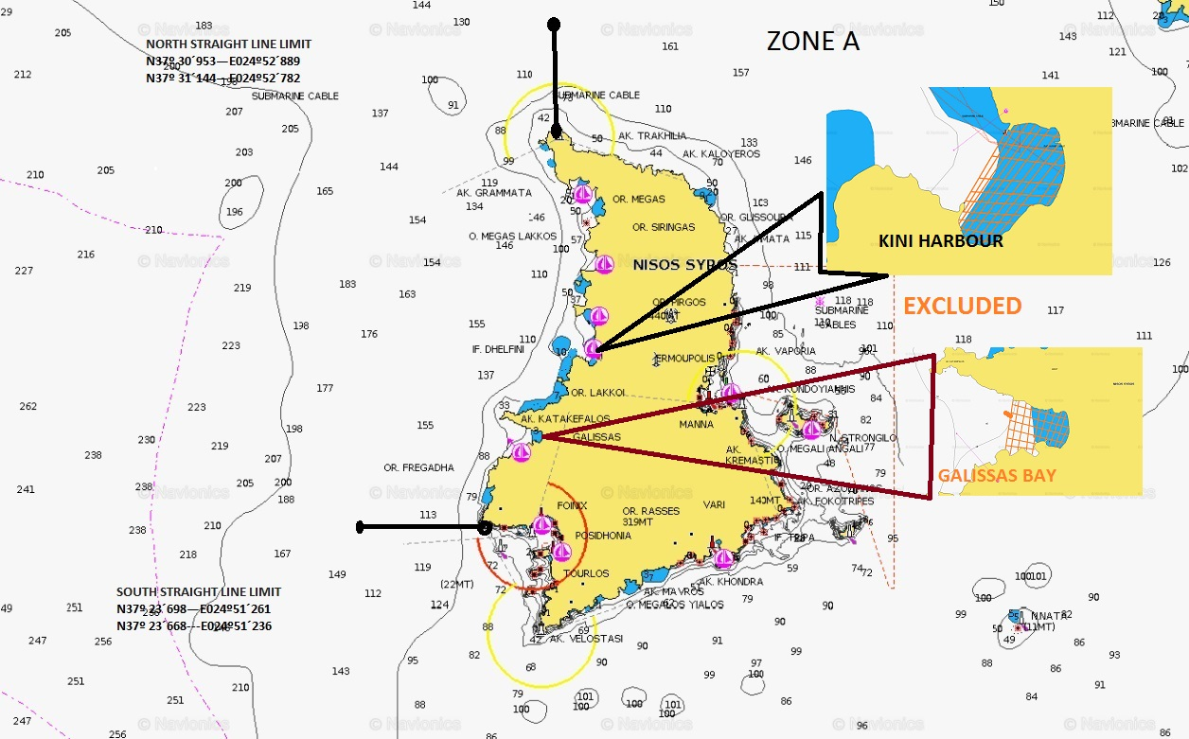

EAST ZONE B.- The second day, the competition will be in the detailed zone .
DAY 2 ZONE B

NORTH STRAIGHT LINE LIMIT
N37º 30´953—E024º52´889
N37º 31´144—E024º52´782

SOUTH STRAIGHT LINE LIMIT
N37º 26´823—E024º56´958
N37º 26´823—E024º57´035

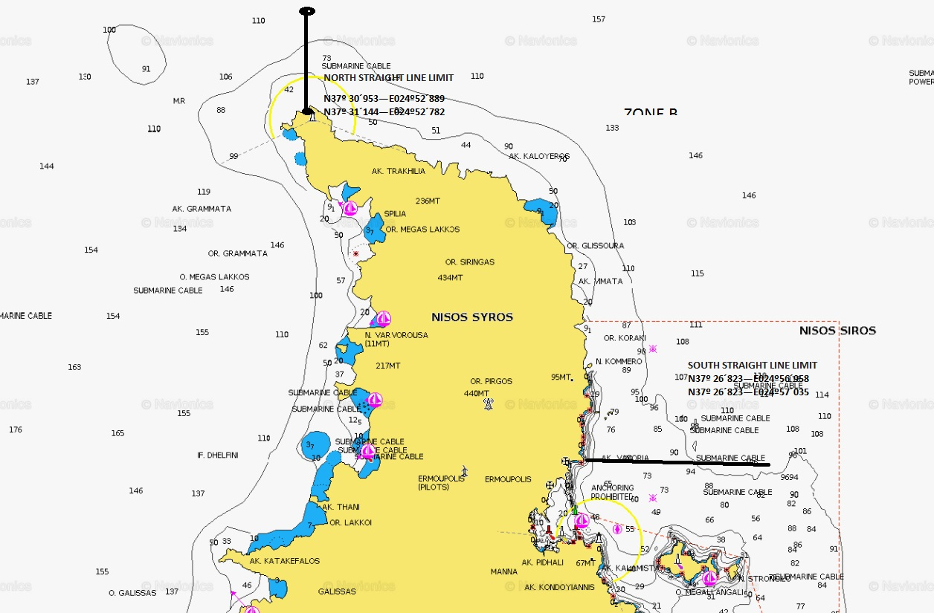

RESERVE ZONE WILL BE SOUTH ZONE , WHICH COORDINATES ARE:

WEST STRAIGHT LINE
N37º 23´698—E024º51´261
N37º 23´668---E024º51´236

EAST STRAIGHT LINE
N37º24´061—E024º58´418
N37º24´101—E024º58´545

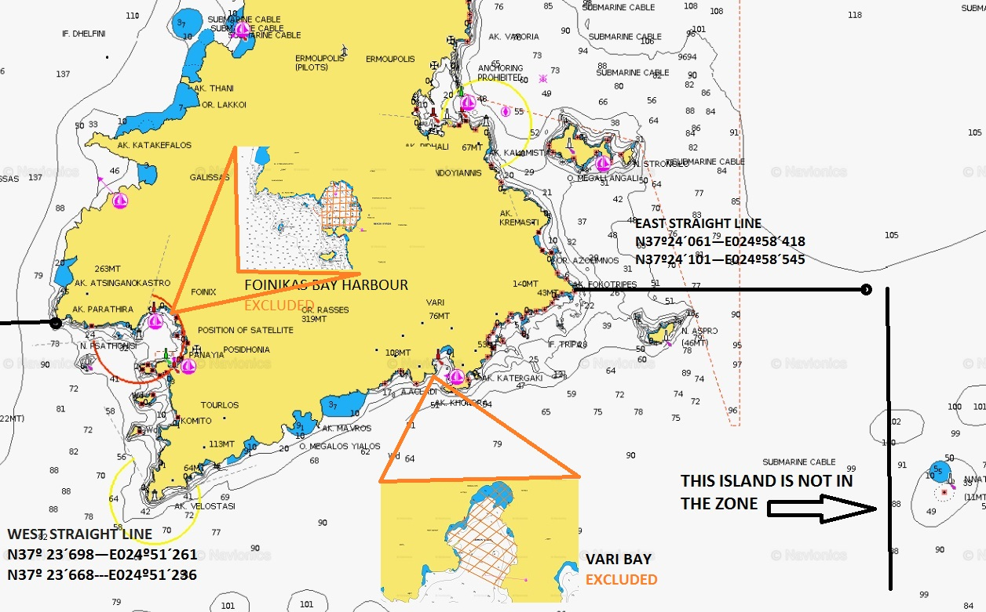

- ANTI-DOPING CONTROL

During the competition, anti- doping control may take place, according to the rules of the CMAS and the WADA.

- RULES AND INTERPRETATION

The CMAS general rules for Spear Fishing championships will be used as the norm for any issue not regulated in this Particular Rules.

- RESPONSIBILITIES

The Underwater Activities Worldwide Confederation CMAS, HFUAS, the Nautical Club of Syros, the Competition Authorities and the organizer committee will not be accountable of eventual accidents, personal or material losses affecting to competitors or third persons that happens before, during and at the end of the championship.

Competitors are going to accept all rules and norms detailed in this Particular Rules by signature at the moment of the final inscription, as well as any additional instruction coming from organization committee, HFUAS or CMAS Technical Delegate.

- ACTIVITIES

Between 15th and 19th September, 2016 – hermoupolis- Syros Island - Greece

THURSDAY, 15th of SEPTEMBER

12:00 AM /12.00 h. = 18:00 PM / 18.00 h. arrival to the Dolphin Bay Hotel.
20:00 PM Dinner

FRIDAY 16th of SEPTEMBER

08:00 AM / 08.00 h. Breakfast
10:00 AM / 10.00 h. Captains technical meeting, boats drawing and commissaries inscription.
12:00 AM /12.00 h. Commissairs meeting
18:00 PM/ 18:00 h. Opening parade in Hermoupolis Harbour
19:00 PM / 19:00 h Championship presentation at Municipality square in the center of the city

SATURDAY 17th of SEPTEMBER- First day of competition

06:00 AM / 06.00 h. Breakfast
07:00 AM / 07:00 h. Concentration on the beach of Hotel Dolphin Bay
08:00 AM / 08:00 h. Leaving to the sea
08:30 AM /08:30 h. Competition Start, First day of competition.
14:30 PM /14:30 h. End of the first day of competition.
15:00 PM /15:00 h. Arrival to the hotel beach, food and drinks.
17:00 PM / 17:00 h. weighting process start at Hermoupolis Municipality square in the center of the city
21:00 PM / 21:00 h. Dinner at the hotel

SUNDAY 18th of SEPTEMBER – Second day of competition

06:00 AM / 06.00 h. Breakfast
07:30 AM / 07.30 h. Concentration at Hermoupolis Harbour
08:30 AM / 08.30 h. Leaving to the sea
09:00 AM / 09.00 h. Competition start, Second day of competition.
15:00 PM /15.00 h. End of the second day of competition.
16:00 PM / 16.00 h. Arrival to the port of Hermoupolis, food and drinks.
17:00 PM / 17.00 h. Weighting process start at Hermoupolis Municipality square in the center of the city.
21:00 PM / 21.00 h. Medals official Award.
22:00 PM / 22:00 h. Closure dinner at Dolphin Bay Hotel

MONDAY 19th of SEPTEMBER
08:00 AM / 08.00 h. Breakfast
11:00 AM / 11.00h. Leaving back home.

NOTE- Timetables can be modified due to necessities.

- ORGANIZATION CONTACT DATA

Our federation is honored to clarify all your doubts, we are at your service.

General Manager for the event: mr. Nikos Kambanis
Telephone number; +30 6945049677
nkambanis@kambanislaw.gr

- GENERAL INFO ABOUT THE VENUE OF THE CHAMPIONSHIP

- SYROS IS LOCATED IN THE SOUTH AEGEAN SEA, IN THE CENTRE OF THE CYCLADES ARCHIPELAGO.
- IT IS COMPRISED OF 84 SQUARE KM AND LIES 80NM FROM PIRAEUS PORT, THE MAIN PORT OF THE CAPITAL CITY OF GREECE (ATHENS).
- HERMOUPOLIS IS THE CAPITAL CITY OF THE ISLAND AND OF THE SOUTH AEGEAN REGION. ALL MAIN PUBLIC AUTHORITIES OF THE REGION RESIDE IN HERMOUPOLIS
- HERMOUPOLIS HAS A MODERN FULLY EQUIPPED HOSPITAL CAPABLE OF TREATING MOST INJURY OR ILLNESS CASES.
- (NO HYPERBARIC CHAMBER, THOUGH)
- SPECIALITIES: LOCAL SAUSAGES, DELIGHTS, CHALVADOPITA AND THE “SAN MICHALI” CHEESE.
- MORE INFO ABOUT THE ISLAND AT: http://www.syros.com.gr/index_gr.html
- THE OFFICIAL WEBSITE OF THE CHAMPIONSHIP WILL BE LAUNCHED SHORTLY. IT WILL BE HOOKED ON A TAG (ALREADY EXISTING) ON THE OFFICIAL WEBSITE OF THE HELLENIC FEDERATION OF UNDERWATER ACTIVITY & SPORTFISHING: www.eoyda.gr
- TRANSPORTATIONS TO/FROM SYROS:
- BY AIR:
- FROM (AND TO) ATHENS INTERNATIONAL AERPORT (AIA) WITH AEGEAN & OLYMPIC AIR FLIGHTS, TIME 35MTS, PRICE FOR RETURN FLIGHTS FROM € 80- € 160
- NO DIRECT OR CHARTER FLIGHTS FROM INTERNATIONAL AERPORTS
- BY FERRY:
- FROM (AND TO) PIRAEUS PORT: 2-4 SHIPS PER DAY, TIME 3H 45MTS (HIGHSPEED FERRIES 2H, 30MTS), PRICE FOR RETURN TRIPS FROM € 60 PER PERSON, € 142 PER CAR, € 180 PER BOAT ON TRAILER.
- LIMITED POSSIBILITIES (NOT EVERY DAY) FROM LAVRION PORT ALSO: TIME 5H 45MTS PRICE FOR RETURN TRIPS FROM € 36 PER PERSON, € 122 PER CAR, € 148 PER BOAT ON TRAILER.
- IT TAKES ONLY 1 – 1,5 HOURS TO GET BY TAXI, BUS OR METRO TO THE PIRAEUS PORT FROM THE AIA.
- THERE IS A FREQUENT (EVERY HALF HOUR) BUS ROUTE THAT RUNS THROUGH THE MOST POPULAR SPOTS OF THE ISLAND. FARE € 1,60. TIMETABLES:
- http://www.ktel-syrou.gr/?q=en/content/timetable-schedule
- ROADMAP:
- http://www.syros.com.gr/index.php?option=com_content&view=article&id=78&Itemid=121&lang=en
- THERE ARE ALL KINDS OF ROOMS AND HOTELS AVAILABLE IN SYROS.
- AFTER THE 20TH AUGUST, PRICES USUALLY START FROM € 30 FOR A DOUBLE BED ROOM.
- http://www.syros.com.gr/index.php?option=com_content&view=section&layout=blog&id=5&Itemid=54&lang=en
- THE WEATHER IN MID SEPTEMBER ON THE ISLAND IS USUALLY WARM BUT GENTLE WITHOUT THE HEAT OUTBURSTS OF THE SUMMER. 15º -30ºC ARE THE USUAL TEMPERATURES OF THE SEASON.
- THE WATER TEMPERATURE VARIES FROM 22º - 25º C AT THIS TIME OF THE SEASON.
- THE VISIBILITY IN THE WATER IS 25-30 METERS.
- http://www.syros.com.gr/index.php?option=com_content&view=article&id=76&Itemid=117&lang=en

