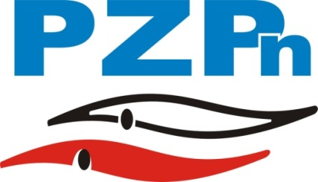
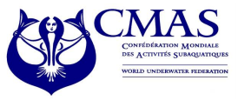
FINSWIMMING EUROPEAN CUP
JUNIOR C, D
7-8.11.2015
OPOLE - POLAND

Enclosure 1
PRELIMINARY ENTRY FORM

(To be filled in and forwarded by 31thOctober 2015)

We will participate inFinswimmingJunior European Cup for group C and D, Opole - Poland.

Please complete this form and send it by e-mail on: biuro@pzp-n.pl
not later than 31thOctober 2015

Country
Club

Total number of Athletes | Male |  | Female

Total number of Officials | Male |  | Female

Total number of the delegation

Please check CMAS Procedures for participation in CMAS FinswimmingWorld Cup, Olsztyn – Poland.

Date,

(President’s Signature/ stamp) (Full name in block letters)

FINSWIMMING EUROPEAN CUP
JUNIOR C, D
7-8.11.2015
OPOLE - POLAND

Enclosure 2
PRELIMINARY HOTEL BOOKING FORM

(To be filled in and forwarded by 31th October 2015)

Country
Club
e-mail |  | Phone

Please complete:
Hotel | 120 euro | 90 euro
Choosed option (x):

 | Number of Rooms | Date
 | Number of Rooms | From | To
Single
Double
Triple

Extra Nights:
If you need extra nights, please fill in the following:
 | Number of Rooms | Date
 | Number of Rooms | From | To
Single
Double
Triple

* Please note that hotel bookings after 31th October 2015 carry a 10 % late booking surcharge!

FINSWIMMING EUROPEAN CUP
JUNIOR C, D
7-8.11.2015
OPOLE - POLAND

Enclosure 3

TRANSFER BOOKING FORM
(Not later than 31thOctober 2015)
Country |  |  | Club
Athletes | Men |  | Women
Officials | Men |  | Women

n. | Family Name | First Name | Athlete, Trainer, Delegation Chief, Doctor, Judge, Other
1
2
3
4
5
6
7
8
9
10

ARRIVAL: |  |  | Time:
Date: |  |  | Flight No.
DEPARTURE: |  |  | Time:
Date: |  |  | Flight No.

Date,

(President’s Signature/ stamp) (Full name in block letters)

