X. Underwater-Rugby World Championships
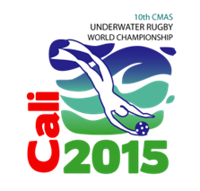
26th July to 1st August 2015
SANTIAGO DE CALI, COLOMBIA

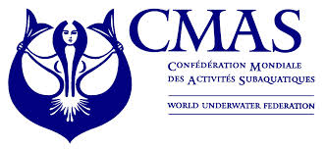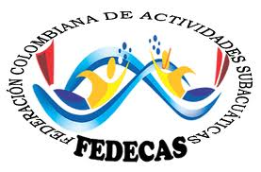
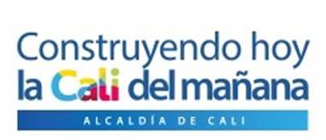

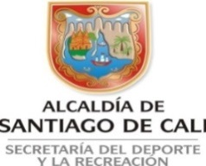

Game plan

Results of the first day:

27th July (Preliminary Round)

1 08.00 Colombia – Australia 21 : 0 (6 : 0)
2 09.00 South Africa – Venezuela 0 : 29 (0 : 15)
3 10.00 Austria – United States 10 : 1 (6 . 0)
4 11.00 Spain – Canada 2 : 2 (2 : 1)
5 15.00 Finland – Colombia 0 : 1 (0 : 1)
6 16.00 Australia – Venezuela 2 : 2 (1 : 1)
7 17.00 Denmark – United States 18 : 0 ( : 0)
8 18.00 Norway – Germany 2 : 1 (1 : 0)
9 19.00 Germany – South Africa 32 : 0 (19 : 0)
10 20.00 Sweden – Austria 9 : 0 (5 : 0)

President CMAS UW-Rugby Commission
Rüdiger Hüls
Web page: www.cmas.org/underwater-rugby or www.uwrworldchampionship.com
eMail: Leistungssport@vdst.de

