
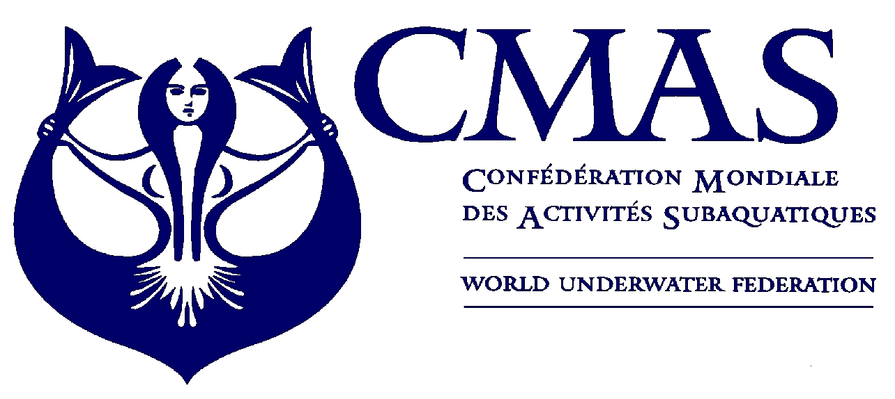
CMAS Sport diving
World Championship
S.Petersburg 2015

Annex 1
INITIAL ENTRY FORM
Before 26 April 2015
We will participate in the “CMAS SPORT DIVING WORLD CHAMPIONSHIP 2015” in S.Petersburg.
Initial Entry Form:
Please complete this form (type or print) and send by e-mail ruf@ruf.ru to the Organizing Committee before 26 April 2015.

Country

Federation

Total No. of Competitors | Male |  | Female

Total No. of Officials | Male |  | Female

Total number of the delegation | N.

Declaration Form:
Release from liability: I hereby declare that I exonerate of all liability however so arising, the CMAS, its affiliates, the event Organizing Committee and staff, the venue owners, sponsors, and any other persons that participate at the Event, in respect to all and every action or claim about accidents that may occur.

Please check the CMAS Procedures for participation in CMAS Championship. You have to send to CMAS document (CMAS attach n. 6) and fee four months before the championship.

Date, ________________________2015

________________________ ________________________
(President Signature/ stamp) (Full name in block letters)

__________________________________________

e-mail: ruf@ruf.ru

