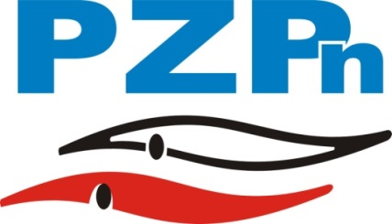
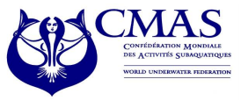
CMAS FINSWIMMING
WORLD CUP
11-12 APRIL 2015
OLSZTYN - POLAND

Enclosure 1
PRELIMINARY ENTRY FORM

(To be filled in and forwarded by 20th March 2015)

We will participate in the 2nd Finswimming University Competition, Olsztyn - Poland.

Please complete this form and send it to the Polish Underwater Federation by e-mail biura@pzp-n.pl
not later than 20th March 2015.

Country
Club

Total number of Athletes | Male |  | Female

Total number of Officials | Male |  | Female

Total number of the delegation

Please check CMAS Procedures for participation in CMAS Finswimming World Cup, Olsztyn – Poland.

Date,

(President’s Signature/ stamp) (Full name in block letters)

CMAS FINSWIMMING
WORLD CUP
11-12 APRIL 2015
OLSZTYN - POLAND

Enclosure 2
PRELIMINARY HOTEL BOOKING FORM

(To be filled in and forwarded by 20th March 2015)*

Country
Club
e-mail |  | Phone

Please complete:
Hotel | 130 euro | 100 euro | 190 euro | 145 euro
Choosed option (x):

 | Number of Rooms | Date
 | Number of Rooms | From | To
Single
Double
Triple

 | Number of Rooms | Date
 | Number of Rooms | From | To
Single
Double
Triple

Extra Nights:
If you need extra nights, please fill in the following:
 | Number of Rooms | Date
 | Number of Rooms | From | To
Single
Double
Triple

 | Number of Rooms | Date
 | Number of Rooms | From | To
Single
Double
Triple

* Please note that hotel bookings after 20th March 2015 carry a 10 % late booking surcharge!

CMAS FINSWIMMING
WORLD CUP
11-12 APRIL 2015
OLSZTYN - POLAND

Enclosure 3

TRANSFER BOOKING FORM
(Not later than 20th March 2015)
Country |  |  | Club
Athletes | Men |  | Women
Officials | Men |  | Women

n. | Family Name | First Name | Athlete, Trainer, Delegation Chief, Doctor, Judge, Other
1
2
3
4
5
6
7
8
9
10

ARRIVAL: |  |  | Time:
Date: |  |  | Flight No.
DEPARTURE: |  |  | Time:
Date: |  |  | Flight No.

Date,

(President’s Signature/ stamp) (Full name in block letters)

