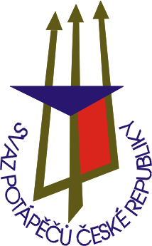
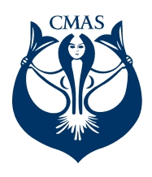
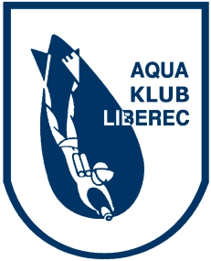
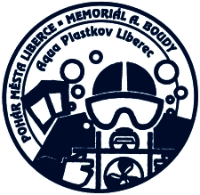
APPLICATION FORM FOR
3rd Competition of WORLD CUP
22nd CHAMPIONSHIP OF CZECH REPUBLIC
IN UNDERWATER ORIENTEERING
Liberec 6.6 – 8.6. 2014
(50th A. Bouda Memorial)
(48th Liberec Cup)

AQUA KLUB LIBEREC
Chelčického 16a
460 01 Liberec 5

Czech Republic
phone/fax: +420485104596
e-mail: aquaklubliberec@volny.cz
silny.kuba@seznam.cz

PLEASE, MARK - X - DISCIPLINE (PARALLEL - COURSE, 5P , TEAM COMPETITION) FOR COMPETITORS

Club |  |  | No. | Men |  |  |  |  | Women
Club |  |  | No. | Name | Born | Paral. | 5P | Team | Name | Born | Paral. | 5P | Team
Address |  |  | 1
Address |  |  | 2
Phone  Fax |  |  | 3
Phone  Fax |  |  | 4
Leader |  |  | 5
Leader |  |  | 6
Couch |  |  | 7
Couch |  |  | 8
Others |  |  | 9
Others |  |  | 10

We are irrevocably ordering lodging for the following number of people:
Please, Specify type of lodgings (hotel, hostel, camp, private)

Date: signature – stamp:

