

Invitation to
4. World Cup 2013 of Underwater Orienteering (Final)
19. – 22. Sept. 2013

The Austrian Diving Federation (TSVÖ) and the Erster Kärntner Unterwassersportklub (EKUS) is pleased to invite you to the 4. World Cup of Underwater Orienteering (Final) 2013. The competition takes place on Maltschachersee, a little lake in the South of Austria.
We are glad to welcome you in this beautiful region of Carinthia and we hope you are successful in competitions and you enjoy this event.

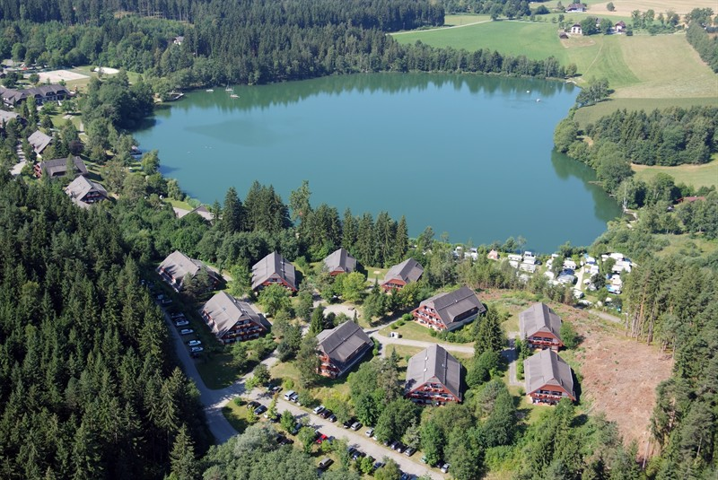

http://www.sotour.at/camping/family-camping-maltschacher-see/anreise.html





4. World Cup 2013 of Underwater Orienteering (Final)
Maltschachersee, Austria

Date: 19. – 22. Sept. 2013
Place: Sonnenresort Maltschachersee
Briefelsdorf 7, A-9560 Feldkirchen (AUSTRIA)
Phone: +43 (0)4277 2644
mailto: Sylvia.DellaPietra@sonnenresorts.at
http://www.sonnenhotels.de/de/hotels/kaernten/hotel-maltschacher-see.html
http://maps.google.at/maps?hl=de&gs_rn=7&gs_ri=psy-ab&cp=13&gs_id=95&xhr=t&q=feriendorf+maltschacher+see&bav=on.2,or.r_qf.&bvm=bv.44158598,d.ZWU&biw=1600&bih=749&um=1&ie=UTF-8&sa=N&tab=wl
Organizer: Tauchsportverband Österreichs (TSVÖ)
Head Organizer: Erster Kärntner Unterwassersportklub (EKUS)

Programme:
Thursday, 19.09.2013
12:00 – 06:00 pm Arrival of teams and registration
02:00 – 05:00 pm Training
07:00 pm Team leader meeting
Friday, 20.09. 2013
02:00 pm Start M-Course women / men

Saturday, 21.09.2013
09:00 Start team-competition women / men
07:30 pm Victory Ceremony and World Cup Award Ceremony
Dinner
Sunday, 22.09.2013 Departure
Conditions for Participation:
Every athlete must have a valid CMAS sport license and a medical examination document not
older than one year.

Starting fee: EURO 85,- per athlete
(including dinner at the Winners Ceremony / Party with live music)
Entry fee and dinner at the Party for attendant: EURO 25,-
The starting fee/ entry fee is to transfer, not later than 15th August 2013, to the account:
Erster Kaerntner Unterwassersportklub
IBAN: AT101700000100221195; BIC: BFKKAT2K; Bank: BKS Bank
End of registration: 15th August 2013
We want to remind you that getting visas is not always easy.
Do you need a special invitation to make it easier?
Please let us know this early enough, and send us an accurate indication of what you need.
Contact for registration: Erster Kärntner Unterwassersportklub
Wienergasse 10, A-9020 Klagenfurt, Austria
Contact person: Gerald Fuchs
Email: office@ekus.at or fuchs.gerald@chello.at
Mobile: ++43-6602598068

Additional information:
All events will be held according the current CMAS rules
Protest fee: EURO 80,-
Only tanks with valid certificates (2 years) will be filled (DIN and INT valves)
The competitors themselves are responsible for a proper condition of their equipment.
The organizer declines any liability. All competitors take part at their own risk.
The organizer keeps right for modifications.
Some specifications of the lake: depth 4m to 12m
Average visibility 1m to 2m
Estimated temperature about 21 °C

Accommodations:
Directly at the place of the competition in “Hotel Sonnenresort Maltschachersee” or on a camping place near the lake.
The booking of accommodation: The participants have to make it themselves.
Room rates please see attachment.
Sonnenresort Maltschachersee
Briefelsdorf 7, A-9560 Feldkirchen (AUSTRIA)
Telefon +43 (0)4277 2644, please contact Mrs. Sylvia Della Pietra (Sylvia.DellaPietra@sonnenresorts.at)
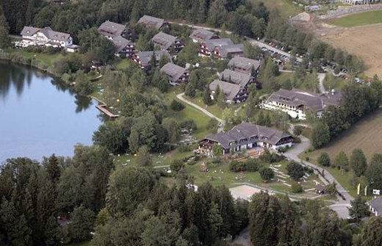

Camping or Mobilhomes:
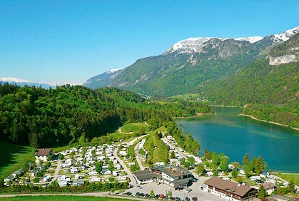

http://www.campientemobilehome.com/de/Campingplatz-Maltschacher-See-Feldkirchen-Im-Oesterreich
http://www.seewirt-spiess.com/

ENTRY FORM
Please fill in this form and send it till 15th of August 2013 to:
Email: office@ekus.at and fuchs.gerald@chello.at or by post to
Adress: Erster Kärntner Unterwassersportklub, Wienergasse 10, A-9020 Klagenfurt, Austria
Country: ……………………………………………………………………………………..
Club: ………………………………………………………………………………………
Number of athletes: ………….....
Number of attendants: ................

Name | Sex m/ f | Date of birth (year) | Athlet / Coach

........................................................................ ........................................................................................
Signature/Stamp Federation Signature / Stamp Club

Room rates for WC-Underwaterorienteering 2013, Maltschach

3 nights in studio with balkon, incl. breakfast per person 99, 00 €
3 nights in studio with balkon, incl. half board per person 117, 00 €
3 nights in studio with balkon, all inclusive per person 134, 00 €

friendly regards

Sylvia Della Pietra  Hoteldirektorin | 
+43 (0) 4277 2644  +43 (0) 4277 264451  Sylvia.DellaPietra@sonnenresorts.at  www.sonnenresorts.at | Sonnenresort Maltschacher See  Maltschacher See Straße 5  Feldkirchen  Kärnten AT – 9560

