CMAS FINSWIMMING LONG DISTANCE WORLD CUP – 1st ROUND 2013
EGYPT – SHARM EL-SHEIKH
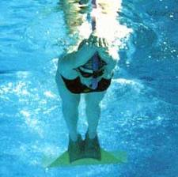
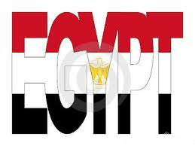

04th – 07th APRIL 2013

Particular Regulation
Denomination:
The Egyptian Diving and Lifesaving Federation (EDLF) with the CMAS Authorization organizes during the days 04th – 07th April 2013, the CMAS Finswimming Long Distance World Cup 2013, 1st Round in Sharm El-Sheikh, Egypt.
Participation Rules and Races:
The competition is ruled by CMAS Finswimming International Rules, by CMAS Finswimming Long Distance World Cup Rules, with his/her enrolment affirms to know and to agree to follow:
CMAS Finswimming Long Distance World Cup Program
Senior (Cat. A) M/F
6000 m. SF
Junior (Cat. B) B/G
6000 m SF
- All team members of National Federations should be affiliated to CMAS.
- Clubs need to send agreements from their national federations affiliated to the Finswimming Commission of the Sports Committee.
- All athletes must be in the possession of "CMAS licenses".
- Each competitor can participate on behalf of only one (1) club during the year
Competition Field:
The competition will take place in Sharm El-Sheikh, the temperature of water is 24 ⁰C.
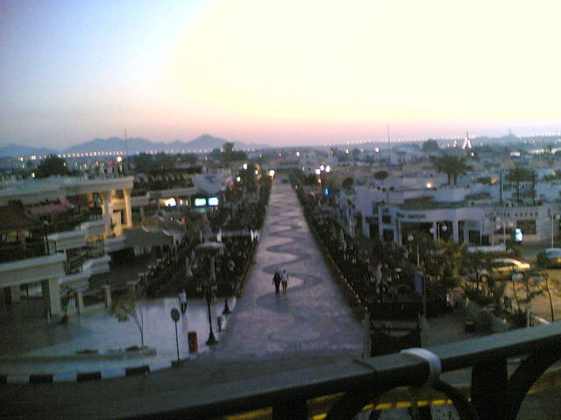

Final Enrolment:
- The application form must be filled in is supplied as attachment to these rules.
- The enrolment must be completed on the attached entry form and must be received before 1st March 2013 at the following e-mail address:
uwf@access.com.eg – edlf_eg@yahoo.com
Prizes:
Individual Prizes: Medals will be given to the first three classified athletes
Teams Prizes: Cups will be given to the first three classified clubs.
Anti-dopping:
WADA – World Antidoping Code
CMAS – Antidopping Rules
All athletes must accept these rules as a pre-condition of their participation
Responsibility:
The Egyptian Diving and Lifesaving Federation, CMAS, the Competition Director, Competition Officers and the Chief Judge are not responsible for accidents or damage caused to people and objects before, during or after the competition. The organizer shall ensure the presence of medical assistance.
Accommodation and Participation Fees:
- The official accommodation starts from the lunch of Thursday 04th April 2013 till the breakfast of Sunday 7th April 2013.
- 150 EURO / person in double or triple rooms, for 3 nights, full board.
- For single room extra charge is 25 EURO / person / night.
- The inscription fees: 25 EURO per club and 15 EURO per athlete.
- Late enrolments may be accepted with a fine of 100 EURO.
- Egyptian Federation will offer local transportation – training - opening and closing ceremony.
Payment Conditions:
- The payment will be in cash on arrival and before the technical meeting.
- All participants who do not accept the accommodation offered by the Egyptian Federation are supposed to pay 50 EURO / person as organizing fees.
Transportation:
- Transfer (Sharm El-Sheikh Airport – Hotel – Sharm El-Sheikh Airport) is for free.
- The cost of transfer (Cairo Airport – Sharm El-Sheikh – Cairo Airport) will depend on the number of persons. Please, contact with the Egyptian Federation.

CMAS Finswimming Long Distance World Cup, 1st Round
04 – 07 April 2013
Thursday 04th April 2013:
12:00 Arrival Teams, Payment of Participant and Accommodation Fee.
14:00 – 16:00 Training

LONG DISTANCE PROGRAM
Friday 5th April 2013:
09:00 Training
14:00 Technical Meeting – Checking of Equipment
18:00 Opening Ceremony
Saturday 6th April 2013:
09:00 6 km F "B" Cat.
09:05 6 km F "A" Cat.
11:00 6 km M "B" Cat.
11:05 6 km M "A" Cat.
Prize Giving
19:00 Closing Ceremony - Gala Dinner Party

Sunday 7th April 2012:
12:00 Departure
=================================================================
For Further Information, Please Contact:
Egyptian Diving and Lifesaving Federation
18 Dr. Mostafa El-Dewani Street, Garden City,
P.O Box 115 – Post Code 11516
Tel.: +2 02 2 794 08 93 - Fax: +2 02 2 795 09 43
Email: uwf@access.com.eg – EDLF_EG@YAHOO.COM
Website: WWW.EDLF-EG.COM
Looking Forward to See You in Sharm El-Sheikh, Egypt
Yours Sincerely
EDLF President
Sameh El-Shazly
Mob. +2 0100 54 64 744

