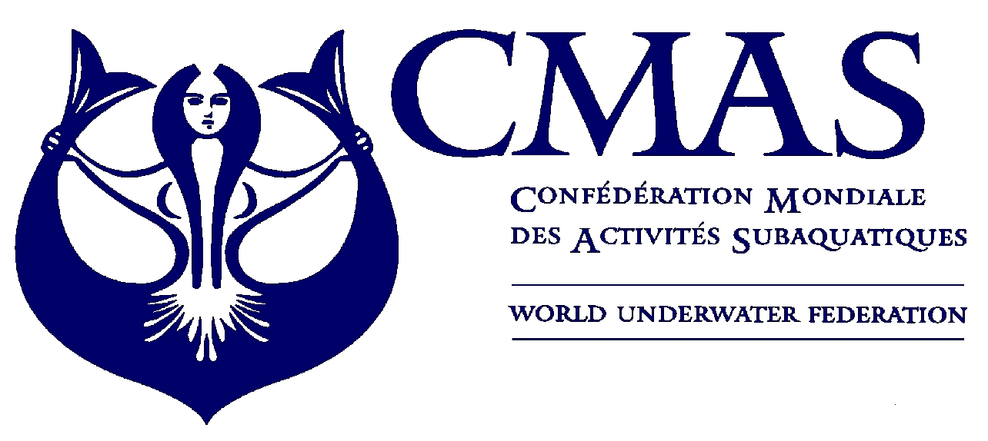
CMAS Aquathlon
Junior World Cup
Evpatoria 2013

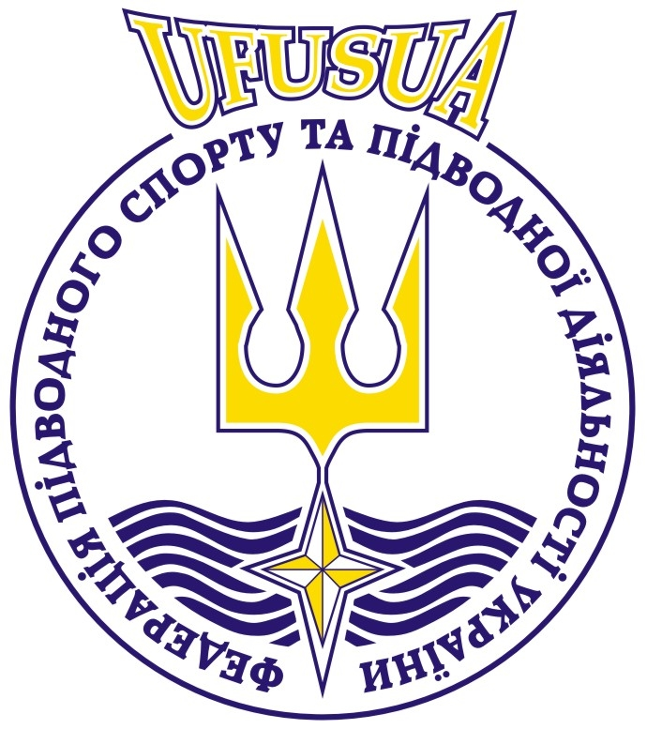

Dear Ms. & Mr. Presidents, Dear Sports Friends,

The Ukraine Underwater Federation has the pleasure to invite you and your team to participate in the CMAS Aquathlon Junior World Cup to be held in Evpatoria from 22 to 26 of March 2013. Herewith you may find all information regarding the Cup as well as all the forms necessary for your participation.

We shall be honored to welcome you soon in Simferopol

Sincerely yours,

Stanislav Predko
President

For further information, please contact us following address.
Organizing Committee Address
Ukrainian Federation of Underwater Sports and Underwater Activities
Tel/Fax: 0038 044 2599111, 0038 067 2097830
www.ufua.org
E-mail: president@ufua.org

