
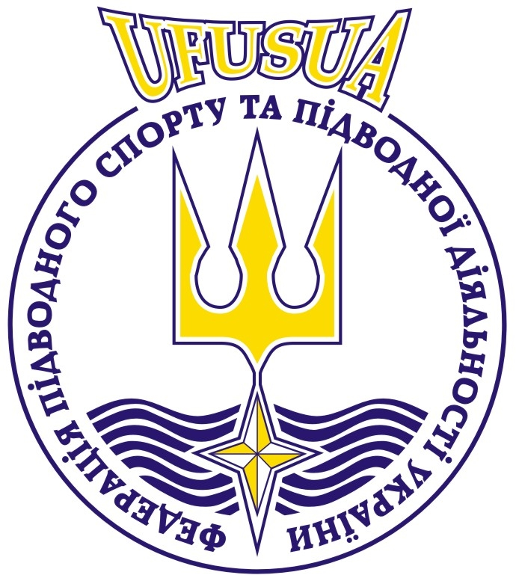
CMAS Aquathlon
Junior World Cup
Evpatoria 2013

1- GENERAL INFORMATION
The competition will take place in Evpatoria (Ukraine) from 22 March to 26 April of 2013.
2- SWIMMING POOL
Indoor swimming-pool temperature 26° C ± 1° C.

3- PARTICIPATION

Eligible to participate in this tournament clubs and the national federations that have been associated with the CMAS. Each team must comply with the rules of the championship, the safety conditions set out by the organizers and the CMAS rules and regulations.

Team should include no more than two (2) competitors in each event.

In the individual competition can be an unlimited number of participants from the team.

Each team must bring two (2) national flags (m 1.00 x 2.00 m) and a CD with the national anthem.

4- CATEGORIES AND WEIGHTS (MEN AND WOMEN)
Age category | Group
Juniors under 16 years | girls
Juniors under 16 years | boys
Juniors under 18 years | girls
Juniors under 18 years | boys
Juniors under 21 years | girls
Juniors under 21 years | boys

5- INTERNATIONAL JURY
International Chief Judge : According to the CMAS rules

6- CLASSIFICATION AND AWARDS
According to the CMAS rules

7- PROTEST
According to the CMAS rules
8- THE BOOKING & ENTRY FEE
50 € – Starting fee
Hotel accommodation is near 25 - 50 m from the pool:
The entry fee for each participant is 50 €. Payment by sending organizations: -
Accommodation in a hotel by different kind of room:
- With 1 bed 30 €
- With 2 beds 11 - 26 - 85 €
- With 3 beds 15 - 30 - 95 €
- With 4 beds 8 €
- With 6 beds 10 €
- With 8 beds 8 €
Breakfast, lunch and dinner, from dinner 22 March to breakfast to 26 March, 2013. 10 - 15 € per day - Single supplement is 30 € per day. –
- Additional costs 55 € per day for the extra day, including three meals a day and accommodation
-Transfer airport-hotel-airport 20 € per person.

9- SECRETARY AND COMPETITION FEE
The participants, who want to use other hotels by themselves, have to pay 50 Euro per person for secretary, competition, opening and closing ceremony.
Fee for participation in the competition can be paid on arrival to the Credentials Committee.
10- VISA
If you need visas, please send copies of the first page of passports of the members of your delegation by e-mail president@ufua.org or contact the Ukrainian Consulate in your country at least 30 days prior to entry in Ukrainian.
11- VARIA
Electrical current in Ukrainian is 220V, 50Hz.
12- DATE LINE - CONDITION FOR ENTRY AND PARTICIPATION
- no later than 28 January 2013
  - (Annex 1) The preliminary declaration of participation and registration form to the CMAS and Organising Committee.
- no later than 28 February 2013
  - (Annex 2) Preliminary Hotel Booking form and entry fee to the Organizing Committee.
  - (Annex 3) Supplying Letter to bank transfer.
- no later than 28 March 2013
- (Annex 4) Final Hotel Booking to the Organizing Committee.
- (Annex 5) Final Entry Form

13- PROGRAM OF THE CHAMPIONSHIP
The Championship will be carried out in a period of 2 days and 4 sessions.
The program of the championships will be the following:

Thursday 22 March 2013
- from the morning Arrival of the delegations
- afternoon Documents check and delivery of Accredit at the swimming pool.

Friday 23 March 2013
- afternoon Training at the swimming-pool
- Technical meeting of the Team leaders at the swimming-pool.

Saturday 24 March 2013
- Warming up
Opening Ceremony
Junior women
Junior men

Sunday 25 March 2013
- Warming up
Junior women
Junior men final

Awarding and Closing Ceremony

Monday 26 March 2013
- from the morning Departure of the delegations

Note: The competition program is subject to change according to CMAS.

