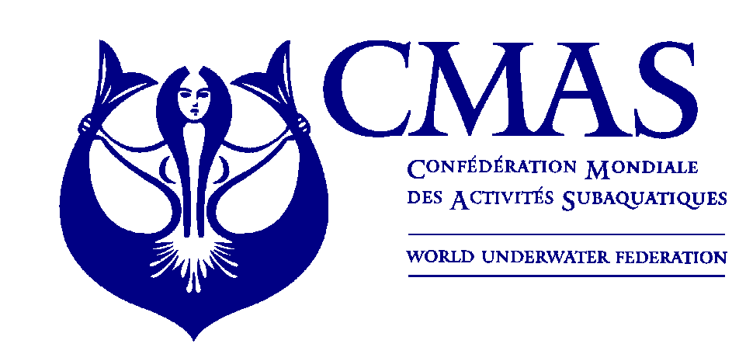
FINNISH DIVERS’ FEDERATION

XXIX SPEARFISHING
EURO-AFRICAN CHAMPIONSHIPS
HELSINKI, FINLAND
From 29th to 30th June 2013

ANNEX 1

ENTRY FORM

(To be filled in and forwarded by 15th February 2013)

Please complete this form and send it to CMAS HQ and Finnish Divers’ Federation by e-mail spo@cmas.org, office@sukeltaja.fi and tapio.salakari@sukeltaja.fi no later than 15th February 2013

Country

Federation

Total number of Athletes | Male |  | Female

Total number of Officials | Male |  | Female

Total number of the delegation

e-mail

Declaration of liability:
Release from liability: I/We hereby declare that I/we exonerate of all liability however so arising CMAS, its affiliates, the event Organizing Federation and/or Committee and staff, the venue owners, sponsors, and any other persons that participate at the event in respect of all and every action or clain about accidente that may occur.

Inscriptions and signatures will only be valid on the presetation by each Federation of the oligatory ACCIDENT INSURANCE COVERAGE POLICY for participants.

Please check CMAS Procedures for participation in CMAS Championship.

Date, …………………. 2013

________________________ _____________________
(President’s Signature/stamp) Full name in block letters)

