
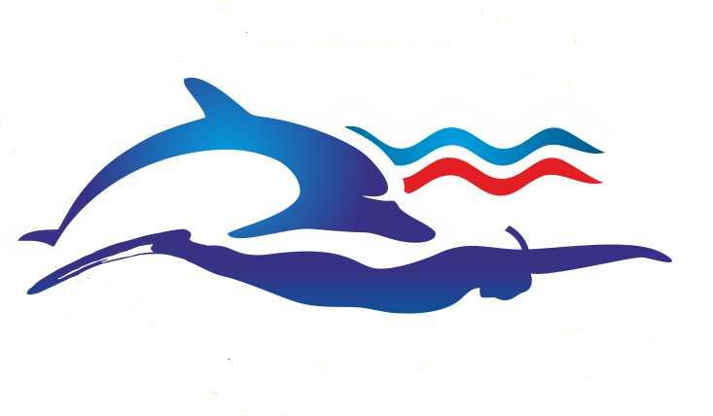
5TH CMAS WORLD CUP
FOR FINSWIMMING – 13th – 15th April 2012, Perm/Russia

PARTICULAR REGULATION

1. DENOMINATION:

Russian Underwater Federation with the CMAS authorization calls and organize during the days 13th –15th of April 2012, the fin swimming–pool race, 4th series for CMAS World Cup 2012.

2. PARTICIPATION RULES AND RACES:

The competition is ruled by the CMAS Finswimming International Rules, by the CMAS Finswimming World Cup-Pool Rules for race, and by this Particular Rules that every athlete, with his/her enrolment, affirms to know and to agree to them.
The races and categories are the following:
CMAS World Cup program
Senior (Cat. “A” ) M/F
50 m ap., 100 m im.,
50 m sf., 100 m sf., 200 m sf., 400 m sf., 800 m sf., relay 4 x 100 m sf.,
50 m bf., 100 m bf., 200 m bf.
Junior Cat. (“B,C,D”) B/G
50 m ap., (competitors of Cat. “D” cannot entering) 100 m im.,
50 m sf., 100 m sf., 200 m sf., 400 m sf., 800 m sf., relay 4 x 100 m sf.,
50 m bf., 100 m bf., 200 m bf.
Ural party program
Senior (Cat. “A” ) M/F
400 m im.
Junior Cat. (“B,C,D”) B/G
400 m im.

All team members of the National Federation, who must be affiliated to the CMAS.
The club need to send agreement from his national federation affiliated to the Sport Committee and the
Finswimming Commission.

All the athletes must be possession of the “CMAS license”.
- Each competitor can take part in a maximum of three (3) individual races and one (1) relay.
- Each team can enrol a maximum of two (2) swimmers for each individual race.
- In the CMAS Finswimming World Cup Meeting only clubs can participate.
- Each competitor can participate for only one (1) club during the year.

3. COMPETITION FIELD

The competition will take place in swimming pool SK «Olympiya-Perm». The swimming-pool has a length of 50 m, with 10 lanes and depth of 2,05m. The temperature of water is 26 °C +1°C. OMEGA electronic system.

4. FINAL ENROLMENTS:

The unique valid application form that must be filled is supplied as attachment with this see of rules.
The final enrolments must be completed on the attached entry form and must be received before 13st March 2012 at the following e-mail address ruf@ruf.ru, PermFinswimming@yandex.ru
The inscription fee for World Cup: Euro 25,00 for club, Euro 7,00 each distance and Euro 10,00 each relay for the participant.
The inscription fee for Ural party is €10 / event.

Payment should be made by direct bank transfer:

International Transfer
Please send your payment to the following account:
RUSSIAN UNDERWATER FEDERATION
Account # 40703978200001000072
with ISBANK CLOSED JOINT STOCK COMPANY MOSCOW RU
SWIFT Code: ISBKRUMM
via account #55041552 with Raiffeisen Bank International AG, Vienna
SWIFT code: RZBAATWW
Reason for payment: Contribution for participation in World Cup

National Transfer
РОО «Пермская краевая федерация подводного спорта»
ИНН 5906092881
р/счет № 40703810349500010600
Западно-Уральский Банк Сбербанк России, в Мот-м отделение №1793 г.Пермь
к/счет № 30101810900000000603 БИК 045773603
перечислять в рублях по курсу ЦБ РФ на день оплаты

5. PRELIMINARY PROCEDURES:

All sport documents of the swimmers will be checked on Friday, 13th April 2012 from 15.00 at the swimming pool.

6. CLASSIFICATIONS:

The classifications will be based on the times registered by the timekeepers; the results will be complied according to CMAS score. For all distance races no final are provided.

7. PRIZES:

Individual prizes: medals will be given to the first three classified athletes in every individual race and in every relay.
The ceremony will take place during the competition, so the interest athletes should be at organizing staff disposal at the right time. During the ceremony the interested athletes must wear the official uniform of their team.

8. ANTIDOPPING:

WADA -World Antidoping Code
CMAS - Antidoping Rules
Athletes accept these rules as a condition of participation

9. RESPONSIBILITY:

Russian Underwater Federation, Perm Underwater Federation, C.M.A.S., the Competition Director, the Competition Officers and the Chief Judge are not responsible for accidents or damage caused to people and things before, during or after the competetion. The organizer shall ensure the presence of medical assistance.

10. SPECIAL NOTES:

The present program could be modified for organization cause. Participating teams will get all information about the changes in time. Swimmers must be available for the Start Judge with their complete equipment at last 10 minutes before the race start. The organizers reserves right to accept and insert an athlete or a relay at any time at their discretion, in or outside the official classification, on request the participating club. Any other rule concerning the competition could be found on the C.M.A.S. Finswimming Rules.

5TH CMAS WORLD CUP
FOR FINSWIMMING – 13th – 15th April 2012, Perm/Russia

PROGRAM

Friday 13th April 2012
15:00 arriving of teams, checking of documents, payment of participant fee and accommodation fee.
16:00 check of equipment (fin, snorkel)
16:00-20:30 training possibility
19,00 Trainer Meeting

Saturday morning 14th April 2012
8:00-9:10 warming up

9:30 Opening ceremony
50 m SF M/F “A” cat.
50 m SF B/G “B,C” cat.
800 m sf M/F “A” cat.
800 m sf B/G “B,C,D” cat.
400 m im M/F “A” cat.
400 m im B,C,D” cat.
Prize Giving

Saturday afternoon 14th April 2012
14:00-15:00 Warming up
15:00 50 m bf M/F “A” cat.
50 m bf B/G “B,C,D” cat.
200 m sf M/F “A” cat.
200 m sf B/G “B,C,D” cat.
100 m im M/F “A” cat.
100 m im B/G “B,C,D” cat.
Prize Giving

Sunday morning 15th April 2012
8:00-8:55 Warming up
9:00 100 m bf M/F “A” cat.
100 m bf B/G “B,C,D” cat.
100 m sf M/F “A” cat.
100 m sf B/G “B,C,D” cat.
400 m sf M/F “A” cat.
400 m sf B/G “B,C,D” cat.
Prize Giving

Sunday afternoon 15th April 2012
14:00-14:55 Warming up
15:00 50 m ap M/F “A” cat.
50 m ap B/G “B,C,D” cat.
200 m bf M/F “A” cat.
200 m bf B/G “B,C,D” cat.
4x100 m relay M/F “A” cat.
4x100 m relay B/G “B,C,D” cat.
Prize Giving and Closing Ceremony

5TH CMAS WORLD CUP
FOR FINSWIMMING – 13th – 15th April 2012, Perm/Russia

ACCOMMODATION

Organizers offer accommodation possibility during the competition deadline of enrolment, March 13th 2012.

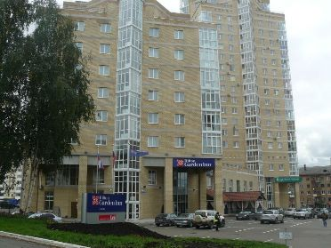 Hotel Hilton (45b, Mira st., Perm, tel (342)2276787),
50 m to the Swimming Pool. Price per room per night: 110€

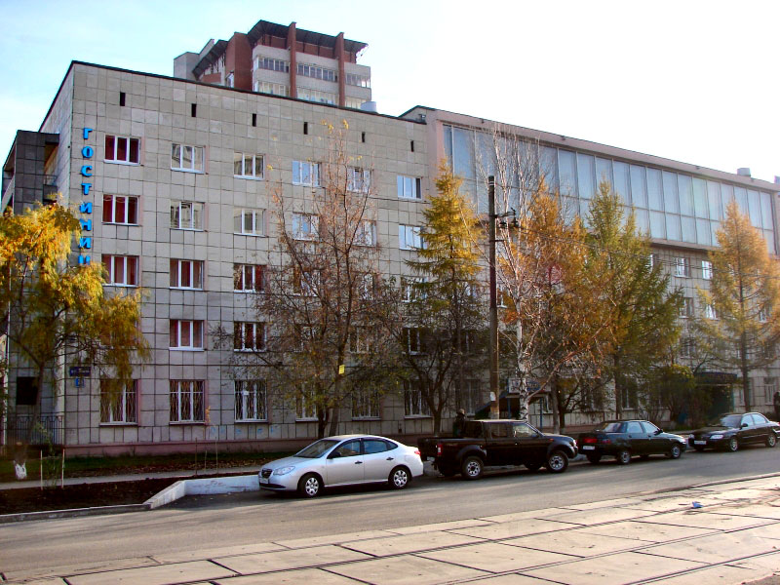 Hotel Profsoyuznaya (21, 9 May st. , Perm, tel (342)2505918),
200 m to the Swimming Pool. Price per person in doudle/triple room per night: 20€

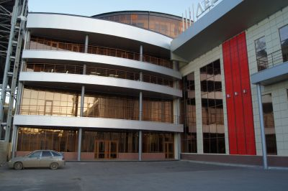 Hotel Suhareva (158a, Kosmonavtov SH, Perm, tel (342)2263967), 2 km to the Swimming Pool. Price per person in doudle/triple room per night: 25€

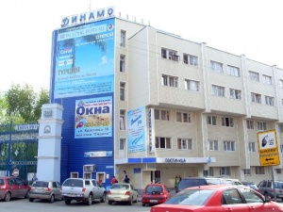 Hotel Dinamo (1, Krasnova st., Perm, tel (342)2125343), 4 km to the Swimming Pool. Price per person in doudle/triple room per night: от 20€

TRANSPORTATION

Transfer fee from Airport Perm-Hotel: 10 € per person.

BOOKING CONDITION AND PAYMENT
BOOKING CONDITIONS

The booking deadline will be on 13th March 2012.

PAYMENT

Payment should be made by direct bank transfer.

СONTACT
E-mail:
ruf@ruf.ru
PermFinswimming@yandex.ru

5TH CMAS WORLD CUP
FOR FINSWIMMING – 13th – 15th April 2012, Perm/Russia

Preliminary Entry
Please enter the team of the National Federation of …………………………… (country) …………………………………………………………………………………… (team name)
Address: ………………………………………………………………………………………..
Phone/Fax: …………………………………………………………………………………….
E-mail: …………………………………………………………………………………………
Expected number of the team:

Competitors: Accompanying person:
Men: ……………………………….. Men: ……………………………..
Women: …………………………… … Women: ……………………………..
Boys ………………………………..
Girls ………………………………..
Total: ………………………….. person

 | Number of rooms  and hotel | Number of rooms  and hotel | - from | - to
single
double

We arrive by Train …. Plain …. Own vehicle …..

We take advantage of transfer: Yes No

Date …………………………………… …………………………………
Signature and stamp
Please complete this form send back to the Organizing Committee at the following e-mail address:
ruf@ruf.ru
PermFinswimming@yandex.ru
Deadline: March 13th 2012

5TH CMAS WORLD CUP
FOR FINSWIMMING – 13th – 15th April 2012, Perm/Russia

FINAL ENTRY - SENIOR / “A” cat. /

Club: ...................................................................... Country: ...............................................
e-mail: .................................................................... fax: ..........................................................

No | Name / N° CMAS Licence | born | m / w | cat.  a | 50 m  bf | 100 m  bf | 200 m  bf | 50 m  ap | 100 m  im | 50 m  SF | 100 m  SF | 200 m  SF | 400 m  SF | 800 m  SF | 400M  IM | 4x100  m SF
1.
2.
3.
4.
5.
6.
7.
8.
9.
10.
11.
12.

Date:_____________________________________ ________________________
(Signature / Stamp)
Please complete this form send back to the Organizing Committee at the following e-mail address
ruf@ruf.ru PermFinswimming@yandex.ru
Deadline: April 1st 2012!

5TH CMAS WORLD CUP
FOR FINSWIMMING – 13th – 15th April 2012, Perm/Russia

FINAL ENTRY - JUNIOR / “B-C-D ”cat. /

Club: ...................................................................... Country: ...............................................
e-mail: .................................................................... fax: .......................................

No | Name / N° CMAS Licence | born | b / G | cat.  B | 50 m  bf | 100 m  bf | 200 m  bf | 50 m  ap | 100 m  im | 50 m  SF | 100 m  SF | 200 m  SF | 400 m  SF | 800 m  SF | 400M  IM | 4x100  m SF
1.
2.
3.
4.
5.
6.
7.
8.
9.
10.
11.
12.

Date:_____________________________________ ________________________
(Signature / Stamp)
Please complete this form send back to the Organizing Committee at the following e-mail address
ruf@ruf.ru PermFinswimming@yandex.ru
Deadline: April 1st 2012!

