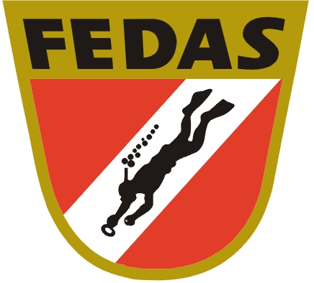
5th OPEN YOUTH EUROPEAN CHAMPIONSHIP IN UNDERWATER ORIENTEERING 2012
from August 25 to September 1, 2012

Date: 25 agust 2012 – 1 september 2012

Place: International Innovation Centre for Outdoor Sports
Zarza de Granadilla , Plasencia (25 km)
Cáceres
Autonomus Community of Extremadura

Lake: Embalse Gabriel y Galán ( Zarza de Granadilla)
average depth: 12 m
average visibility: 1,5 m
current: -
temperature : 19 to 22ºC

Organizers: Federación Extremeña de Actividades Subacuáticas
Federación Española de Actividades Subacuáticas FEDAS

Program: Star course
5 Points Course
M- course
Parallel course

Classifications: Individual junior women
Individual junior men

COMPETITION PROGRAM

Saturday, 25 August 2012

arrival of the teams
training (03:00 pm – 07:00 pm)
from 04:00 pm registration
dinner 08:00 pm – 09:30 pm

Sunday, 26 August 2012

07:30 am – 09:00 am breakfast
10:00 am - 04:00 pm training
12:30 pm – 04:00 pm lunch
05:30 pm opening ceremony
08:00 pm – 09:30 pm dinner
09:30 pm team leader meeting

Monday, 27 August 2012

07:30 am – 09:00 am breakfast
12:30 pm – 02:00 pm lunch
04:00 pm qual. PARALLEL (junior women)
04:30 pm qual. PARALLEL (junior men)
08:00 pm – 09:30 pm dinner

Tuesday, 28 August 2012

07:30 am – 09:00 am breakfast
12:30 pm - 01:00 pm STAR course junior men
12:30 pm – 02:00 pm lunch
03:30 pm - 04:00 pm STAR course junior women
07:00 pm victory ceremony (MONK-STAR)
08:00 pm – 09:30 pm dinner
09:30 pm CMAS Commission meeting

Wednesday, 29 August 2012

07:30 am – 09:00 am breakfast
12:30 pm - 01:00 pm 5 POINT junior women
12:30 pm – 02:00 pm lunch
03:00 pm - 03:30 pm 5 POINT course junior men
08:00 pm – 09:30 pm dinner
09:30 pm trainer/team leader meeting

Thursday, 30 August 2012

07:30 am – 09:00 am breakfast
12:30 pm - 01:00 pm M COURSE junior men
12:30 pm – 02:00 pm lunch
03:00 pm - 03:30 pm M COURSE junior women
07:00 pm victory ceremony (5 Point – M)
08:00 pm – 09:30 pm dinner

Friday, 31 August 2012

07:30 am – 09:00 am breakfast
12:30 pm – 02:00 pm lunch
03:30 pm - 04:00 pm FINAL PARALLEL junior
08:00 pm victory ceremony
closing ceremony, banquet

Saturday, 1 September 2012

07:30 am – 09:00 am breakfast
Departure of the teams

CONDITIONS FOR PARTICIPATION:

Every athlete must have a valid CMAS license. We ask you an id photo in order to make an id- card. Please bring the id photo to the registration.

ORGANIZATION FEE:

The organization fee is 75 € per junior athlete
It contains:
. every organizing cost
. bottle filling
. administration
. doping control

PARTICIPATION FEE:

The participation fee is 550 €/participant

The lodging will be realizad in hotels and rural housings near to the area of the competition. The organizer reserves all accommodation according to the registration.

The participation fee contains:
- Full accommodation from the 25th August to the 1st September. Full accommodation starts at 25 August lunch and end with breakfast 1 September.
- Closing ceremony and banquet
- Presents

TRAINING CAMP:

It is possible to train from 23 to 25 August.
- full board accommodation is 100 € per person/day
- training fee ist 10 € per person/day (inc. Bottle filling)

INSCRIPTIONS

End of registration:
The deadline is the 15 th of June, Friday ( 24:00 h)

Fees payment:

- until 15 june 2012: 75 + 550 €/ person
- after 15 June 2012: 75 + 550 €/person + 10%
- cash payment: 75 + 550 €/ person + 15%

Entry form:

Fullfill the “Entry Form” (Appendix 1) and send it to the headquarters of the CMAS and FEDAS (Spanish Federation) before 15 th June 2012.
e-mail CMAS: spo@cmas.org
e-mail FEDAS: fedas@fedas.es fax: 0034 932 411 680

Account holder: Federación Española de Actividades Subacuáticas

BANK: Caixa d’Estalvis i Pensions de Barcelona·
IBAN: ES26 2100-1122-5502-0007-3751 BIC: CAIXESBBXXX

FEDAS (Federación Española de Actividades Subacuáticas)
C/ Santaló, 15, 3º 1ª
08021 BARCELONA
ADDICIONAL INFORMATION:

- All events will be held according to the current rules of CMAS.
- The schedules will be able to be changed according to needs of the organization.
- The protest fee will be 80 €.
- The compressor service is available with DIN and INT adapters.
- Only cylinders with a valid certificated will be filled.
- The competitors themselves are responsible for the proper condition of theri equipment.
- The competition will be run in “Embalse Gabriel y Galán”, in the surrounding area of “el anillo” (International Innovation Centre for Outdoor Sports) situated in Zarza de Granadilla (Cáceres) Autonomus Community of Extremadura. (www.elanillo.org).

Location:

270 Km from the International Airport of Madrid (Barajas).

Recommended route by road:

The peninsula where the Ring is located is in two municipal areas, Zarza de Granadilla and Guijo de Granadilla, to a few minutes of the highway of the silver (Autovía de la Plata) and in an environment with magnificent possibilities for the practice of different sports disciplines.
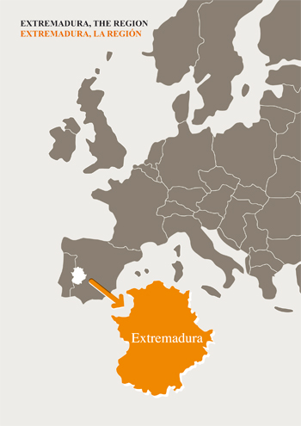
Placed in a strategic point A-5 Madrid - Lisbon, A-6 Seville - Gijon. It is a zone of influence of big centres of population.

Caceres: 90.000 Inhabitants. 40 '.
Plasencia: 45.000 Inhabitants. 25 '.
Merida: 55.000 Inhabitants. 80 '.
Salamanca: 200.000 Inhabitants. 70 '.
Badajoz: 170.000 Inhabitants. 100 '.
Madrid: 3.128.000 Inhabitants. 150 '.

Transfer service from/to Madrid:

The equipments will be able to request transfer from and towards the Madrid airport (Barajas) . Tranfer service will be available from/to Madrid airport twice a day. The organization provides this service under request . The price/person depend on the number of users. The estimated cost is approximately 120 €/person (minimun 10 pax). The definitive price will know once realized the inscription of the equipments.

The deadline to request the transfer will be the 15 th of June.

Service of transfer the days before the competition: 2 transfer/day (1 in the morning and 1 in the evening).
The teams who used the transfer service are requested to specify clearly the hour of arrival and the number of people.

Liability:

The organizer declines any liability.
All competitors take part at their own risk.
The organizer keeps the right for modification.

JUNIOR COMPETITOR’S LIST FORM ( Before 30 June)
5th OPEN YOUTH EUROPEAN CHAMPIONSHIP IN UNDERWATER ORIENTEERING 2012

Country
Federation
Nº Competitors | Nº Junior Men ___________ | Nº Junior Women __________
Nº Technicians | Nº Men ___________ | Nº Women __________

 |  | Name & First name | Birth Date | CMAS license
Junior Women | 1
Junior Women | 2
Junior Women | 3
Junior Women | 4
Junior Women | 5
Junior Men | 1
Junior Men | 2
Junior Men | 3
Junior Men | 4
Junior Men | 5
Team leader
Trainer
Technician
Others

Date, ____________________________________2012

_______________________ _____________________
(President Signature/ stamp) (Full name in block letters)

