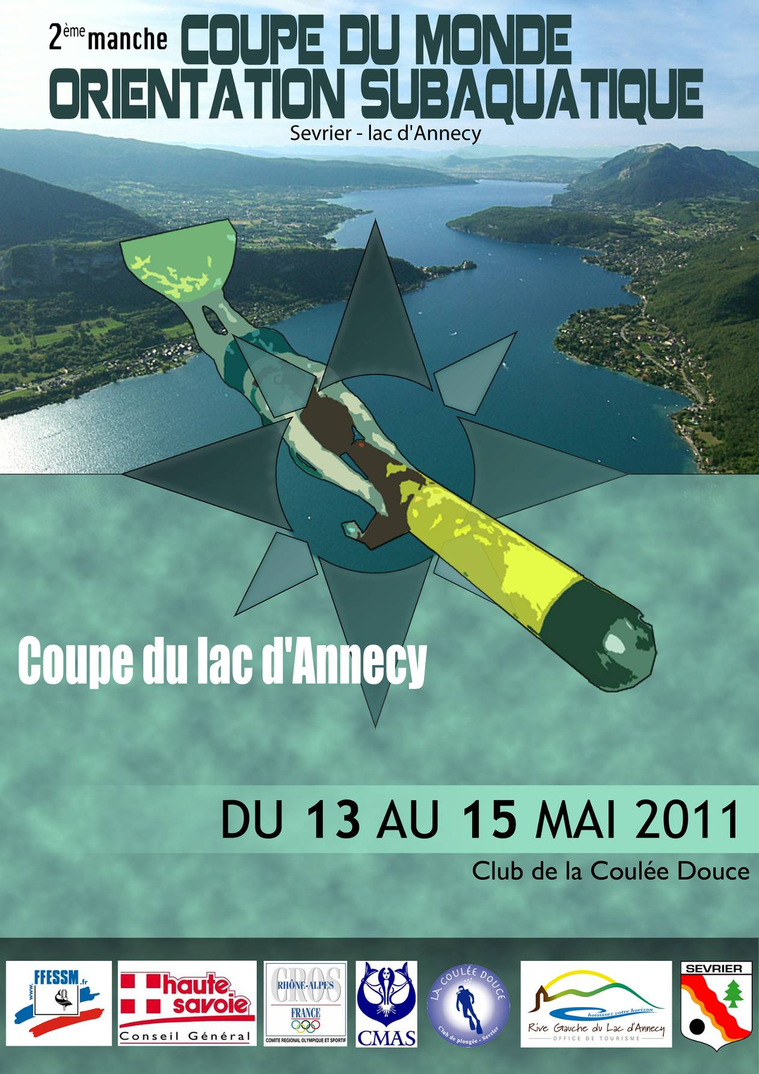

2nd World Cup round in Underwater Orienteering 2011
Annecy Lake Cup
Sévrier (74) -France

Date : From may 13th to may 15th 2011
Place : Sévrier (France), Club La Coulée douce
Lake : Annecy Lake

Average depth : 3m to 20 m
Average visibility : more than 3 m (variable)
Current : None
Temperature : 14° (variable)

Organizer : Fédération Française d’Etudes et de Sports Sous-Marins
Head-organizer : Commission Nationale d’Orientation Subaquatique

Program : Parallel-Course, 5 points-Course, Team-Competition « A »
Classification : Individual women, Individual men, Teams (club/nation)

Prices : Place one to three in individual events are honored with a medal
Place one to three in team event are honored with a medal for all members of the Team

Program :

Friday, May 13th, 2011

- 09:00 am – 12:00 am Arrival of the teams
- 12:00 am Teams-leaders meeting
- 10:00 am – 03:00 pm Training
- 04:00 pm Starting of Parallel-Race (Qualification)

Saturday, May 14th, 2011

- 09:00 am 5 points-Course Women/Men
- 04:00 pm Parallel-Race (Final rounds)
- 08:00 pm Gala Dinner

Sunday, May 15th, 2011

- 09:00 am Team-Course
- 03:00 pm Award Ceremony & Toast

Conditions for participation:
Every athlete must have:
- A valid CMAS license,
- A medical examination (not older than one year at the competition date).

Fees:
Registration Fee : 50,00 € (only € are accepted)
Complaint Fee : 80,00 €
End of Registration : May, 1st, 2011 (12:00 pm, postmark date)

Contact : Person : Mr Serge Zaepfel
Address : 15, rue des Champs
F-67201 Eckbolsheim
France
E-Mail : serge.zaepfel@evc.net
Phone : 00 33 3 88 77 07 52
Fax : 00 33 6 21 97 02 94

Additional information:
1. All events will be held according to the current rules of the CMAS.
2. The organizer offers compressor service (DIN and INT adapters will be available).
Only cylinders with a valid DIN/EN certificate will be filled.
3. Competitors themselves are responsible for the proper condition of their equipment.

How to go to SEVRIER (350, Route de la plage) :

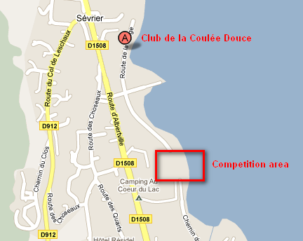
- Highway A41/E712
- Exit 16 “Annecy sud”,
- Go to direction “Albertville/lac”,
- Follow “Albertville” until “Sévrier”
- At “Sévrier” follow ‘’Port’’,
- On your left : which is Club of “La Coulée Douce”,

Address:
350, route de la plage
Sévrier, France

LIABILITY:
The organizer declines any responsibility. All competitors take part at their own risk.
The organizer keeps the right for any modifications.

PRELIMINARY / FINAL ENTRY FORM
Annecy Lake Cup May 13th-15th, 2011

Please complete this form (type or print) and email-it to the contact address
Form to be return before:
      - April 1st, 2011 for pre-registration
      - May 1st, 2011 for final registration

Country ;

Club :

Number of Participants :
Men : ………….. Women : ……………..

NAME & FIRSTNAME | SEX  M / W | BIRTH DATE  (dd-mm-yyyy) | T-shirt SIZE (XS, S, M, L or XL)

--------------------------------------------------- -------------------------------------------------
(Signature / Federation Stamp) (Signature / Club Stamp)

The organization and journalists will take photos and films of the competition; if you do not wish to be photographed or filmed check the box: □

ACCOMMODATIONS
Hotels list :
- LE RIANT PORT (near the competition area)
170, route des Choseaux 74320 SEVRIER
Tel : +33 (0)4 50 52 41 08 - Fax : +33 (0)4 50 52 48 44
Description and prices at the end of the program
Web : www.hotel-riant-port.com
Email : contact@hotel-riant-port.com
- RESIDEL
20, chemin des Aires 74320 SEVRIER
Tel : +33 (0)4 50 52 67 50 - Fax : +33 (0)4 50 52 67 11
Web : www.hotel-residel.com
Email : contact@hotel-residel.com
- AUBERGE DES TONNELLES
1080, route d’Albertville74320 SEVRIER
Tel : +33 (0)4 50 52 41 58 – Fax : 33 (0)4 50 52 60 05
Web : www.hotel-lestonnelles.com
Email : info@hotel-lestonnelles.com
- LA FAUCONNIERE
660, route d’Albertville 74320 SEVRIER
Tél : +33 (0)4 50 52 41 18 – Fax : 33 (0)4 50 52 63 33
Email : raffatin.jean-claude@wanadoo.fr

Camping :

AU CŒUR DU LAC (near the competition area, possibility to reach the area by foot)

3233, route d’Albertville – RD 1508 74320 SEVRIER

Tel : +33 (0)4 50 52 46 45 – Fax : +33 (0)4 50 19 01 45
Web : www.campingaucoeurdulac.com
Email : info@aucoeurdulac.com

Lunches : Friday midday (12 €), Saturday midday (12 €), Sunday midday (12€)
Gala Dinner : Saturday evening (25 €)

Could you please confirm the number of wished meals before May, 1st, 2011?
Only reserved meals will be served. No possibility to reserve the meal on the current day.

--------------------------------------------------------------------------------------------------------------------------------------------------
COUPON TO BE RETURNED BEFORE MAY 1st, 2011

Team : _ _ _ _ _ _ _ _ _ _ _ _ _ _ _ _ _ _ _ _ _ _ _ _ _ _

Number of meals Friday, 13th midday : _ _ _ _ _

Number of meals Saturday, 14th midday : _ _ _ _ _
Number of Gala Dinner Saturday, 14th evening : _ _ _ _ _

Number of meals Sunday, 15th midday : _ _ _ _ _

