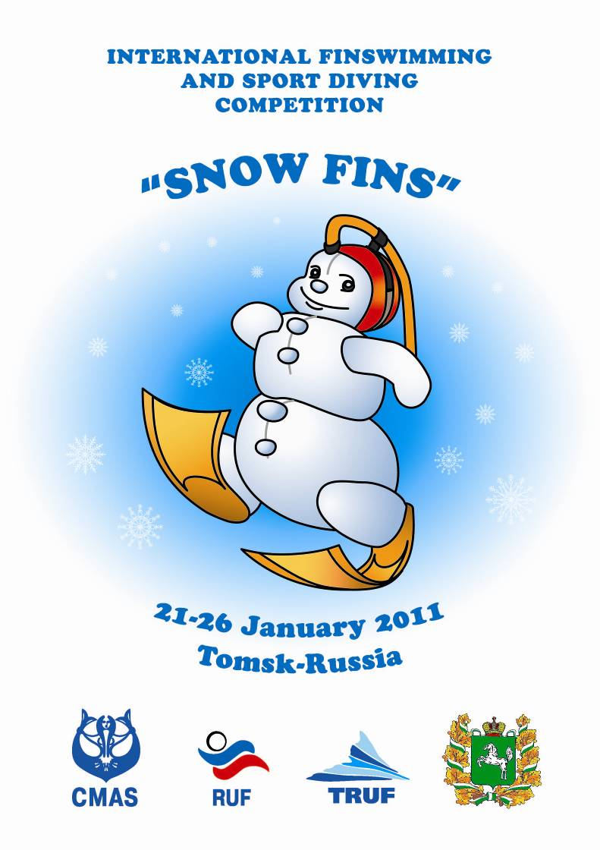
Regulations and competition program

1. Denomination:
- Tomsk region underwater federation (TRUF) with the agreement of Russian underwater federation (RUF) and World Underwater Federation (CMAS) will organize the International Finswimming and Sport diving competition “Snow Fins”, which will be held in Tomsk on 21-25 January 2011.

2. General information:
- CMAS International Finswimming and Sport diving rules will be applied.

3. Organization:
- Competition will be held in two categories for finswimming competition
- junior category (B) - 1994 and younger (50 ap., 50 sf., 100 sf., 200 sf., 50 bf., 100bf., 200 bf.)
- senior category (A) (50 ap., 50 sf., 100 sf., 200 sf., 50 bf., 100bf., 200 bf.)
- One category for sport diving competition
- senior category (A) (300 m. Trial M)

4. Participation conditions:
- The competition are for individuals ONLY;
- Each competitor must have the National Federation Licence and CMAS International Sport Licence. Junior category athletes can take part in races of the senior category, but the swimmer cannot compete on the same distance in two different categories;
- Each competitor can take part at a maximum of three (3) individual races.

5. Competition place:
- The competition will be held in:

I) Finswimming competition - swimming pool “Kedr”, 25 meters, 6 lanes, water temperature is 27°C ± 1°C
Address: Tomsk, Visotskogo Street 7

II) Sport diving - swimming pool “TSU”, 25 meters, 5 lanes, water temperature is 27°C ± 1°C
Address: Tomsk, Lenina Street 36

6. Enrolments:
- The enrolments must be complete in the enclosed form and must be send by e-mail at the following addresses:
oxanasartakova@gmail.com
band88@mail.ru
THE ENROLMENTS MUST BE SEND AT BOTH E-MAILS
- Hotel reservation and transportation:
oxanasartakova@gmail.com
band88@mail.ru
LETTERS MUST BE SEND AT BOTH E-MAILS

- To receive an invitation and visa support, please write to:
ruf@ruf.ru Tel/fax - +7 495 493 83 83

PRELIMINARY ENTRY FORMS DEADLINE - 20.11.2010
FINAL ENTRY FORMS DEADLINE - 20.12.2010

7. Competition program:

FINSWIMMING

21 January 2011
- arrival and accommodation for finswimming competition participants
(!) 10:00 - 16:00 - athletes and other participants registration (IN SWIMMING POOL “KEDR”)
10:00 - 18:00 - training (IN SW. POOL “KEDR”)
16:00 - technical meeting (IN SW. POOL “KEDR”)
17:00 - judge meeting (IN SW. POOL “KEDR”)

22 January 2011
morning
9:30 - 10:15 - warm up
10:30 - start
- 50 apnea (girls, boys, women, men)
- 100 bi-fins (girls, boys, women, men)
- 100 surface (girls, boys, women, men)

evening
15:30 - 16:30 - warm up
16:45 - opening ceremony
17:00 - start
- 50 bi-fins (girls, boys, women, men)
- 200 surface (girls, boys, women, men)

23 January 2011
morning
11:00 - 11:45 - warm up
12:00 - start
- 50 surface (girls, boys, women, men)
- 200 bi-fins (girls, boys, women, men)

evening
19:00 - closing and award ceremony
Stand-up- meal and party at nightclub

SPORT DIVING

24 January 2011
- arrival and accommodation for sport diving competition participants
(!) 10:00 - 16:00 - athletes and other participants registration (IN SWIMMING POOL “TSU”)
10:00 - 18:00 - training (IN SW. POOL “TSU”)
16:00 - technical meeting (IN SW. POOL “TSU”)
17:00 - judge meeting (IN SW. POOL “TSU”)

25 January 2011
16:00 - warm up
17:00 - start
- 300 m. Trial M
- closing and award ceremony

26 January 2011
Departure

8. Race judges and time registration:
The race will be directed by CMAS and RUF judges.
International chief judge - according to CMAS rules

9. Protest:
- According to CMAS rules
- CMAS International Finswimming and Sport diving rules with a fee of 100 Euros

10. Prizes:
- Medals will be given for the first, second and third classified athletes in every individual race.
- The best athletes (men and women, category A) who had best result in a sum of 3 distances (“SUPER SPRINT 1” and “SUPER SPRINT 2”) will be given special prizes.

SUPER SPRINT 1 SUPER SPRINT 2
3 best men and 3 best women in 3 best men and 3 best women in
50 ap + 50 sf + 100 sf 50 ap + 100 sf + 200 sf

11. Doping control:
According to CMAS rules.

12. Behavior rules:
Team manager is responsible for the behavior of the athletes during the competition.

13. Responsibility:
- TRUF, RUF, CMAS, the Competition Director, the Competition Officers and the Chief Judge are not responsible for accidents or damages caused to people and things before, during or after the competition;
- All athletes must have certificates of medical condition and ability to take part in the competition.

14. Accommodation:
Organizing Committee offers accommodation in:
Hotel “Sputnik”, address: Tomsk, Belinskogo Street 15
a) Economy class:
From 25 Euros / person / night / breakfast (Single, double or triple room)
b) Semi-luxe:
From 40 Euros / person / night / breakfast (Single or double room)
Meals:
Lunch + dinner can be organized in hotel for additional 15 Euros per person.

15. Competition fee:
To participate in competition each athlete pays 35 Euros.
(Cost of organized International competition “Snow Fins”.)

16. Transportation:
Airport Tomsk - hotel - Airport Tomsk - 30 Euros/person
Airport/Train station Novosibirsk - hotel Tomsk - Airport/Train station Novosibirsk - 100 Euros/person

17. Special note:
THE PRESENT PROGRAM COULD BE MODIFIED FOR ORGANIZATION CAUSE.
Preliminary / Final Hotel & Travel Form
Please complete this form (type or print) and e-mail (oxanasartakova@gmail.com , band88@mail.ru) it to the Organizing Committee before: Preliminary 20.11.2010
Final 20.12.2010
Country / Club
Tel. / Fax
E-mail

Please complete:
Hotel | Type of room | No. of rooms | Date
Hotel | Type of room | No. of rooms | From | To
Hotel | Single
Hotel | Double
Hotel | Triple
Travel details:
Arrival:
Flight/train
Arrival Date
Flight/train information | Time of arrival | Airline | Flight No. | No. of persons
Departure:
Flight/train
Departure Date
Flight/train information | Time of departure | Airline | Flight No. | No. of persons

Number of participants: Men ____; Women ____; Boys ____; Girls ____; Officials ____.
Name of person to be contacted: ……………………………………………………………….

Signature of federation:________________________ Stamp
Final Entry Form
Please complete this form (type or print) and e-mail (oxanasartakova@gmail.com , band88@mail.ru) it to the Organizing Committee before: 20.12.2010
Federation: ______________________________________________________________________________________________

Club / country ____________________________________________________________________________________________

Number of Participants : Men ( ) Women ( ) Boys ( ) Girls ( )

Name | Sex | Category | Born | Finswimming |  |  |  |  |  |  | Sport diving
 |  |  |  | 50 ap | 50 sf | 100 sf | 200 sf | 50 bf | 100 bf | 200 bf | 300 m

____________________________ _____________________________
(Signature / stamp Federation) e-mail, name of person to be contacted

