
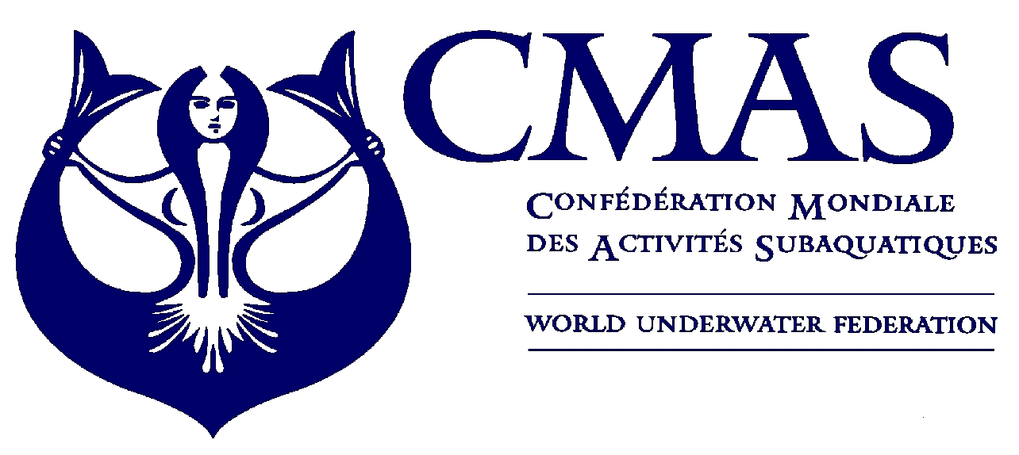
I Sport Diving
European Championship
Kazan 2010

Annex 2
HOTEL BOOKING FORM
Before 15 June 2010
Hotel Booking Form:
Please complete this form (type or print) and send by e-mail ruf@ruf.ru to the Organizing Committee before 15 June 2010.

Country

Federation

Telephone

Fax |  | e-mail

Please complete:
 Hotel
 | Number of Rooms | Date
 | Number of Rooms | From | To
Single
Double/Triple

Extra Nights:
If you need extra nights, please fill in the following:
 | Number of Rooms | Date
 | Number of Rooms | From | To
Single
Double/Triple

Method of Payment:
Please check (x) in one of the following:
a) Bank Transfer |  | Date of transfer :
b) Cash on Arrival

Date, ________________________2010

________________________ ________________________
(President Signature/ stamp) (Full name in block letters)

________________________________________

e-mail: ruf@ruf.ru

