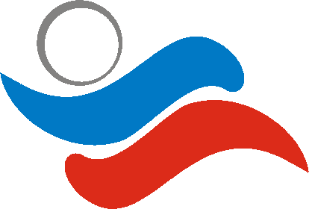
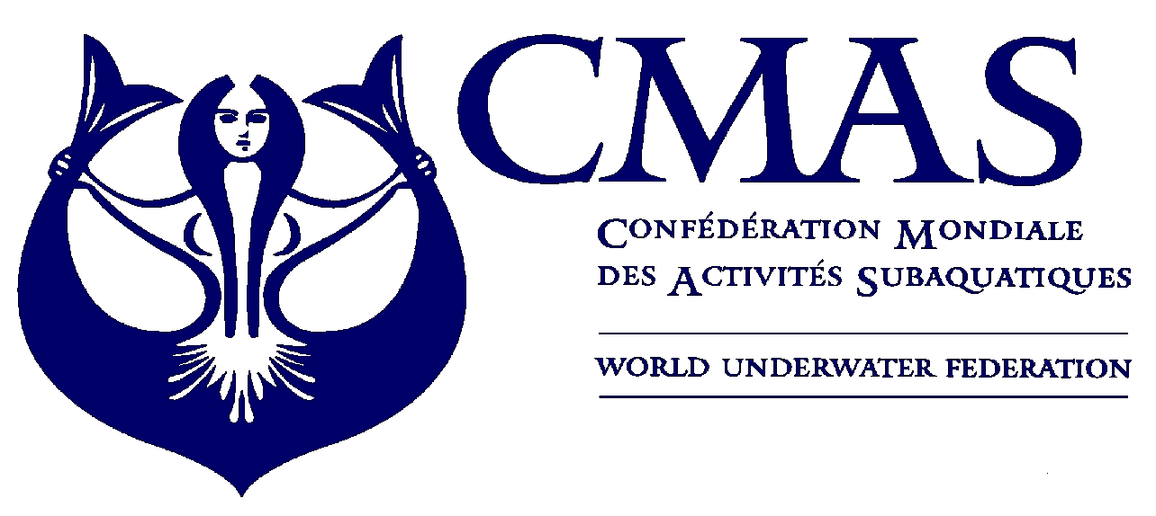
I Sport diving
European Championship
Kazan 2010

Annex 1
INITIAL ENTRY FORM
Before 15 June 2010
We will participate in the “CMAS SPORT DIVING EUROPEAN CHAMPIONSHIP 2010” in Kazan.
Initial Entry Form:
Please complete this form (type or print) and send by e-mail ruf@ruf.ru to the Organizing Committee before 15 June 2010.

Country

Federation

Total No. of Competitors | Male |  | Female

Total No. of Officials | Male |  | Female

Total number of the delegation | N.

Declaration Form:
Release from liability: I hereby declare that I exonerate of all liability however so arising, the CMAS, its affiliates, the event Organizing Committee and staff, the venue owners, sponsors, and any other persons that participate at the Event, in respect to all and every action or claim about accidents that may occur.

Please check the CMAS Procedures for participation in CMAS Championship. You have to send to CMAS document (CMAS attach n. 6) and fee four months before the championship.

Date, ________________________2010

________________________ ________________________
(President Signature/ stamp) (Full name in block letters)

__________________________________________

e-mail: ruf@ruf.ru

