
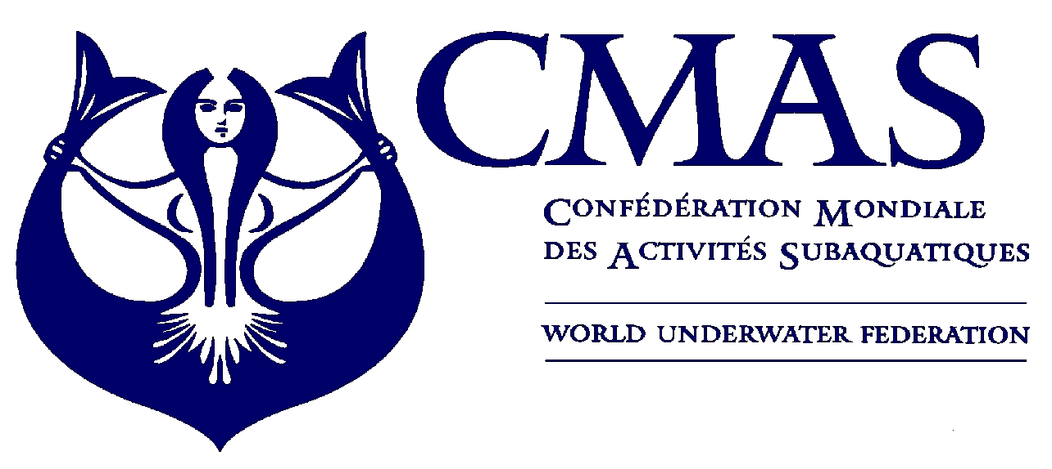
I Aquathlon
European championship
Kazan 2010

Dear Ms. & Mr. Presidents, Dear Sports Friends,

The Russian Underwater Federation has the pleasure to invite you and your team to participate in the I CMAS Aquathlon European Championship to be held in Kazan from 28 of July to 01 of August 2010. Herewith you may find all information regarding the championship as well as all the forms necessary for your participation.

We shall be honored to welcome you soon in Kazan

Sincerely yours,

Anna Arzhanova
President

For further information, please contact us following address.
Organizing Committee Address
Russian Underwater Federation
Tel: +7 (987) 296 08 07
Fax: +7 (495) 493 83 83
www.ruf.ru
E-mail: ruf@ruf.ru

Please send your payment to the following account:
Account Bank: Raiffeisen Zentralbank Oesterreich AG, Vienna
Swift code: RZBAATWW
Receiver's Bank: SOFIA BANK, Moscow, A/C # 55041552
Swift Code: SOFYRUMM
Receiver's Name: RUSSIAN UNDERWATER FEDERATION
A/C # 40703978200001000072
Reason for payment: Contribution for participation in European Championship

Dear Sirs!
To comply with Russian currency regulations would you be so kind supplying the transfer (payment throw bank) with a letter on blank and with stamp of your federation (Annex 3) by fax +7 (495) 493 83 83.

__________________________________________
E-mail: ruf@ruf.ru http://www.ruf.ru
125364, Москва, ул. Лодочная, 43/1 43/1 Lodochnaya str., Moscow, 125364
Факс: +7 (495) 493 23 65 Fax: +7 (495) 493 23 65

