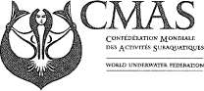

Aquathlon commission

25 May 2010

Reply to the letter of Rome, 24 May 2010 PROT.447/SG/2010

Mr, Alessandro Zerbi
Secretaire General

cc
Mr.Xavier Duran Soler
CMAS Sport Committee President presidente@fedas.es
All Federation member of Aquation Commission

Object: Aquation Judge Course
Dear Sirs, dear sport friends
I would like to inform you that Aquation judge course CMAS will be held in Kazan ( Russia) on the 28th-29th of July, because the Aquathlon European Championship will be held on the 30th-31st of July.

Thank you in advance for your collaboration. Your Sincerely,
Igor Ostrovsky president of aquathlon commissijn:E-mail: aquathlon2005@ gmail.com

