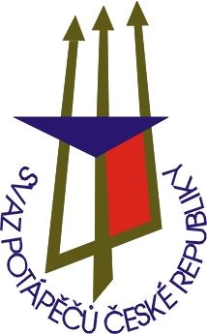
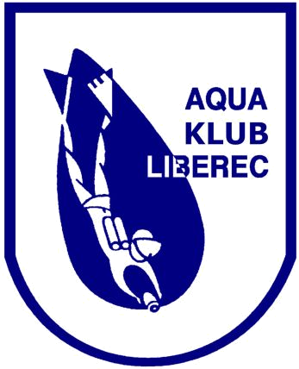
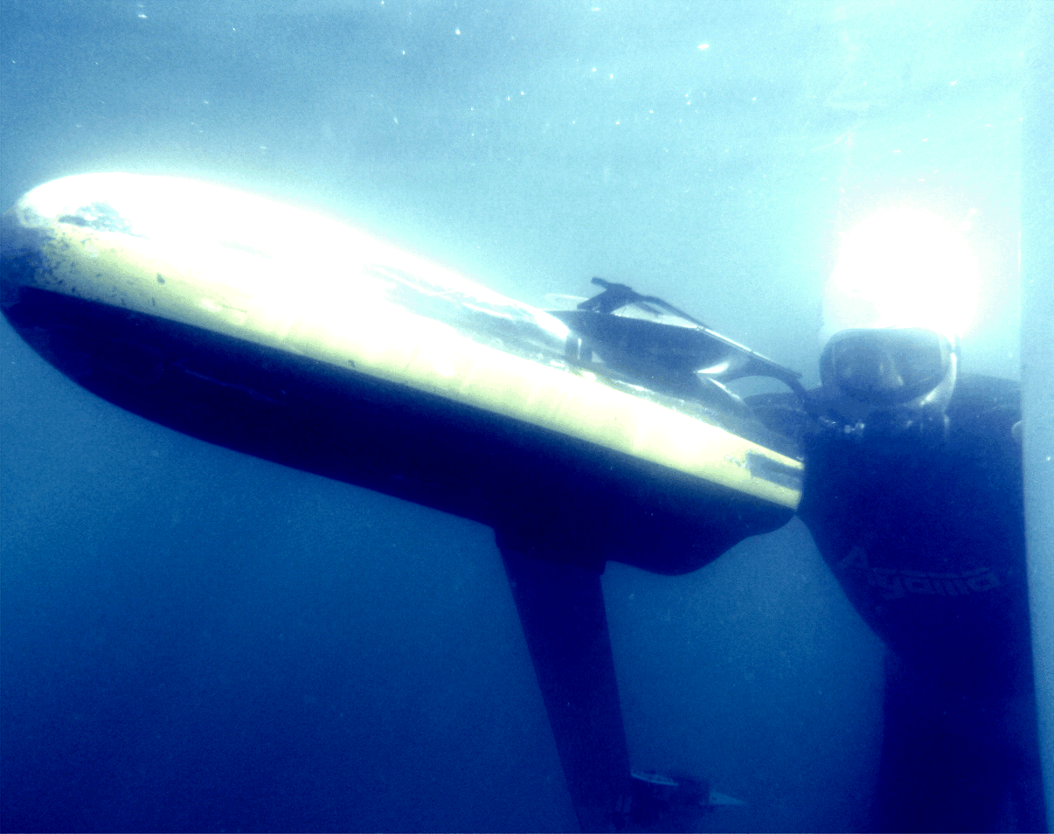
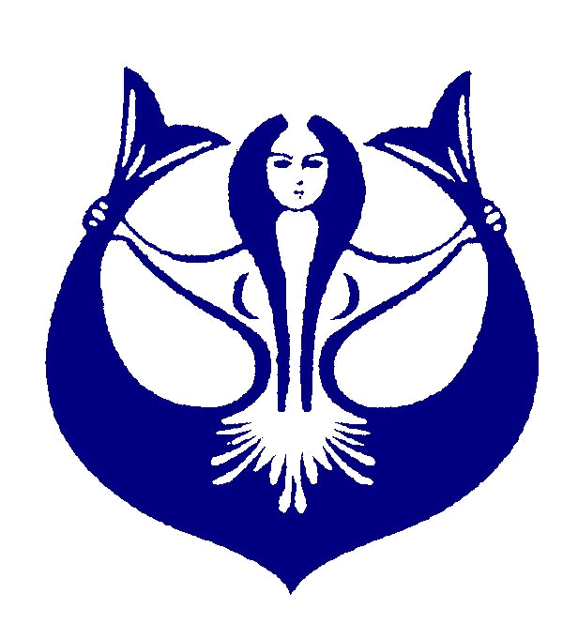
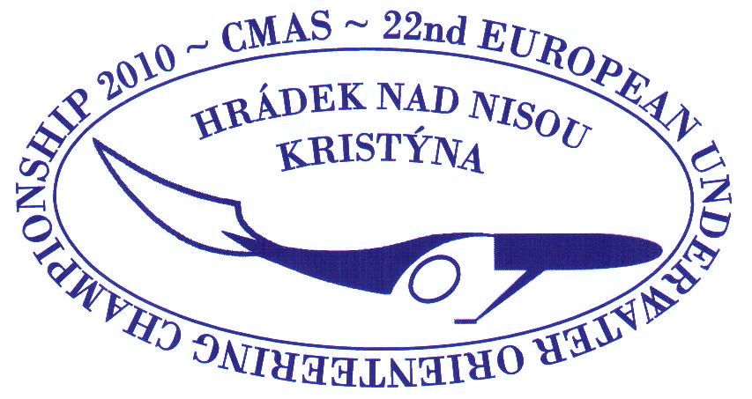
22nd OPEN EUROPEAN CHAMPIONSHIP
3rd OPEN YOUTH EUROPEAN CHAMPIONSHIP
IN UNDERWATER ORIENTEERING 2010
28.8. – 5.9. 2010
Czech Republic - Hrádek nad Nisou - Kristýna

CMAS

Organized by CMAS, Czech Divers Federation and Aqua klub Liberec


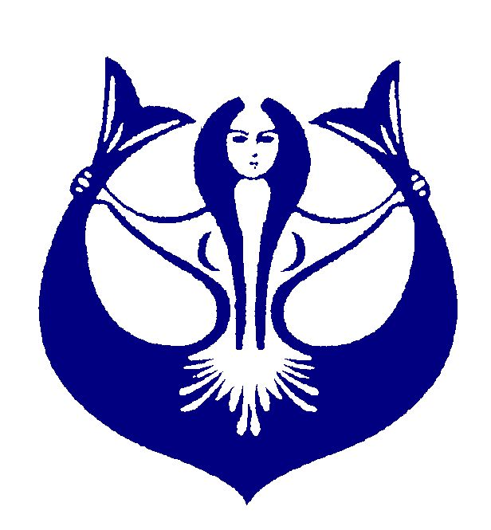
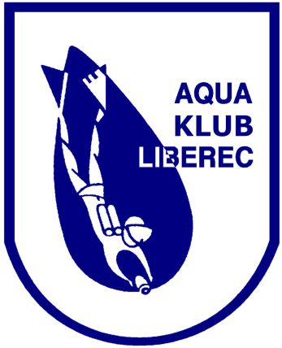
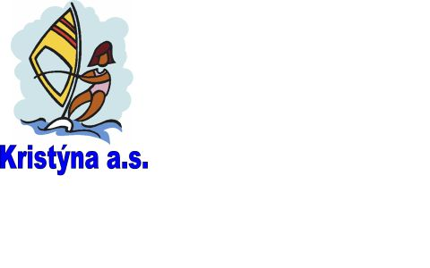
22nd OPEN EUROPEAN CHAMPIONSHIP
3rd OPEN YOUTH EUROPEAN CHAMPIONSHIP
IN UNDERWATER ORIENTEERING 2010
Czech Republic - Hrádek nad Nisou - Kristýna

CMAS

DATE 28.8. - 5.9. 2010

VENUE Area Kristýna
Hrádek nad Nisou
Czech Republic

PROGRAM

Saturday, August 28, 2010ur Arrival of the teams

Sunday, August 29, 2010 10:00 - 19:00 Training and Checking in 17:00 Opening ceremony
20:00 Team leaders and judges’ meeting

Monday, August 30, 2010 09:00 MONK competition W - M
14:00 PARALLEL course - qual. W - M - Y

Tuesday, August 31, 2010 09:00 5 point course W - M - Y
Victory ceremony - MONK competition
Victory ceremony - 5 point course

Wednesday, September 1, 2010 09:00 STAR course W - M - Y

Thursday, September 2, 2010 09:00 M - course W - M - Y
Victory ceremony - STAR course
Victory ceremony - M-course

Friday, September 3, 2010 09:00 PARALLEL course - final W - M - Y

Saturday, September 4, 2010 09:00 TEAM competition W - M
Victory ceremony - PARALEL course
Victory ceremony - TEAM competition
Closing ceremony and farewell party

Sunday, September 5, 2010 Team departures

22nd OPEN EUROPEAN CHAMPIONSHIP
3rd OPEN YOUTH EUROPEAN CHAMPIONSHIP
IN UNDERWATER ORIENTEERING 2010
Czech Republic - Hrádek nad Nisou - Kristýna

CMAS

ORGANIZED BY

Competition authorized by: Divers Association of Czech Republic – CMAS member

Technical performance: AQUA KLUB LIBEREC
Chelčického 16a
460 01 Liberec 5
Czech Republic

Application: By April 30, 2010 - provisional application
BY Jun 30, 2010 - binding application + fees
to competition office’s address

Fees: EUR 550 per adult competitor
(includes EUR 400 – organization fee + EUR 150
- starting fee)
EUR 475 per youth competitor
(includes EUR 400 – organization fee + EUR 75
- starting fee)
EUR 400 per other person

EUR 100 - protest fee

Starting and organization fees must be paid until the 30th of Jun 2010 to the
competition bank account. The organization fee paid after 30th of Jun 2010:
EUR 440 per person.

Competition Office: AQUA KLUB LIBEREC
Chelčického 16a
460 01 Liberec 5
Czech Republic

phone/fax: +420 485 104 596
e-mail: aquaklubliberec@volny.cz
web site: www.aquaklubliberec.cz

Competition bank account: account number: 234 957 980 /0300
BIC: CEKOCZPP IBAN: CZ63 0300 0000 0002 3495 7980

22nd OPEN EUROPEAN CHAMPIONSHIP
3rd OPEN YOUTH EUROPEAN CHAMPIONSHIP
IN UNDERWATER ORIENTEERING 2010
Czech Republic - Hrádek nad Nisou - Kristýna

CMAS

Bank address: ČSOB a.s.
Tř. 1. Máje 18
460 01 Liberec 1
Czech Republic

Lodging and meals: The lodging and meals will be in the competition place
- area Kristýna

Request for visa: Only at the contact: diver@svazpotapecu.cz
phone: +420 241 445 803
fax.: +420 241 445 803

CMAS Commisar: Dirk Preuss

Miscellaneous:

- This competition will be organised according to the current CMAS rules!
- The organizer offers compressor service.
- The competitors themselves are responsible for the proper condition of their
equipment!
- The organizer declines any liability!
- All competitors take part at their own risk!!
- The organizer keeps the right of modification.

