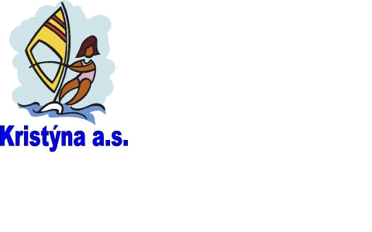
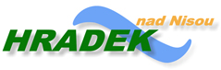
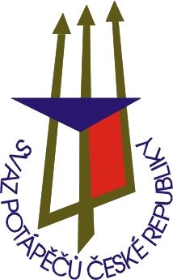
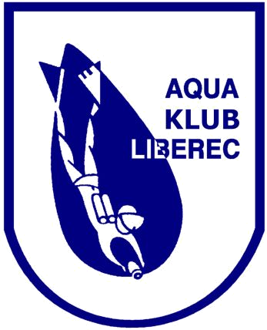
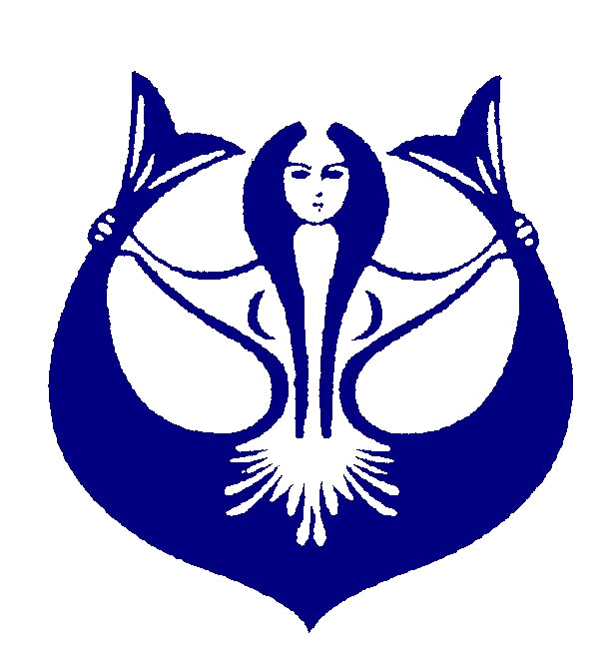
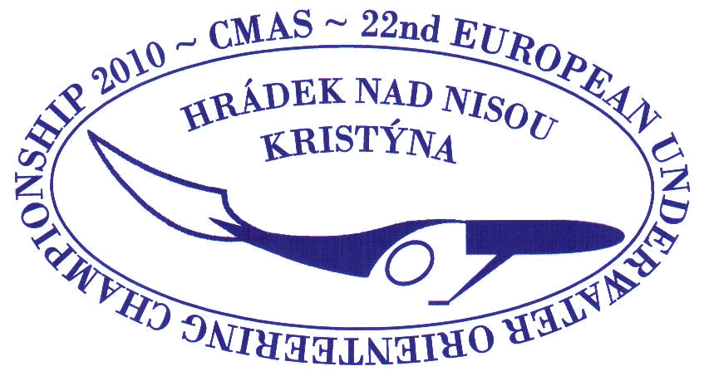
APPLICATION FORM

22nd OPEN EUROPEAN CHAMPIONSHIP
3rd YOUTH OPEN EUROPEAN CHAMPIONSHIP
IN UNDERWATER ORIENTEERING 2010

28.8. - 5.9. 2010
Czech Republic - Hrádek nad Nisou - Kristýna

AQUA KLUB LIBEREC
Chelčického 16a
460 01 Liberec 5
Czech Republic

phone/fax: +420 485 104 596
e-mail: aquaklubliberec@volny.cz
CMAS

Team |  | A / Y | No. | Men |  | Women
 |  |  |  | Surname / Name | Born | Surname / Name | Born
Address |  |  | 1
Address |  |  | 2
Phone |  |  | 3
Fax |  |  | 4
E-mail |  |  | 5
Leader |  |  | 6
Couch |  |  | 1
Others |  |  | 2
Others |  |  | 3
Others |  |  | 4
Others |  |  | 5
Others |  |  | 6

Date: Signature – stamp:

