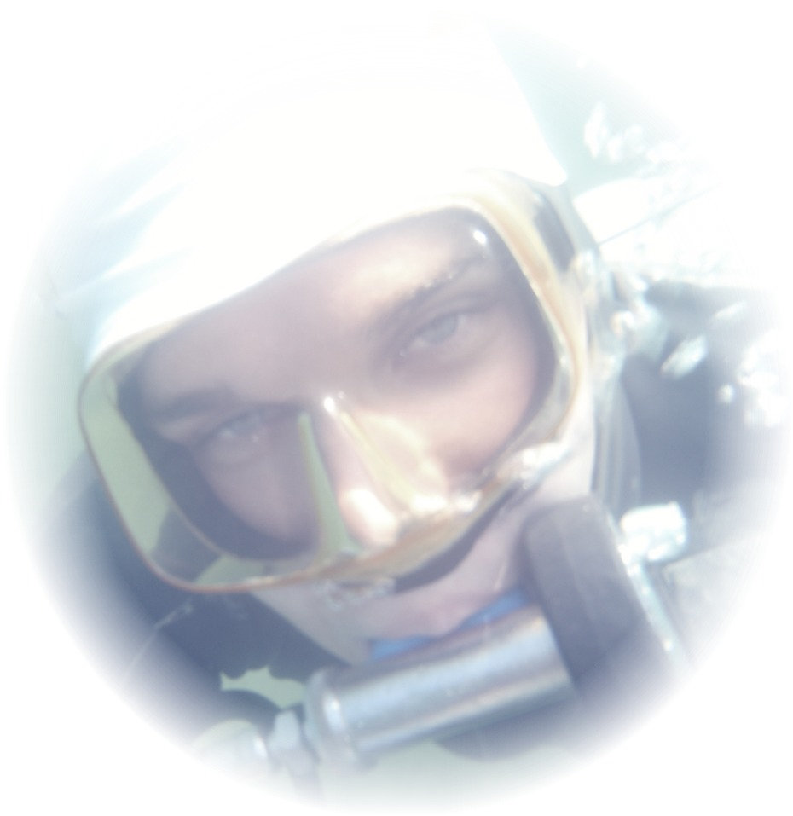

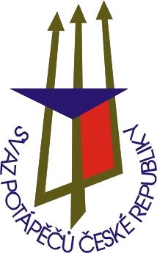
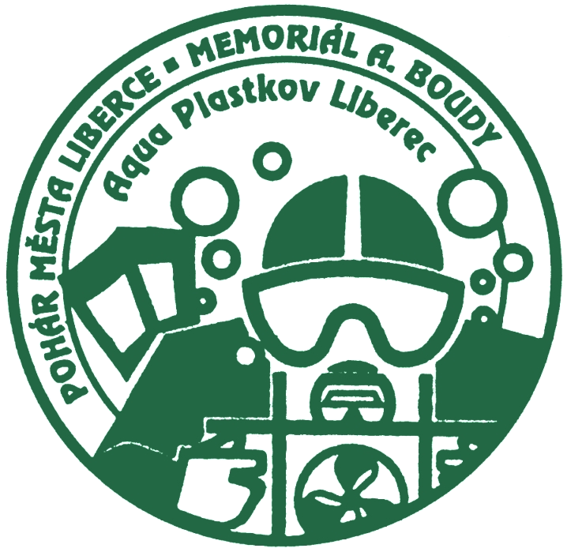
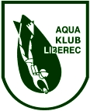
WORLD CUP
18th Championship of Czech Republic
Underwater orienteering
Hrádek nad Nisou 25.6. - 27.6. 2010
Czech Republic

INVITATION TO

WORLD CUP
18th CHAMPIONSHIP OF CZECH REPUBLIC
IN UNDERWATER ORIENTEERING
Hrádek nad Nisou 25.6. – 27.6. 2010
(46th A. Bouda Memorial)
(44th Liberec Cup)

VENUE Area Kristýna
Hrádek nad Nisou
Czech Republic

PROGRAMME

Friday, June 25, 2010

12:00 - 19:00 Training and Checking in
19:30 Team leaders and judges’ meeting

Saturday, June 26, 2010

09:00 Start of
„5P“ W – M

16:00 Start of
„PARALLEL - KURS“ W - M

Sunday, June 27, 2010

09:00 Start of
„TEAM COMPETITION“ W - M

15:00 Reading the best competitors and teams
and closing the competition.

ORGANIZED BY

Competition authorized by: Divers Association of Czech Republic – CMAS member

Technical performance: AQUA KLUB LIBEREC
Chelčického 16a
460 01 Liberec 5
Czech Republic

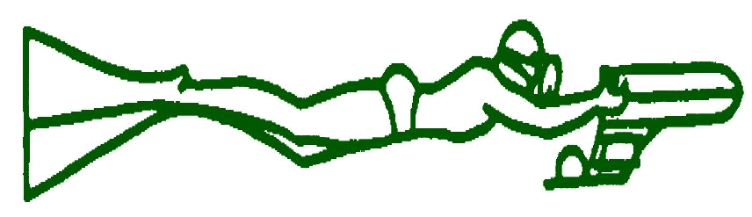



INVITATION TO

WORLD CUP
18th CHAMPIONSHIP OF CZECH REPUBLIC
IN UNDERWATER ORIENTEERING
Hrádek nad Nisou 25.6. – 27.6. 2010
(46th A. Bouda Memorial)
(44th Liberec Cup)

Applications: By June 1, 2010
to competition office’s address

Competition Office: AQUA KLUB LIBEREC
(at the clubroom - Chelčického 16a
Aqua klub Liberec) 460 01 Liberec 5
Czech Republic

phone/fax: +420 485104 596
e-mail: aquaklubliberec@volny.cz
silny.kuba@seznam.cz

Lodging: The lodging will be arranged by the
organizer on receiving an irrevocable
order by June 1, 2010!
Camp area Kristýna – Hrádek nad Nisou

Meals: Unsecured by organiser

Starting fee: EUR 60 per competitor

Check-in: At the area Kristýna – Hrádek nad Nisou

Request for visa: Only at the contact: diver@svazpotapecu.cz
phone: +420 241 445 804
fax.: +420 241 445 803
CMAS Commisar: Gundula Richter

Miscellaneous :

- This competition will be organised according to the current CMAS rules!
- The organizer offers compressor service.
- The competitors themselves are responsible for the proper condition of their
equipment!
- The organizer declines any liability!
- All competitors take part at their own risk!!
- The organizer keeps the right of modification.

INVITATION TO

WORLD CUP
18th CHAMPIONSHIP OF CZECH REPUBLIC
IN UNDERWATER ORIENTEERING
Hrádek nad Nisou 25.6. – 27.6. 2010
(46th A. Bouda Memorial)
(44th Liberec Cup)

Parallel Course

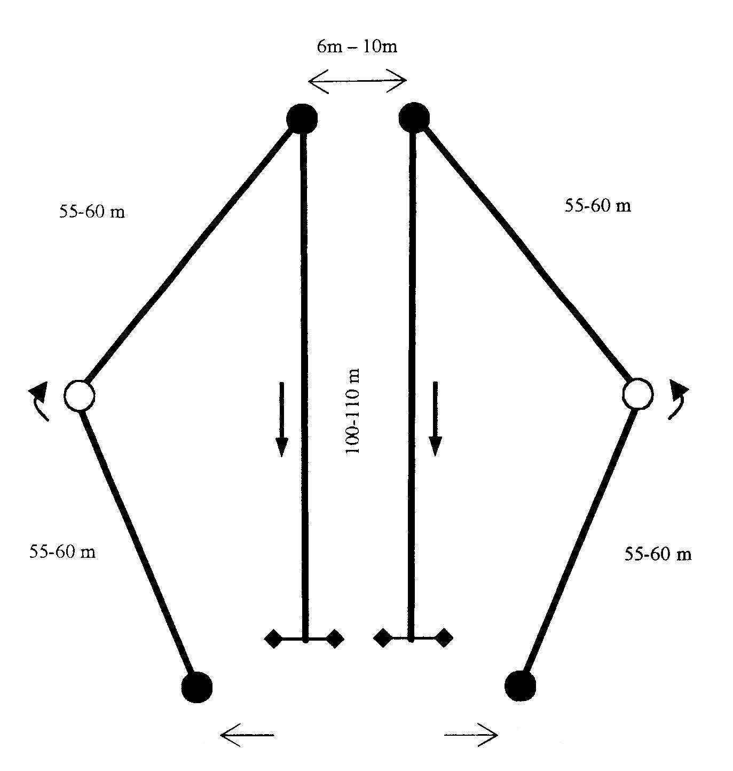
Start 1
Start 2
Point A
Point B
SIDE A
SIDE B
Destination zones 3 m
minimally 20 m

- Competitors start in pairs in two rounds
- Impaired competitor start single
- Competitors start in turns from the Start 1 (Side A) and the Start 2 (Side B)
- Measured are the competitors reaching the goal in both rounds
- The final sequence is made up by the sum of times of both rounds
- Start interval – 3 minutes

INVITATION TO

WORLD CUP
18th CHAMPIONSHIP OF CZECH REPUBLIC
IN UNDERWATER ORIENTEERING
Hrádek nad Nisou 25.6. – 27.6. 2010
(46th A. Bouda Memorial)
(44th Liberec Cup)
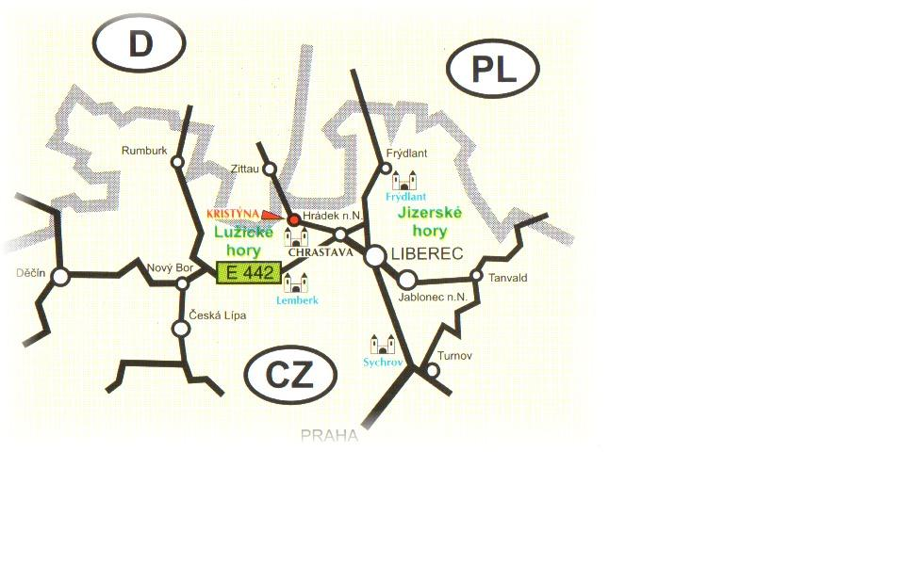

Area Kristýna – Hrádek nad Nisou

