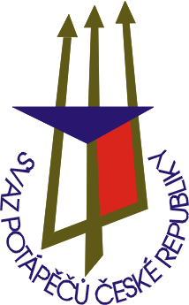
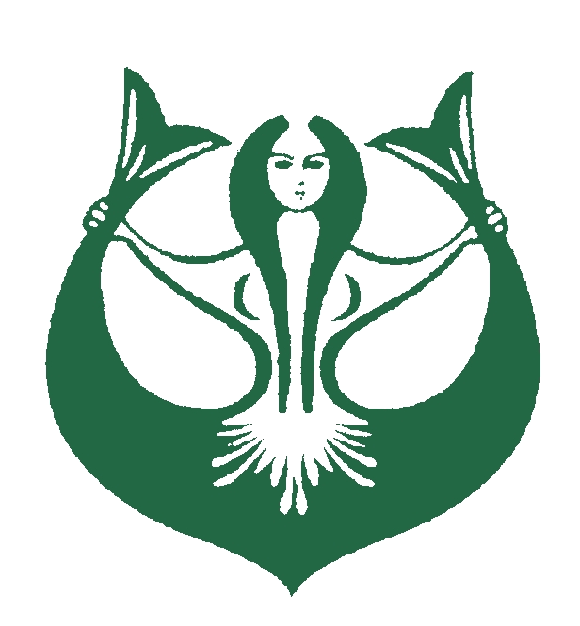
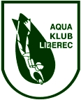
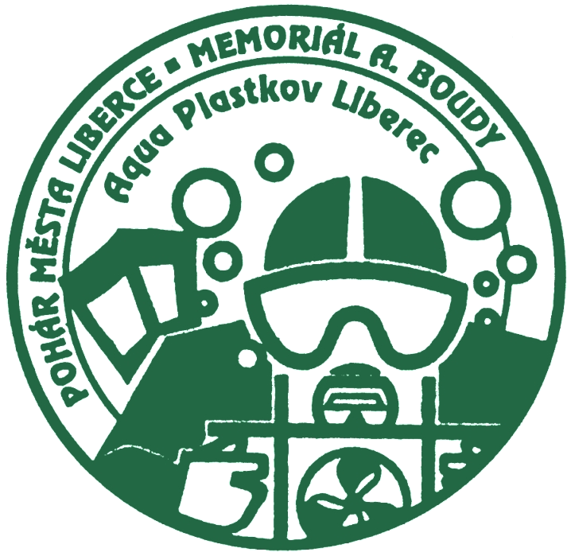
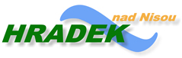
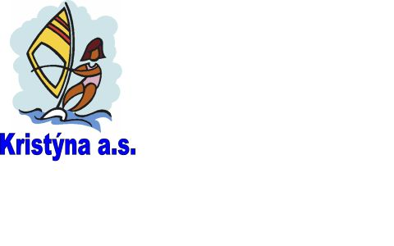
APPLICATION FORM FOR
WORLD CUP
18th CHAMPIONSHIP OF CZECH REPUBLIC
IN UNDERWATER ORIENTEERING
Hrádek nad Nisou 25.6 – 27.6. 2010
(46th A. Bouda Memorial)
(44th Liberec Cup)

AQUA KLUB LIBEREC
CHELČICKÉHO 16a
460 01 LIBEREC 5

CZECH REPUBLIC

phone/fax: +420 485 104 596
e-mail: aquaklubliberec@volny.cz
silny.kuba@seznam.cz

PLEASE, MARK - X - DISCIPLINE (PARALLEL - COURSE, 5P , TEAM COMPETITION) FOR COMPETITORS

Club |  |  | No. | Men |  |  |  |  | Women
 |  |  |  | Name | Born | Paral. | 5P | Team | Name | Born | Paral. | 5P | Team
Address |  |  | 1
Address |  |  | 2
Phone  Fax |  |  | 3
Phone  Fax |  |  | 4
Leader |  |  | 5
Leader |  |  | 6
Couch |  |  | 7
Couch |  |  | 8
Others |  |  | 9
Others |  |  | 10
We are irrevocably ordering lodging for the following number of people:
Women: MEN:

Date: signature – stamp:

